FOR IMMEDIATE RELEASE
MARCH 17, 2022

RISING STAR BRELAND NOMINATED FOR
THREE 2022 CMT MUSIC AWARDS SET TO AIR APRIL 11TH
AT 7 PM (CT) ON CBS

JUST ANNOUNCED: BRELAND FEATURED IN AMAZON MUSIC’S FOR LOVE & COUNTRY DOCUMENTARY FILM TO RELEASE APRIL 7TH

MARK YOUR CALENDAR: BRELAND TO HOST BRELAND & FRIENDS BENEFITING THE OASIS CENTER AT THE RYMAN AUDITORIUM APRIL 12TH

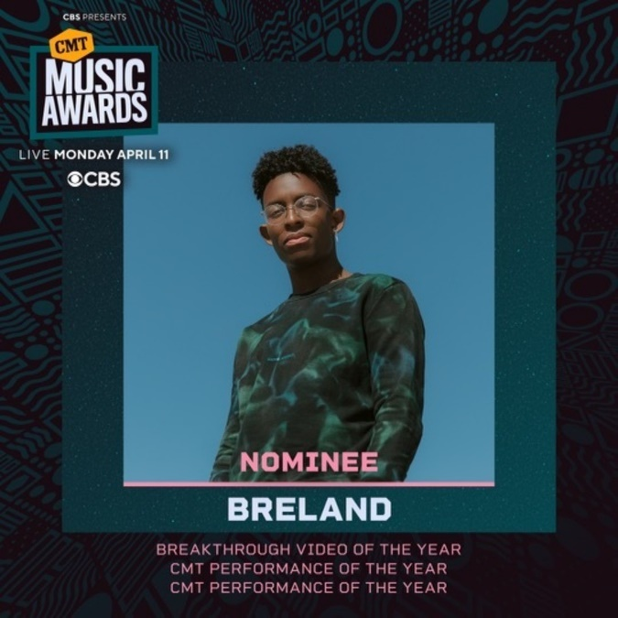
Download Asset Here

LOS ANGELES, CA. (March 17, 2022) – This just in: rising star BRELAND snags THREE CMT Music Awards nominations. Completely surprised by the news, BRELAND sat down with PEOPLE and Tennessean to capture his genuine reaction. The Bad Realm Records / Atlantic Records / Warner Music Nashville multi-talent was nominated for Breakthrough Video of the Year ("Cross Country"), and two CMT Performance Of The Year nods – “Friendship Train (from 2021 CMT Music Awards)” with Mickey Guyton and Gladys Knight plus “Ride Wit Me (from CMT Crossroads: Nelly & Friends)” with Nelly, Kane Brown, and Blanco Brown. Tune in on April 11th at 7 PM (CT) to watch the entirely fan-voted awards show live on CBS. Fans can vote up to 10 times per day now through 9 AM (CT) on April 4th. Vote here: vote.cmt.com

“Cross Country' is not just a song I wrote and perform; it's the title song of my entire movement," BRELAND tells Tennessean of his nomination. "I'm breaking down genres by building bridges between them. I tell my story in that song, hoping to inspire other people to tell their stories [in country music]. The video is the first music video that I ever came up with the concept for — so it is also important."
He proceeded to reflect about “Cross Country” to PEOPLE stating, “…it plays with the idea of what would happen if I never put 'My Truck' out. What would my life have looked like if I hadn't put the song out? If I hadn't pressed upload. And now, it's become so clear to me that this is what happens when you do it."

As announced on Tuesday (3/15), BRELAND is part of FOR LOVE & COUNTRY, an Amazon Music Original feature-length documentary that examines Country music’s evolution through the lens of a new generation of black artists. The film will feature in depth interviews and performances from current established and rising Black artists. The Breakthrough Artist for Amazon Music, BRELAND, joins the company of Jimmie Allen, Blanco Brown, Shy Carter, Mickey Guyton, Willie Jones, Valerie June, Amythyst Kiah, Reyna Roberts, Allison Russell, Brittney Spencer, and Frankie Staton.

Watch the trailer of FOR LOVE & COUNTRY here.

On the heels of announcing his forthcoming album CROSS COUNTRY (Pre-Save/Pre-Add HERE) set to release summer 2022, BRELAND wrapped a week of travelling across the globe. Making his debut performance at the 57th Annual Academy of Country Music Awards on March 7th singing his brand-new song “Praise The Lord (feat. Thomas Rhett)” live from Las Vegas, NV, the PLATINUM-selling artist headed straight to London to perform for C2C: Country To Country Festival at London’s The O2 Arena (3/11), where he received a warm welcome with Lyric Magazine praising him as a “musical maestro,” and Building Our Own Nashville stating “BRELAND has to return as soon as possible and we hope it will be for both a headline tour and a main stage C2C spot.”

Up next, BRELAND makes his return to the Grand Ole Opry (3/19) followed by the last stop on Russell Dickerson’s ALL YOURS, ALL NIGHT TOUR at Ryman Auditorium (3/25). He’ll then head to Ft. Lauderdale, FL, for Tortuga Music Festival (4/9) and then back to Nashville for BRELAND and Friends concert at Ryman Auditorium to benefit the Oasis Center, which supports Nashville youth in need (4/12). He’ll close out April taking the stage at high-profile Stagecoach Country Music Festival (4/29), with more dates to come.

ABOUT BRELAND
With his PLATINUM debut “My Truck,” singer/songwriter/producer BRELAND has emerged as a bold new force on today’s music landscape. The newly named Breakthrough Artist by Amazon Music first popped off when the Hip-Hop and Country hybrid hit #1 on Spotify’s Global Viral 50 in 2019, and a remix featuring Sam Hunt landed on best-of-the-year lists from NPR to The New York Times. Debuting his brand-new song “Praise The Lord (feat. Thomas Rhett)” at the 2022 ACM Awards, the “symbol of Country music’s ongoing evolution” (Rolling Stone) will be featured on his highly anticipated debut album CROSS COUNTRY slated for release this summer. Featured on Dierks Bentley’s Top 5 and rising single with HARDY, “Beers On Me,” BRELAND also teamed up with Keith Urban for the buzzy track “Throw It Back.” Since signing to Bad Realm Records / Atlantic Records / Warner Music Nashville, he has collaborated with heavy-hitters such as Gary LeVox of Rascal Flatts, Nelly, Blanco Brown, Lauren Alaina, and Chase Rice, and scored high profile looks on The Kelly Clarkson Show, ABC’s 2021 CMA Awards, ABC’s CMA Summer Jam, CMT Crossroads, ABC’s Jimmy Kimmel Live!, ABC’s Good Morning America, CBS’ New Year’s Eve Live: Nashville’s Big Bash, YouTube’s Artist on The Rise, and a Chevy campaign that launched during NFL’s season opener. Coined “1,000 percent the whole package” by Rolling Stone, he’s nominated for three fan-voted nominations for the 2022 CMT Music Awards. He’s out on the road for Russell Dickerson’s ALL YOURS, ALL NIGHT TOUR and is recognized in the Country Music Hall of Fame® and Museum’s brand-new exhibit, American Currents: State of the Music.

CONNECT WITH BRELAND
WEBSITE | INSTAGRAM | FACEBOOK | TWITTER | YOUTUBE | SOUNDCLOUD

FOR BRELAND
Fairley McCaskill / Fairley.McCaskill@atlanticrecords.com
Jensen Sussman / jensen@sweettalkpr.com
Mary Catherine Rebrovick / MaryCatherine@wmg.com

