DEATH CAB FOR CUTIE RELEASES OFFICIAL MUSIC VIDEO FOR “ROMAN CANDLES”

ONE-TAKE VISUAL DIRECTED BY FILMMAKER LANCE BANGS

HIGHLY-ANTICIPATED TENTH STUDIO ALBUM ASPHALT MEADOWS ARRIVES SEPTEMBER 16TH

WATCH HERE
BUY/STREAM “ROMAN CANDLES” HERE
PRE-ORDER ASPHALT MEADOWS HERE

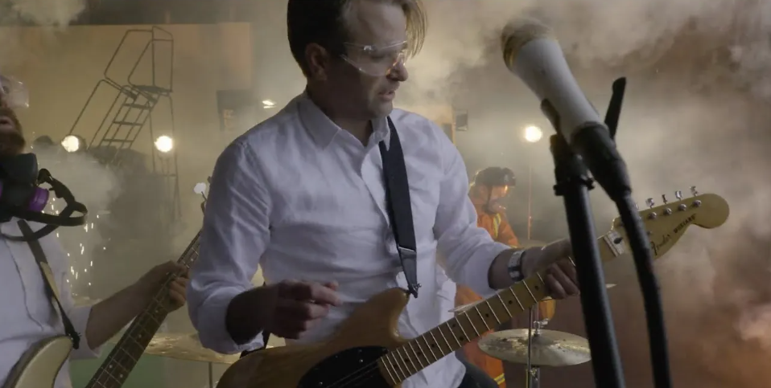

8x GRAMMY® Award-nominated rock band Death Cab for Cutie have today released the official music video for “Roman Candles,” the first track off their highly-anticipated tenth studio album Asphalt Meadows.

Starring the band in full, the video was directed by filmmaker Lance Bangs (Sonic Youth, Nirvana, Kanye West) and shot entirely in one take.

WATCH “ROMAN CANDLES” OFFICIAL VIDEO HERE

Of the experience working with Bangs, lead vocalist and guitarist Ben Gibbard shares:
"We’ve known Lance for years and it was great to get a chance to work with him again. He took this concept I had come up with and made it better than we could ever have imagined. The dude is brilliant and a total blast to work with."

Death Cab for Cutie’s tenth album Asphalt Meadows is due out September 16th. Included below is the press release from the release of “Roman Candles” earlier this month, which officially announced the album and the band’s eponymous fall headline tour.

***

FOR IMMEDIATE RELEASE
MAY 11, 2022

DEATH CAB FOR CUTIE RETURN WITH “ROMAN CANDLES”

8X GRAMMY® AWARD-NOMINATED BAND SHARE FIRST TRACK OFF HIGHLY-ANTICIPATED TENTH STUDIO ALBUM ASPHALT MEADOWS – ARRIVING SEPTEMBER 16

FALL HEADLINE TOUR GETS UNDERWAY SEPTEMBER 22 IN MADISON, WI

PRESALES BEGIN MONDAY, MAY 16 AT 10:00 AM (LOCAL)

GENERAL ON SALE STARTS FRIDAY, MAY 20 AT 10:00 AM (LOCAL)

BUY/STREAM “ROMAN CANDLES” HERE | WATCH OFFICIAL LYRIC VIDEO HERE

PRE-ORDER ASPHALT MEADOWS HERE

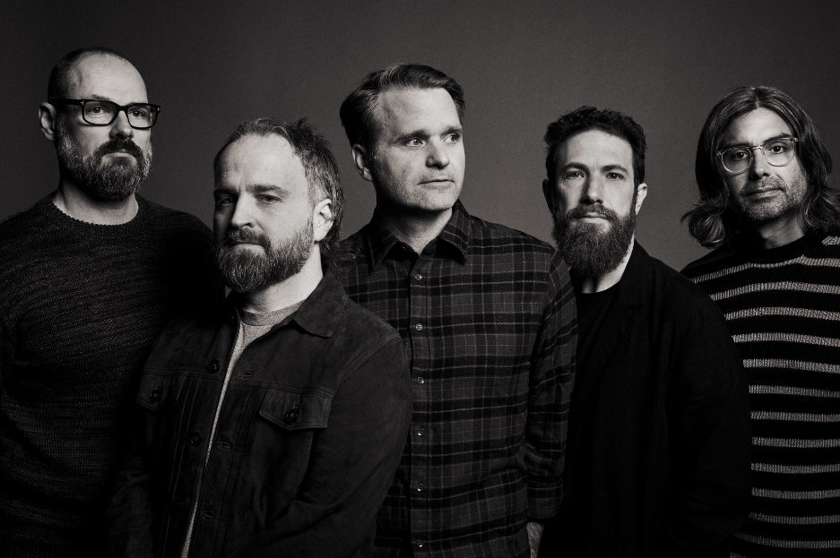
download hi-res press photo; credit Jimmy Fontaine

8x GRAMMY® Award-nominated rock band Death Cab for Cutie return today with “Roman Candles,” the first track off their highly-anticipated tenth studio album Asphalt Meadows. The new track from the indie rock veterans – now in their 25th year as a band – is available at all DSPs and streaming services via Atlantic Records (buy/stream here). The song arrives with an official lyric video designed by Juliet Bryant (Justin Vernon, Japanese Breakfast, Laura Jane Grace) – watch here.

Announced officially with today’s release, Asphalt Meadows arrives everywhere on Friday, September 16. Pre-orders are available now here.

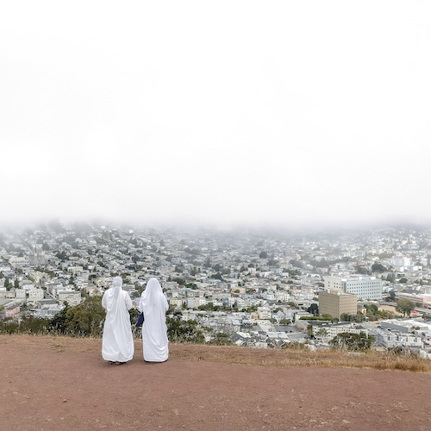
(download hi-res album artwork; photo credit: Benjamin Gibbard)

As with the forthcoming album in its entirety, “Roman Candles” was produced by GRAMMY® Award-winner John Congleton (St. Vincent, Sharon Van Etten, Wallows).

Of the inspiration for the song, the band shares: “‘Roman Candles’ is about the crippling, existential dread that goes hand in hand with living in a nervous city on a dying planet. And that the only way to be in the moment is to let it all go.”

The track was born from co-founder, lead vocalist, and guitarist Benjamin Gibbard’s determination to create something succinct, loud, and strikingly direct. He shares: “The lyrics were cobbled from a couple of different songs dealing with my general sense of anxiety; the feeling that the fabric that weaves a functioning society together was crumbling during the pandemic.”

Also unveiled today is a wide-ranging US headline tour to celebrate the arrival of Asphalt Meadows. The run kicks off September 22 at The Sylvee in Madison, WI and culminates with a two-night hometown finale at Seattle, WA’s Paramount Theatre on October 26 and 27 (full routing enclosed). The tour will feature support from Low and Yo La Tengo on select dates.

Presales for the tour begin Monday, May 16 at 10:00 am (local) and continue through Thursday, May 19 at 10:00 pm (local). General on sale begins Friday, May 20 at 10:00 am (local). For early access to the artist presale and complete details, visit www.deathcabforcutie.com.

The new dates join previously announced summer headline shows kicking off July 7 at Cincinnati, OH’s PromoWest Pavilion at Ovation. Support on that run will come from illuminati hotties. Also previously announced is the group’s much anticipated return to NY’s Forest Hills Stadium on September 30. Additionally, the coming months will see Death Cab for Cutie performing at a number of festivals and high profile events, including Guadalajara, Mexico’s Corona Capital Guadalajara (May 21), Portland, OR’s “TEDxPortland Year 10” (May 28), and Milwaukee, WI’s Summerfest (July 9).

Death Cab for Cutie’s ninth studio album Thank You for Today was released in 2018. That album saw the band entering its second decade by both expanding and refining its signature sound, with highlights including lead single, “Gold Rush,” which reached #1 on Billboard’s “Adult Alternative Songs” chart.

The band continued to affirm their lasting artistic legacy with a wide range of creative activity in the years that followed, including diverse collaborations such as Chance the Rapper’s 2019 album track, “Do You Remember (ft. Death Cab for Cutie),” and Tycho & Gibbard’s acclaimed 2021 single, “Only Love.”

Gibbard presented a series of “Live From Home” livestreams throughout the duration of the COVID-19 pandemic, helping raise over $250K in donations and supplies for various Seattle-area relief organizations. The livestreams – which showcased songs from Death Cab for Cutie, The Postal Service and his solo material, along with covers and other surprises – drew over 4.5 million total views as well as high profile media attention from The New York Times, The New Yorker, Rolling Stone, Newsweek, Variety, NPR, and Stereogum, the latter of which pondered, “Is Ben Gibbard going to single-handedly get us all through quarantine?”

December 2020 saw Death Cab for Cutie release The Georgia EP, initially offered as a 24-hour Bandcamp exclusive in advance of the crucial Georgia runoff elections that ultimately turned the state blue and secured Democratic control of the US Senate. The five-song project – which features covers of iconic artists from the great state of Georgia – raised over $100K for Fair Fight Action, the national voting rights organization founded by Stacy Abrams to promote fair elections around the country through voter education, election reform, and combating voter suppression. “Fair Fight is grateful for the support of Death Cab for Cutie in our fight for free and fair elections in Georgia and nationwide,” Abrams said later. “The Georgia EP helps tell the story of Georgia just as their contributions have helped us write the next chapter.”

In February of this year, Gibbard conceived, curated, and executive produced Ocean Child: Songs of Yoko Ono, an acclaimed tribute to the groundbreaking singer, songwriter, multimedia artist, and activist released in celebration of her 89th birthday. The collection – which includes Death Cab for Cutie’s own cover of “Waiting For The Sunrise” – also features contributions from a stunning range of diverse artists, including David Byrne, Japanese Breakfast, The Flaming Lips, and Sharon Van Etten. Ocean Child earned worldwide critical acclaim spanning The New York Times, Rolling Stone, NPR, The Guardian and more.

Formed in Bellingham, WA in 1997, Death Cab for Cutie almost immediately entered the ranks of the era’s definitive bands, fueled in large part by the remarkable power of co-founder, vocalist, guitarist, and lead songwriter Benjamin Gibbard’s complex, often bittersweet songcraft. The band made their worldwide popular breakthrough with 2003’s RIAA gold certified Transatlanticism, later named by NPR as one of “The Decade's 50 Most Important Recordings.” Plans, their 2005 Atlantic Records debut release, saw Death Cab for Cutie ascending to even greater heights, earning RIAA platinum certification and a GRAMMY® Award nomination for “Best Alternative Album” while spawning the chart-topping singles, “Soul Meets Body” and “I Will Follow You into the Dark,” the latter of which was honored with a GRAMMY® nod for “Best Pop Performance By Duo Or Group With Vocals.” Their following albums – including Narrow Stairs (2008), The Open Door (2009), Codes and Keys (2011), and Kintsugi (2015) – all received various GRAMMY® Award nominations, bringing their total career nominations to eight overall.

###

DEATH CAB FOR CUTIE
TOUR 2022

MAY
21 – Guadalajara, MX – Corona Capital Guadalajara *
28 – Portland, OR – TEDxPortland Year 10 @ Moda Center/Theater of the Clouds

JULY
7 – Cincinnati, OH – PromoWest Pavilion at Ovation †
8 – Grand Rapids, MI – GLC Live at 20 Monroe †
9 – Milwaukee, WI – Summerfest @ Generac Power Stage *
11 – Buffalo, NY – ARTPARK †
12 – LaFayette, NY – Beak & Skiff Apple Orchards †
14 – Harrisburg, PA – Harrisburg University at Riverfront Park †
15 – Uncasville, CT – Mohegan Sun Arena †
16 – Poughkeepsie, NY – MJN Convention Center †

SEPTEMBER
22 – Madison, WI – The Sylvee ^
23 – Minneapolis, MN – Surly Brewing Festival Field
24 – Chicago, IL – The Salt Shed
26 – Columbus, OH – KEMBA Live! ^
27 – Washington, DC – The Anthem ^
29 – Philadelphia, PA – The Met ^
30 – New York, NY – Forest Hills Stadium ^

OCTOBER
1 – Boston, MA – Leader Bank Pavilion ^
3 – Raleigh, NC – Red Hat Amphitheater ^
4 – Atlanta, GA – Coca-Cola Roxy ^
6 – Richmond, VA – Virginia Credit Union LIVE! ^
7 – Asheville, NC – Rabbit Rabbit ^
8 – Charleston, SC – Firefly Distillery ^
10 – Pittsburgh, PA – Stage AE ^
11 – Detroit, MI – The Masonic ^
13 – St. Louis, MO – The Factory ^
14 – Kansas City, MO – Arvest Bank Theatre at The Midland ^
15 – Tulsa, OK – Cain’s Ballroom
17 – Phoenix, AZ – The Van Buren
18 – Anaheim, CA – House of Blues Anaheim #
19 – Santa Barbara, CA – Santa Barbara Bowl #
21 – Los Angeles, CA – The Greek Theatre #
22 – San Diego, CA – Venue TBA #
23 – Oakland, CA – Fox Theater #
24 – Oakland, CA – Fox Theater #
26 – Seattle, WA – Paramount Theatre
27 – Seattle, WA – Paramount Theatre

* Festival Performance
† w/Special Guests illuminati hotties
^ w/Special Guests Low
# w/ Special Guests Yo La Tengo

# # #

CONNECT WITH DEATH CAB FOR CUTIE
DEATHCABFORCUTIE.COM | FACEBOOK | TWITTER | INSTAGRAM | YOUTUBE

