FOR IMMEDIATE RELEASE
JUNE 3, 2022

GOODY GRACE RELEASES SUMMER-READY SONG “WHAT DO I DO?”

BREEZY NEW SINGLE PRODUCED BY GOODY & CO-WRITTEN ALONGSIDE LOVELYTHEBAND’S MITCHY COLLINS

LATEST SONG ARRIVES ON THE HEELS OF COACHELLA PERFORMANCE WITH THE LOST KINGS

FOLLOW-UP TO 2021’S NOSTALGIA KILLS EP DUE OUT THIS SUMMER

DOWNLOAD/STREAM “WHAT DO I DO?”

DOWNLOAD/STREAM NOSTALGIA KILLS

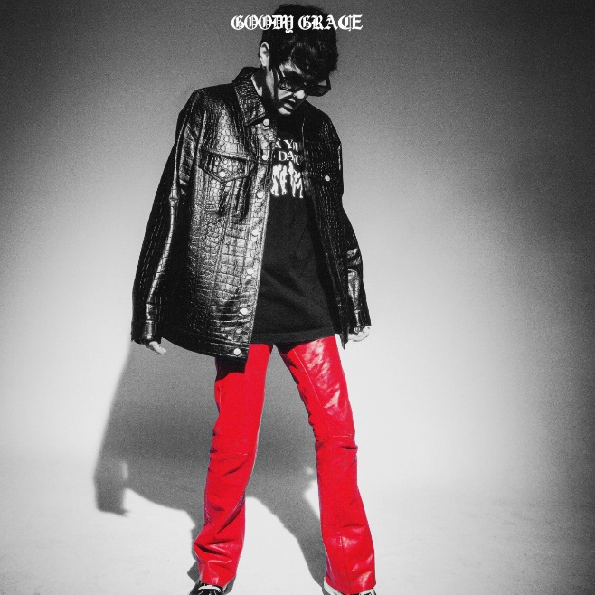
DOWNLOAD ARTWORK HERE

Acclaimed singer-songwriter-producer Goody Grace has released the summer-ready single, “What Do I Do?” self- produced and co-written by lovelytheband’s Mitchy Collins. Available now via Atlantic Records – LISTEN HERE.

Featuring a breezy, tropical-inspired production, “What Do I Do?” marks Goody’s first release since 2021’s Nostalgia Kills. 2022 ushers in an exciting new era for the Canadian artist with new EP due out this summer.

“What Do I Do?” was started in one of my best friends living rooms in my hometown. It was the dead of winter and I had been listening to a lot of Paul Simon, Vampire Weekend & Burna Boy and wanted to make a few major, uplifting ideas. To contrast the summer feel of the song, I wanted to approach the lyrics from a more emotional and raw direction. I made the base of the song & got back and finished writing it with my friend Mitchy Collins from lovelytheband. I hope everyone loves the new sound & is excited for what is to come.”
- GOODY GRACE

“What Do I Do?” follows Goody’s Coachella appearance alongside The Lost Kings and Nostalgia Kills, the five-track collection including lead single “Hold Me In Moonlight” and standout track “Gear.” Co-produced by MINGO, “Gear” arrived alongside a Geny Andrews-directed music video.

In 2021, Goody released his debut full-length project, Don’t Forget Where You Came From. Equally inspired by his coming of age in remote Selkirk, Manitoba as it is fueled by a genre-blurring array of musical influences, the project included collaborations with several artists Goody has admired and grown close to throughout his career thus far, including his childhood heroes blink-182, G-Eazy, Juicy J, Cigarettes After Sex, Burna Boy, Mr. Hudson, Anthony Fantano, Bakar, and Lexi Jayde. Among its many highlights are standout singles ““Winter (Ft. Burna Boy),” the vulnerable “Used To Be,” the middle-finger-to-the-sky anthem “If I Want To,” and the star-studded “Nothing Good (Feat. G-Eazy & Juicy J),” and “On Repeat (Feat. Cigarettes After Sex & Lexi Jayde),” the latter of which is joined by a lo-fi companion video, directed by frequent visual collaborator Kyle Dunleavy (Jason Mraz, Breaking Benjamin).

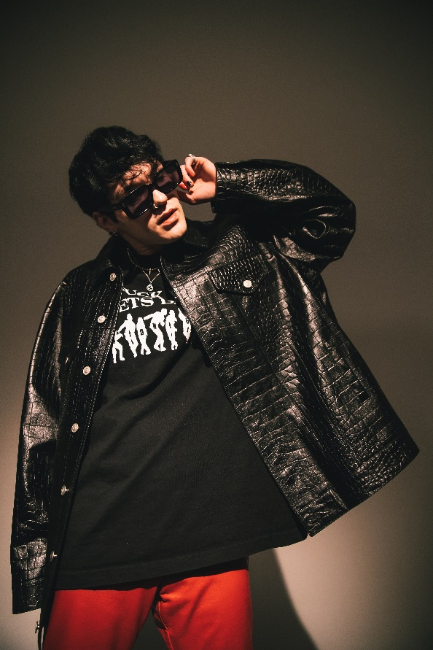
DOWNLOAD PRESS PHOTOS // PHOTO CREDIT: YOSHI UEMURA

WHAT PEOPLE ARE SAYING ABOUT GOODY GRACE:
“(Goody has) a signature ‘cinematic’ style, encompassing pop, punk, hip-hop, and folk and nodding to influences as diverse as David Lynch, Danzig, Morrissey, and Watchmen.” - BILLBOARD

“In the age of viral fame and meme music, Goody Grace stands out as a rockstar in the truest sense of the term. He unapologetically makes the music he wants to make, stays true to his roots, is stylish as hell, and comes across as a genuine person while doing it.”
- LA WEEKLY

“Fast approaching the top of alt-pop…(Goody Grace) effortlessly combines stunning indie vocals with upbeat trap rhythms for a unique experience sure to set the stage for a bright musical future.” - ALTERNATIVE PRESS

“Goody Grace is on the rise in the music world, with a unique style that can’t be easily defined or put into a single category…He sings angelically, plays a mean guitar, and raps with a lyrical grace beyond his years…his music and style only fit into a class all their own.” - LADYGUNN

“Symbolic of a modern-day punk rocker, Grace displays originality and unique style on all levels.” - FLAUNT

“Goody Grace is the perfect embodiment of the modern pop-star; a child of the internet generation that isn’t afraid to give the middle-finger to genre rules and just make the kind of music that feels genuine at the moment.” - SUBSTREAM

“Progressive and dark…Goody Grace encapsulates punk rock vibes that inextricably intertwine with his edgy vocals that make for a sonic experiment tiptoeing between alternative rock and R&B genres.” - ONES TO WATCH

CONNECT WITH GOODY GRACE
WEBSITE | INSTAGRAM | TWITTER | FACEBOOK | YOUTUBE | PRESS ASSETS

# # #

FOR PRESS INQUIRIES, PLEASE CONTACT
Jessica Nall – Jessica.Nall@atlanticrecords.com
Jason Davis – Jason.Davis@atlanticrecords.com

