FOR IMMEDIATE RELEASE
APRIL 22, 2022

ATLANTIC RECORDS OFFICIALLY WELCOMES CARSON, CA RAPPER JAYSON CASH

MUSTARD & THA EASTIE BOYZ - PRODUCED SINGLE,
“TOP DOWN,” OUT NOW

DEBUT PROJECT READ THE ROOM SET TO RELEASE MAY 27

SWAY’S UNIVERSE CYPHER STREAMING HERE

WATCH “TOP DOWN” HERE

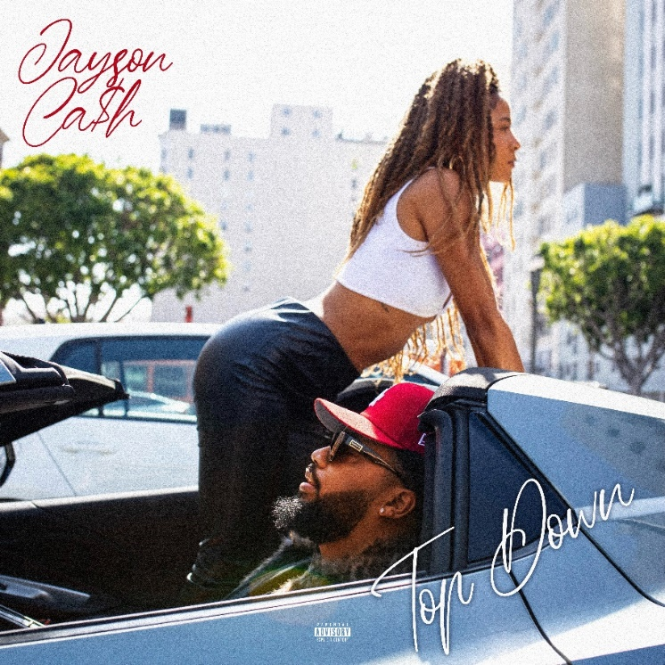
DOWNLOAD SINGLE ARTWORK HERE

Atlantic Records officially announces its signing of Carson, CA-based rapper Jayson Cash with today’s Billboard.com premiere of “Top Down”, available now on all DSPs and streaming services. Produced by Mustard (Roddy Ricch, Ty Dolla $ign, YG) and Cash’s in-house producers Tha Eastie Boyz (Blxst, Schoolboy Q, Ty Dolla $ign), the track is joined by an official music video, streaming now via YouTube. Cash’s full-length Atlantic debut, Read The Room, is set to release May 27th.

Cash – who recently rocked Sway’s Universe Cypher, streaming HERE – has been unleashing a steady series of bangers in recent months, including “Priority (Feat. BLXST),” “All I Know,” and “Been In My Bag (Feat. 1TakeJay & Major Myjah),” all available now for streaming and download and joined by official music videos streaming now at YouTube.

In addition, Cash has also proven his lyricism on electrifying freestyles for Real 92.3 LA’s Bootleg Kev & DJ Hed (streaming HERE) and Power 106 Los Angeles’ LA Leakers (streaming HERE), the latter of which has earned close to 30K views via YouTube and sees Cash raping over Jermaine Dupri’s “Money Ain’t A Thang” and Snoop Dogg’s “Still A G Thang.” What’s more, after local LA magazine, A Day In LA, dropped their “LA Rap Report Card” and gave Jayson a “D+,” instead of being salty about the grade, he jumped in the booth and responded in the freestyle fashion he’s widely known for (streaming HERE). The Editor-In-Chief of the magazine responded in fun and Mustard stepped up to stan the freestyle as a new fan.

Standing firm on representing for his hometown, Carson, CA, Cash’s signature style is the feel of LA summer barbecues, Sunday morning services, and West Coast hip-hop. In between holding down a gig at TSA in 2017, he popped out to rep his section of Carson with early fan favorite, “Carson In The House,” and hosted local concerts. In 2018, Cash dropped his Affiliated project, including guest appearances by Suga Free and BLXST. 2021 saw him land a deal with Atlantic Records, dropping “Priority (Feat. BLXST)” and “All I Know.” “All I Know” – which features chorus vocals R&B singer-songwriter, PJ – came to life after a creative back and forth with President of Asylum Records and EVP of A&R Atlantic Records Dallas Martin. Jayson pushed back during this discussion and let him know he had to make something for his city. The result was “All I Know,” which proved a satisfying result for both.

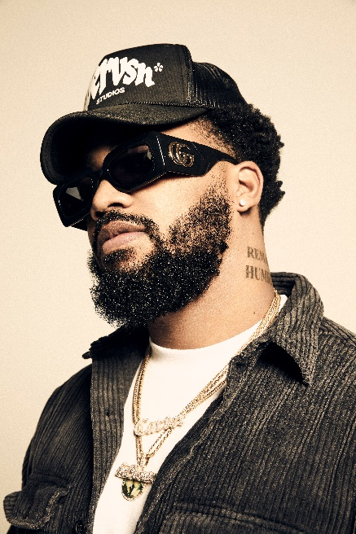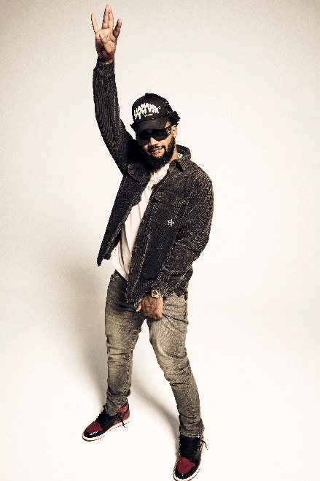

CONNECT WITH JAYSON CASH
INSTAGRAM | TWITTER | FACEBOOK| YOUTUBE

CONTACT FOR JAYSON CASH
BRITTANY.BELL@ATLANTICRECORDS.COM

###

