FOR IMMEDIATE RELEASE
JUNE 9, 2022

RISING R&B SENSATION JOSH LEVI UNVEILS DISC TWO

LONG AWAITED SOPHOMORE EP INCLUDES SUCH AS “VICES,” & “NASA”
+
NEW SINGLE “DON’T THEY REMIX (FEAT. NORMANI)”

DISC TWO AVAILABLE NOW VIA RAEDIO/ATLANTIC RECORDS HERE

LISTEN TO “DON’T THEY (REMIX)”

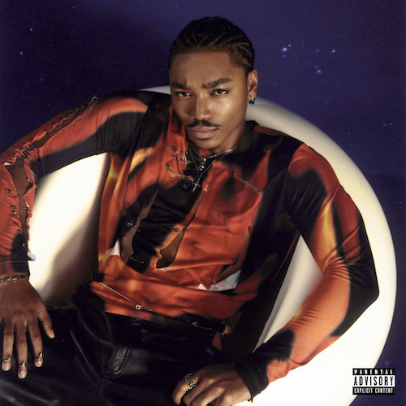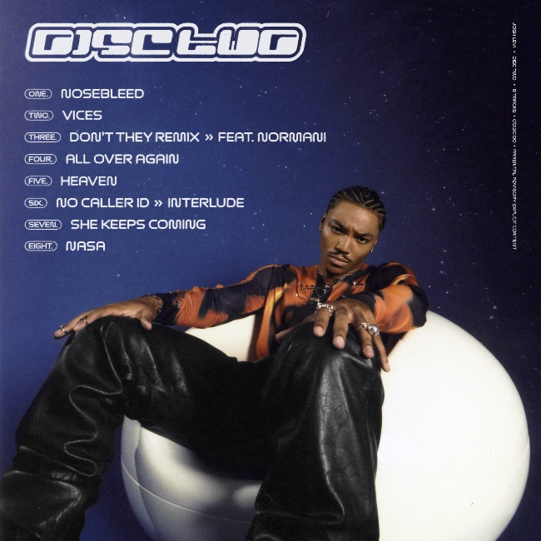
DOWNLOAD HI-RES ARTWORK

Raedio/Atlantic Records recording artist Josh Levi has announced today’s release of his eagerly awaited new EP, DISC TWO, available now at all DSPs and streaming services HERE. EP includes latest single,
“DON’T THEY REMIX (FEAT. NORMANI)” premiered on Apple’s Zane Lowe Show earlier this week.

DISC TWO includes the luxurious single and self-directed official video “VICES,” a personal favorite of Justin Bieber; who shared the record on his Instagram feed and story. The new EP was first heralded last summer with “NASA,” which premiered alongside a Loris Russier-directed companion visual streaming HERE. This year saw the rising R&B star showing off his intimate approach with a spectacular live performance video of “NASA,” streaming HERE.

Named by PEOPLE as one of last year’s “25 Emerging Musical Artists You Should Add to Your Playlist This Fall,” Levi recently celebrated the arrival of DISC TWO with a stunning live performance of “VICES” on The Terrell Show, as well as an exclusive interview with Rated R&B. He was featured in Disney/Pixar’s blockbuster, Turning Red, starring as the voice of Aaron Z., a member of the teenage heartthrob boyband 4*Town. The soundtrack’s feel-good first single, “Nobody Like U,” written by GRAMMY® Award-winning singer-songwriters Billie Eilish and Finneas O’Connell, was recently nominated in the Best Musical Moment category for the 2022 MTV Movie & TV Awards. The hit single proved an immediate smash, ascending to the upper half of Billboard’s “Hot 100” and sending Levi’s monthly Spotify listeners to more than 4.5M.

Josh Levi immediately captivates with each inhale of experience and exhale of emotion. The Houston, TX-raised and Los Angeles-based singer, songwriter, and actor developed a fervent fan base through roles on such hit series as Friday Night Lights as well as a series of viral YouTube covers and consistent touring. Hailed by Earmilk as “an all-encompassing showcase of how much of an anomaly he is,” Levi’s 2020 debut EP, DISC ONE – highlighted by such tracks as “IF THE WORLD,”– earned high profile media attention from the likes of Billboard, Wonderland, and V, which declared him “your classic triple threat.” As a result, Levi caught the attention of Issa Rae's label imprint, Raedio, featuring his 2021 single, “What’s The Use,” on the soundtrack to her critically acclaimed HBO Series, Insecure: Season 5. The track proved an instant smash for Levi, named by Billboard at #6 on their “Tunefind Top TV/Movie Syncs of 2021.”

CONNECT WITH JOSH LEVI:
TWITTER | INSTAGRAM | TIKTOK | FACEBOOK | YOUTUBE

PRESS CONTACT:
Brittany Bell | Brittany.Bell@atlanticrecords.com

