FOR IMMEDIATE RELEASE
MAY 4, 2022

JAYSON CASH TAPS DOM KENNEDY FOR SECOND SINGLE/VIDEO
“HIM” OFF FORTHCOMING LABEL DEBUT PROJECT

WATCH VIDEO HERE

FIRST SINGLE “TOP DOWN” PRODUCED BY MUSTARD + THE EASTIE BOYZ

TRACKLIST REVEALS FEATURES INCLUDING SYMBA, KALAN.FRFR & MORE
READ THE ROOM OUT ON MAY 27TH
PRE-ADD/PRE-SAVE HERE

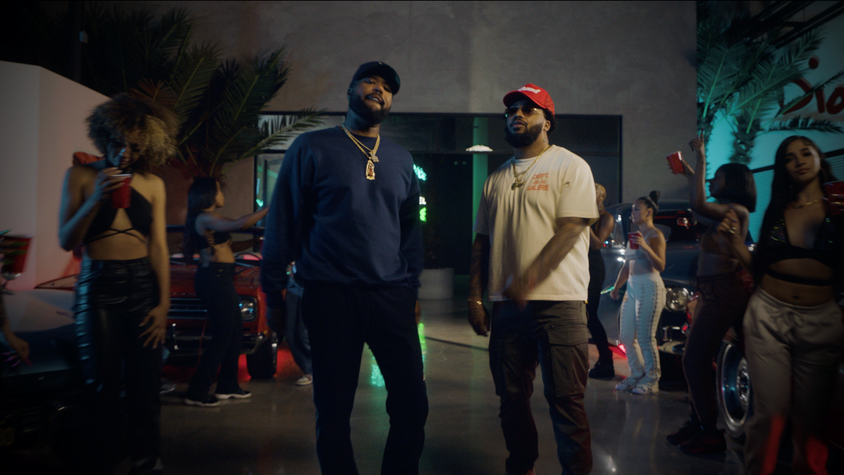
DOWNLOAD THUMBNAIL HERE
Carson, CA-based rapper Jayson Cash reminds everyone why he’s that guy with new single “Him Ft. Dom Kennedy,” produced by Cash’s in-house producers, Tha Eastie Boyz. Watch official video HERE. Cash continues to lyrically set the tone after dropping summertime feel-good record, “Top Down,” produced by Mustard and Tha Eastie Boyz. His full-length Atlantic debut, Read The Room, is set to release May 27th with a track list featuring West Coast acts Symba, Kalan.FrFr and more.

Cash recently announced his label signing and premiered his first single with a Billboard exclusive, after being featured on Sway’s Universe Cypher, streaming HERE. Carving out his own lane as a standout lyricist and tapping back into what he’s recognized for, Cash recently dropped a freestyle over Jack Harlow’s “First Class.” Check it out HERE.

While unleashing a steady series of bangers last year, including “Priority (Feat. BLXST),” “All I Know,” and “Been In My Bag (Feat. 1TakeJay & Major Myjah),” he proved his lyricism on electrifying freestyles for Real 92.3 LA’s Bootleg Kev & DJ Hed (streaming HERE) and Power 106 Los Angeles’ LA Leakers (streaming HERE). The latter has earned close to 30K views via YouTube and sees Cash raping over Jermaine Dupri’s “Money Ain’t A Thang” and Snoop Dogg’s “Still A G Thang.”

After local LA magazine, A Day In LA, dropped their “LA Rap Report Card” and gave Jayson a “D+,” instead of being salty about the grade, he jumped in the booth and responded in the freestyle fashion he’s widely known for (streaming HERE). The Editor-In-Chief of the magazine responded in fun and Mustard stepped up to stan the freestyle as a new fan.

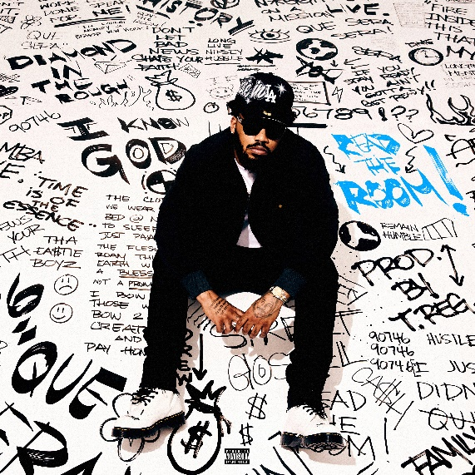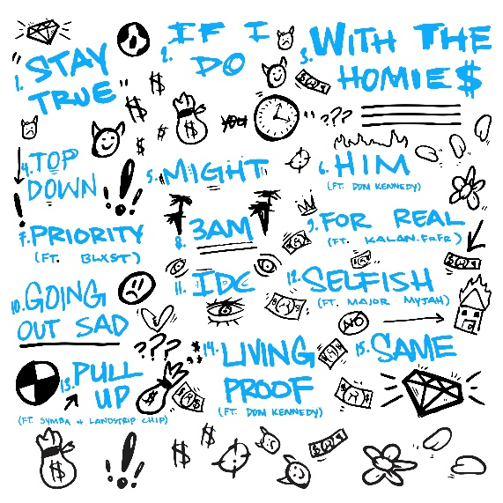
DOWNLOAD HIGH-RES COVER ART HERE

Read The Room Tracklist:
Stay True
If I Do
With The Homies
Top Down
Might
Him (feat. Dom Kennedy)
Priority (feat. Blxst)
3AM
For Real (feat. Kalan.FrFr)
Going Out Sad
IDC
Selfish (feat. Major Myjah)
Pull Up (feat. Symba & Landstrip Chip)
Living Proof (feat. Dom Kennedy)
Same
ABOUT JAYSON CASH:
Standing firm on representing for his hometown, Carson, CA, Cash’s signature style is the feel of LA summer barbecues, Sunday morning services, and West Coast hip-hop. In between holding down a gig at TSA in 2017, he popped out to rep his section of Carson with early fan favorite, “Carson In The House,” and hosted local concerts. In 2018, Cash dropped his Affiliated project, including guest appearances by Suga Free and BLXST. 2021 saw him land a deal with Atlantic Records, dropping “Priority (Feat. BLXST)” and “All I Know.” “All I Know” – which features chorus vocals R&B singer-songwriter, PJ – came to life after a creative back and forth with President of Asylum Records and EVP of A&R Atlantic Records Dallas Martin. Jayson pushed back during this discussion and let him know he had to make something for his city. The result was “All I Know,” which proved a satisfying result for both.

CONNECT WITH JAYSON CASH
INSTAGRAM | TWITTER | FACEBOOK| YOUTUBE

CONTACT FOR JAYSON CASH
BRITTANY.BELL@ATLANTICRECORDS.COM

###

