FOR IMMEDIATE RELEASE
MAY 16, 2022

KEHLANI ANNOUNCES BLUE WATER ROAD TOUR

FEATURING SPECIAL GUESTS RICO NASTY ACROSS NORTH AMERICA DATES AND DESTIN CONRAD ACROSS ALL SHOWS

TICKETS ON SALE STARTING FRIDAY MAY 20TH AT 10AM HERE

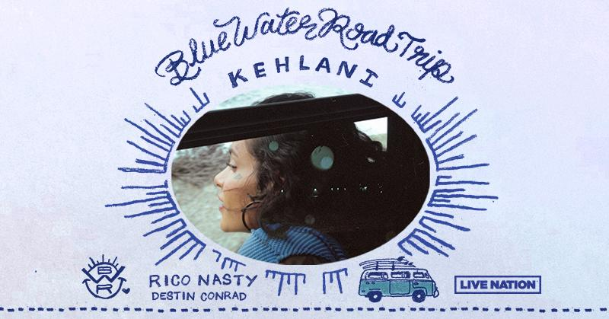

DOWNLOAD HI-RES ART HERE

Following the release of her critically acclaimed album, Blue Water Road, Kehlani has announced her Blue Water Road Tour featuring special guests Rico Nasty on North American dates and Destin Conrad across all dates. Produced by Live Nation, the 28-city North American leg kicks off on July 30th at ​​Red Hat Amphitheater in Raleigh, NC making stops across the U.S. in Miami, New York, Houston, and more before wrapping up in Oakland at Oakland Arena on September 30th. Her tour then continues through Europe, see full routing below.

Tickets go on sale starting Friday, May 20th at 10am local time HERE. Citi is the official card of the Blue Water Road Tour U.S. shows. Citi cardmembers will have access to presale tickets beginning Tuesday, May 17th at 10am ET local time until Thursday, May 19th at 10pm local time through the Citi Entertainment program. For complete presale details visit www.citientertainment.com.

BLUE WATER ROAD TOUR DATES:

JULY
30 – Raleigh, NC – Red Hat Amphitheater

AUGUST
01 – Miami, FL – FPL Solar Amphitheater
03 – Atlanta, GA – Coca-Cola Roxy
05 – Charlotte, NC – Charlotte Metro Credit Union Amphitheatre
07 – Washington, DC – The Anthem
09 – New York, NY – Radio City Music Hall
12 – Boston, MA – Leader Bank Pavilion
13 – Bridgeport, CT – Hartford HealthCare Amphitheater
15 – Philadelphia, PA – Skyline Stage @ The Mann Center
16 – Pittsburgh, PA – UPMC Events Center
17 – Cincinnati, OH – The Andrew J Brady Music Center
19 – Minneapolis, MN – The Armory
22 – Detroit, MI – Fox Theatre
24 – Toronto, ON – Budweiser Stage!
26 – Chicago, IL – Byline Bank Aragon Ballroom
28 – Indianapolis, IN – TCU Amphitheater at White River State Park
30 – Houston, TX – Bayou Music Center

SEPTEMBER
01 – Austin, TX – Moody Amphitheater
03 – Dallas, TX – South Side Ballroom
06 – Denver, CO – Fillmore Auditorium
09 – Las Vegas, NV – The Chelsea @ The Cosmopolitan of Las Vegas
10 – Los Angeles, CA – YouTube Theater
14 – Phoenix, AZ – Arizona Federal Theatre
15 – San Diego, CA – Cal Coast Credit Union Open Air Theatre
17 – Portland, OR – Theater of the Clouds @ Moda Center
18 – Seattle, WA – WAMU Theater
21 – Vancouver, BC – PNE Forum!
30 – Oakland, CA – Oakland Arena

OCTOBER
21 – Honolulu, HI – Waikiki Shell*!

* Not A Live Nation Date | ! Citi Presale Not Applicable

ADDITIONAL EUROPEAN DATES:

NOVEMBER
17 – Copenhagen, Denmark – Grey Hall
18 – Stockholm, Sweden – Annexet
21 – Oberhausen, Germany – Turbinhalle*
22 – Berlin, Germany – Tempodrom*
24 – Zurich, Switzerland – Komplex 457
26 – Vienna, Austria – Gasometer*
27 – Munich, Germany – Zenith*
29 – Milan, Italy – Fabrique*
30 – Paris, France – Salle Pleyel

DECEMBER
03 – Tilburg, Netherlands – O13
04 – London, UK – Brixton Academy
07 – Dublin, Ireland – Olympia
09 – Glasgow, UK – O2 Academy
10 – Birmingham, UK – Academy
12 – Manchester, UK – Victoria Warehouse

*Not A Live Nation Show

ABOUT KEHLANI:
Kehlani will open your eyes, open your mind, and open your heart. For as blunt as she may be about life, longing, lust, and love, her music occupies an elevated state above even the best high—yet accessible by simply listening. The Bay Area-born two-time GRAMMY® Award-nominated multi-platinum songstress unlocks this place anytime she picks up a pen or grabs a microphone. Since 2014, her light has only continued to glow brighter. Thus far, she has picked up over twenty gold and platinum RIAA certifications, tallied 5 billion streams, and garnered a pair of GRAMMY® Award nominations in the categories of “Best Urban Contemporary Album” for the gold-certified mixtape You Should Be Here and “Best R&B Performance” for the platinum single “Distraction.” Beyond blockbuster collaborations with Cardi B, Justin Bieber, Post Malone, Kiana Ledé, Teyana Taylor, and Kyle, she has appeared on soundtracks such as Suicide Squad: The Album, The Fate of the Furious: The Album, and more. Along the way, she received the “Rule Breaker Award” from Billboard Women In Music and performed at Voodoo Music + More, Coachella, and beyond. She reached a critical and creative high watermark with her sophomore offering, It Was Good Until It Wasn’t. It not only bowed at #2 on the Billboard Top 200, but it also concluded 2020 on over a dozen year-end lists from Billboard, Esquire, Hypebeast, Nylon, Seventeen, Spin, Stereogum, The Guardian, and many more. Now, she welcomes everyone into the rapture of her third full-length album, Blue Water Road [Atlantic Records].

MEDIA CONTACTS:

Sydney Margetson | sydney.margetson@atlanticrecords.com
Courtni Asbury | courtni.asbury@ledecompany.com
Cara Hutchison | cara.hutchison@ledecompany.com

