FOR IMMEDIATE RELEASE
MAY 13, 2022

LIL EAZZYY DROPS TOO EAZZYY MIXTAPE PRODUCED BY
GRAMMY-NOMINATED AND MULTI-PLATINUM PRODUCER CHOP SQUAD DJ
STREAM HERE

FEATURES INCLUDE FELLOW CHI-TOWN NATIVE SHOEBOX BABY

LIL EAZZYY JOINS NLE CHOPPA ON U.S HEADLINING TOUR
PURCHASE TICKETS HERE

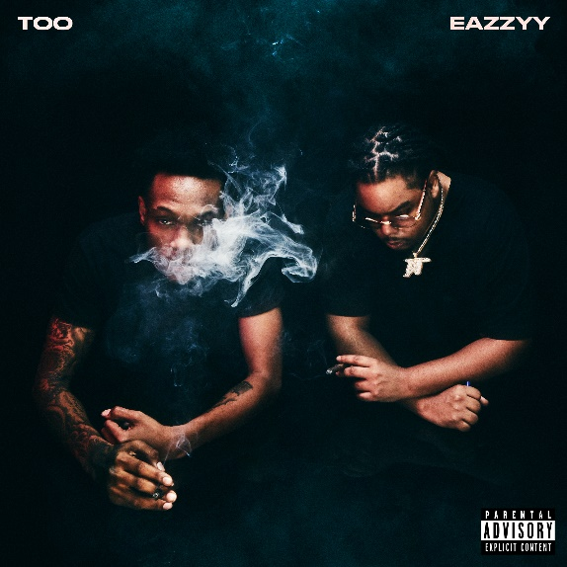
DOWNLOAD HIGH-RES ARTWORK HERE |DOWNLOAD PRESS IMAGES HERE (press image credit: Jimmy Fontaine)

Lil Eazzyy reclaims his name through his effortless flow on new mixtape, Too Eazzyy, produced by Grammy-nominated and multi-platinum producer, Chop Squad DJ. Eazzyy keeps it all in the city with fellow Chicago native, Shoebox Baby, featured on the ten-track project and previously released singles “Bring Some Mo ft. NLE Choppa,” “Nothing Left,” and “Forever Been Steppin”. Stream HERE.

The mixtape release comes a week after Eazzyy embarked on his first U.S headlining tour with NLE Choppa, which began May 1st and wraps in Los Angeles at the Novo by Microsoft on June 5th. Eazzyy recently sat down with TRSH MAG for their TRSH TALK interview series and live performance of “Forever Been Steppin,” positioning himself in line with the greats coming out of Chicago.

Initially announcing himself with “Finesse” in 2019 before posting up millions of streams via “Listen Up,” “Letter To Tracy,” and “Yerk Attack these records paved the way for his 2020 major-label debut, Underrated. Lead single “Onna Come Up” popped off as a viral phenomenon surpassing 80 million streams, vaulting to #6 on the Spotify US Viral 50 and #14 on the Global Viral 50 and captured #21 on Rolling Stone’s Breakthrough 25 Chart. Multi-platinum Chicago luminary, G Herbo, hopped on the “Onna Come Up Remix” featured on Eazzyy’s second project, Rookie of the Year, surpassing 134M million streams worldwide and 185 million views globally of its official video, as well as claimed prime spots on influential ‘playlists including Apple’s New Music Daily and The Plug, Spotify’s Rap Caviar and Most Necessary, and Amazon Music’s Hype Music where it graced the cover.

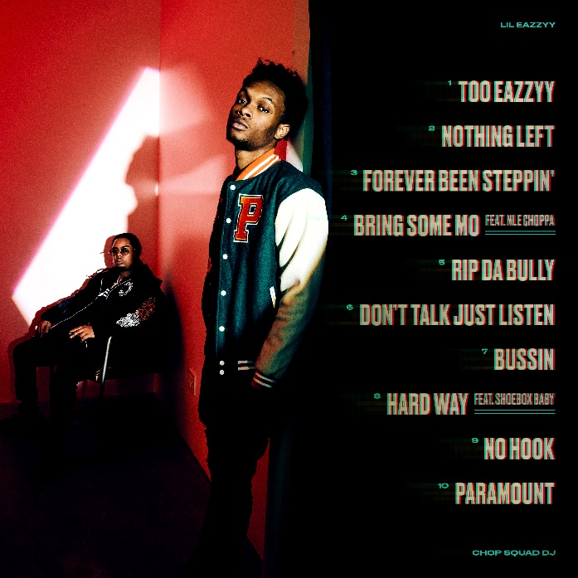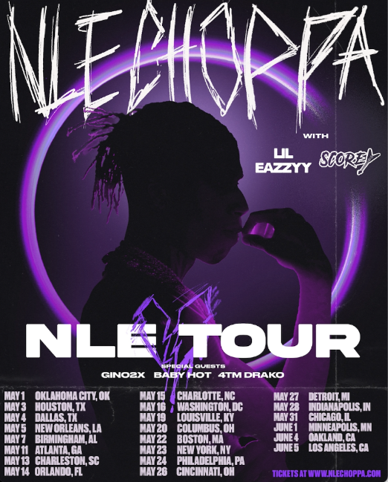

CONNECT WITH LIL EAZZYY
TWITTER | INSTAGRAM | SPOTIFY | YOUTUBE | SOUNDCLOUD

LIL EAZZYY PRESS CONTACT
BRITTANY BELL | BRITTANY.BELL@ATLANTICRECORDS.COM

