FOR IMMEDIATE RELEASE
MAY 25, 2022

NOGA EREZ RELEASES “NAILS”
+ SIGNS TO NEON GOLD/ATLANTIC RECORDS

POP RENEGADE RETURNS WITH RAZOR SHARP NEW SINGLE + INDY HAIT-DIRECTED VIDEO

EREZ TO PLAY BONNAROO THIS SUMMER
+ SUPPORT TOVE LO AND FLORENCE + THE MACHINE ON SELECT US TOUR DATES

LISTEN TO “NAILS” HERE | WATCH THE VIDEO HERE
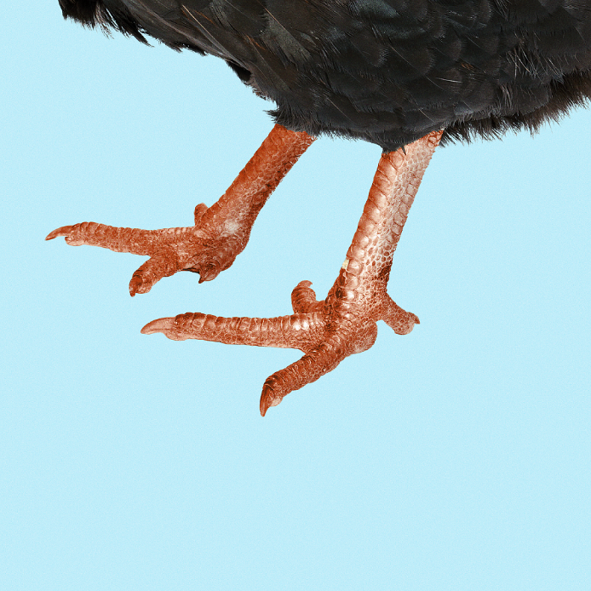
DOWNLOAD ARTWORK HERE

Flowing with her trademark swaggering attitude, gritty lyrics and slick production, pop renegade Noga Erez has returned with her razor sharp new single, “NAILS" – available now HERE.

Along with the new single, Erez has announced her signing to Neon Gold/Atlantic Records, revealed exclusively on Billboard. Of the new partnership, Erez said, "I’m super excited to begin to work with the people of Atlantic/Neon Gold. This partnership is a big step for me. We’ve already started to get the ball rolling creatively and we have some big plans ahead of us."

Neon Gold Co-Founder Derek Davies shared, “Neon Gold has long been defined by iconoclastic international pop talents — from Charli XCX and MARINA to Tove Lo and Christine And The Queens — and we are thrilled to welcome the genreless and borderless Noga Erez to the fold as one of the most visionary artists we've ever had the pleasure of working with.” Atlantic Records SVP, A&R Jeff Levin & A&R Director Madison Vickery added, “Noga Erez breaks down the barriers of genre with a unique creative vision that plays with elements of pop, alternative, R&B and rap. Erez represents another leap forward for the label and for music. Their live show brings stadium level energy to every room. We’re proud to welcome her to our roster and provide a platform for her creative vision.”

On “NAILS” Erez and her collaborative and life partner Ori Rousso playfully explore the grip that takes hold when jealous thoughts flood our consciousness, fleshing them out with defiant beats and her effortless vocal flow. With a talent and style as formidable as her own, even Erez isn’t safe from the wrath of the green-eyed monster. Rather than run from this negativity, she tackles the gargantuan emotion head on with humor and wit, minimizing it with her animated mantra “I’ll bump a bitch / flesh pieces in my nails.”

“‘NAILS’ is a song about jealousy, and how being jealous of people, in this particular case another woman, makes you idealize that person in a very weird and dark way,” Erez comments. This is something that Erez explores in the track’s accompanying video, directed by Indy Hait.

“The video features me and a group of characters who all look completely different and weird, but they all look like they're about to do something really big,” Erez explains. There is a real tension as if something is about to happen. What we are actually walking towards is a woman who looks like a model. She has that typical / classic body image. The unrealistic societal standards of beauty - skinny, tall, sexy, flawless. She's walking in slow motion, and as we all come into the same shot, you realize that she is actually ten times our size.Then there is a David and Goliath type of situation where I take out a slingshot and shoot her straight in the forehead and she drops dead. It’s very weird and ugly and funny.” With these absurdly themed visuals, Erez bites back against her jealous doubts, making light of their negative grip.

The deeply satisfying sound of Erez tapping her own nails on different surfaces also underscores the new anthem. Their crunch adds a palpable, physical energy to the song, further emphasizing the sharp humor that fuels her fierce words. “I look at my nails a lot and I am always making sounds with them. They’re an extension of my playful self,” Erez comments. Armed with her embellished fingertips, she gleefully antagonizes her jealous thoughts, imagining her own nails as an amusing weapon with which to take down her adversaries.

Erez acknowledges the privilege of being allowed to work through these emotions in her music. “I feel like we live in a culture that says, 'Don't think those negative thoughts. Don't even let that cross your mind' but sometimes I'm like - ‘these bitches are looking at my man, I don't want that!’ - it's very, very funny. So I say, let it cross your mind, so that you can leave these things at the thought level, and get the poison out of you. The song is an invitation for everyone to feel that empowering, aggressive vibe and embrace it.” ‘Nails’ certainly gives listeners the opportunity to tap out the toxic impulses that these ridiculous resentments often instigate.

An acclaimed live performer, Erez has sold out shows at legendary venues including LA’s El Rey and NY’s Bowery Ballroom. Erez is slated to play Bonnaroo and Summerfest this summer and will be supporting Tove Lo and Florence + The Machine on select US tour dates. See all upcoming North American tour dates below. For all touring updates and details please visit: https://www.nogaerez.com/.

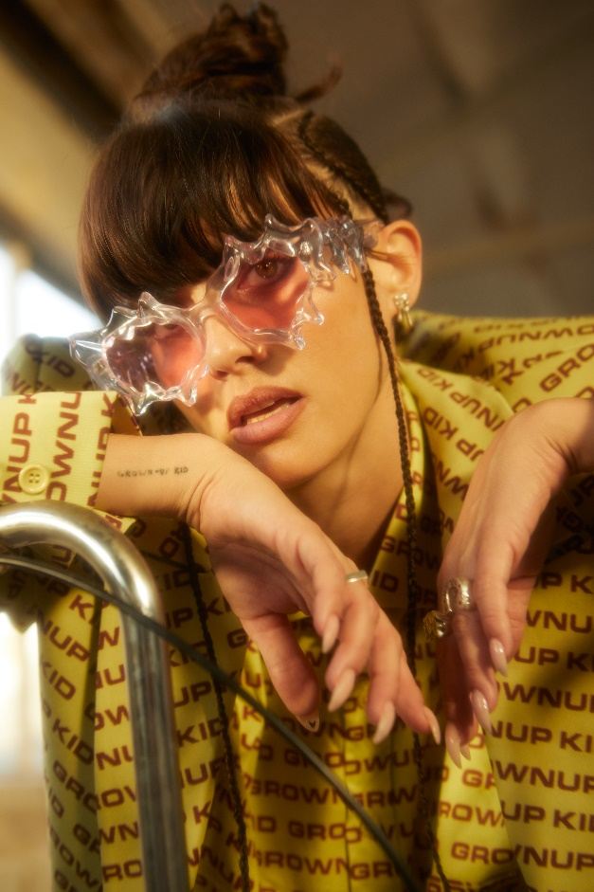
DOWNLOAD PRESS PHOTO

NOGA EREZ
NORTH AMERICAN TOUR DATES

JUNE
11 - WonderRoad Fest - Indianapolis, IN
13 - Roadrunner - Boston, MA *
14 - Fillmore - Washington, DC *
15 - Fillmore - Charlotte, NC *
17 - Bonnaroo Festival - Manchester, TN
21 - Zanzabar - Louisville, KY
22 - Lincoln Hall - Chicago, IL
23 - Electric Forest Festival - Rothbury Michigan
25 - Summerfest - Milwaukee, MI
28 – Camp Centerland – Buffalo, NY
29 – Velvet Underground – Toronto, ON

SEPTEMEBER
16 - Madison Square Garden - New York, NY ^
17 - Madison Square Garden - New York, NY ^

* supporting Tove Lo
^ supporting Florence + The Machine

ABOUT NOGA EREZ
Since the release of her debut album Off The Radar in 2017 via City Slang, the world has changed significantly for Noga Erez and her musical & life partner Ori Rousso. The Tel-Aviv based musician and producer gained critical acclaim for her first LP, so the hype around her second album was understandably high. Together, Erez and Rousso took their time to finalize the tracklist for what would become their second album, KIDS.

Whilst Off The Radar felt more politically charged in terms of its lyrical content and a strong emphasis in the press on Erez’s hometown of Tel Aviv, 2021’s KIDS was a natural evolution into more personal spheres. Through clever lyrics, slick production and commanding beats, Erez blazed an exhilarating musical trail through grief, inner violence, relationships and growth, acknowledging the internal and external factors that affect these elements. The record propelled her into the global spotlight, earning her a ‘Best Pop Album’ nomination from A2IM, nearly 20 million YouTube views and garnering a legion of famous fans in the process, including Billie Eilish, Finneas, Gal Gadot, Marion Cotillard, Katy Perry & Hayley Williams.

From performing to a packed hometown crowd at the Menora Arena in Tel Aviv, to selling out shows in Europe and the United States, as well as playing stages at festivals like Primavera, Austin City Limits, Outside Lands, Lollapalooza, Bonnaroo & Shaky Knees, Erez’s sound pulses with ambitious, authentic energy. Now, with two full length releases under her belt and newly signed to Neon Gold/Atlantic Records, she has cemented her status as a formidable voice in the world of alternative pop, one which stands head and shoulders above the rest.

CONNECT WITH NOGA EREZ
OFFICIAL SITE | INSTAGRAM | TIKTOK | TWITTER | YOUTUBE

For press inquiries, please contact:
Kelly McWilliam / Kelly.McWilliam@atlanticrecords.com

