FOR IMMEDIATE RELEASE
JUNE 24, 2022

HAYLEY KIYOKO SHARES “DEEP IN THE WOODS”

HIGHLY ANTICIPATED SOPHOMORE ALBUM PANORAMA ARRIVES JULY 29

SUMMER TOUR WITH LAUV KICKS OFF AUGUST 11

LISTEN TO “DEEP IN THE WOODS” | WATCH OFFICIAL VISUALIZER
PRE-ORDER/PRE-SAVE PANORAMA

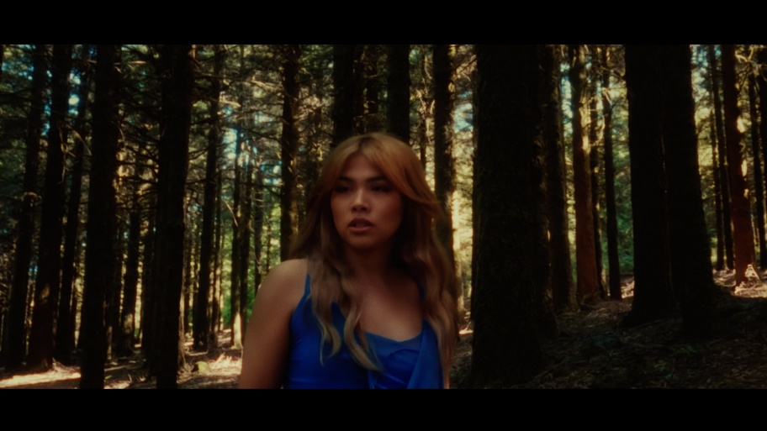

Trailblazing pop star Hayley Kiyoko has shared “Deep in the Woods,” the latest track from her highly anticipated sophomore album, PANORAMA, arriving via Atlantic Records on July 29 and available for pre-order now HERE. Co-written by Hayley and produced by Kiyoko, Danja (Beyoncé, Britney Spears) and frequent collaborators, Pat Morrissey and Kill Dave, “Deep in the Woods” is joined by a cinematic visual offering fans the first official glimpse into the world of PANORAMA. Listen HERE and stream the visualizer via YouTube HERE.

“‘Deep in the Woods’ is a song that captures the feeling of instant connection, as if you've known someone forever even though you’ve only just met,” says Hayley. “It feels as if your entire being is haunted by their presence wherever you go. It's that instantaneous moment of knowing you are willing to do anything to be with the one you love.”

Hayley first announced PANORAMA last month as she unveiled the standout lead single “For The Girls,” a bass-boosted mission statement that followed previously released album tracks including the effervescent “Chance” and self-affirming “Found My Friends”. Arriving alongside a self-directed music video in which Kiyoko stars in a romantic queer parody of America’s favorite dating show, “For The Girls” was met with instant critical praise from Billboard, Rolling Stone, People, NYLON, Stereogum and Cosmopolitan, which declared it “a Summer Bop With a Powerful Message” while The Daily Beast named it among their list of “2022 Song of the Summer Contenders.” Watch the official video, complete with chaotic and hysterical reality melodrama, HERE.

Hayley will celebrate PANORAMA by joining Lauv as special guest on his “All 4 Nothing Tour,” kicking off August 11 at the Armory in Minneapolis, MN and highlighted by stops at New York’s Hammerstein Ballroom (August 26 and 27) and Los Angeles’ famed Greek Theatre (September 9). For complete details and ticket information, please visit hayleykiyoko.lnk.to/LauvTour.

Read Hayley’s full Teen Vogue June cover story HERE.

ABOUT HAYLEY KIYOKO:
Kiyoko has become one of the most celebrated pop artists since releasing EXPECTATIONS, which — according to Rolling Stone, placed her “at the forefront of an unapologetically queer pop movement.” In #20GAYTEEN, the multihyphenate performer was nominated for two VMAs and won “Push Artist Of The Year.” Since her 2015 debut, Hayley has amassed nearly 1B global streams and over 2.26M YouTube subscribers, accrued over 819M lifetime YouTube views, and sold out numerous venues across the country and abroad. Lauded as one of “The 21st Century's Most Influential Women Musicians” by NPR, Hayley inspires her community through nuanced storytelling and lyricism, encouraging hope as her resounding message.

Last year, Hayley launched her first-ever gender-inclusive fragrance, Hue, available to order at huebyhayley.com. An audacious scent designed as an expression of liberation, freedom, and self-empowerment, Hue became a 2022 finalist for the Fragrance Foundation’s “Universal Prestige Award” and has received coverage from Vogue, Allure, NYLON, Glamour, Cosmopolitan, and more.

(Download Hi-Res Album Artwork + Press Photos // Credit: Trevor Flores)

HAYLEY KIYOKO ON TOUR 2022

AUGUST
11 – Minneapolis, MN – The Armory
12 – Chicago, IL – Byline Bank Aragon Ballroom
13 – Detroit, MI – Meadow Brook
15 – Toronto, ON – RBC Echo Beach
16 – Montreal, QC – Place Bell
17 – Boston, MA – Leader Bank Pavilion
19 – Philadelphia, PA – The Met Philadelphia
20 – Pittsburgh, PA – Stage AE
21 – Cincinnati, OH – ICON (Rockstar Energy Drink Stage at Smale Park)
23 – Columbus, OH – KEMBA Live!
25 – Washington, DC – The Anthem
26 – New York, NY – Hammerstein Ballroom
27 – New York, NY – Hammerstein Ballroom
28 – Asbury Park, NJ – Stone Pony Summer Stage
30 – Charlotte, NC – Charlotte Metro Credit Union Amphitheater
31 – Atlanta, GA – Coca-Cola Roxy

SEPTEMBER
1 – Nashville, TN – Ryman Auditorium
3 – Houston, TX – 713 Music Hall
4 – Dallas, TX – Pavilion at Toyota Music Factory
6 – Denver, CO – Mission Ballroom
7 – Ogden, UT – Ogden Amphitheater
9 – Los Angeles, CA – Greek Theatre
11 – San Diego, CA – Cal Coast Credit Union Open Air Theatre
12 – Phoenix, AZ – Arizona Federal Theatre
15 – Berkeley, CA – Greek Theatre @ UC Berkeley
17 – Vancouver, BC – Doug Mitchell Thunderbird Sports Centre
20 – Seattle, WA – WaMu Theater

CONNECT WITH HAYLEY KIYOKO:
WEBSITE | FACEBOOK | TWITTER | INSTAGRAM | TIKTOK | YOUTUBE | PRESS ASSETS

PRESS CONTACT:
Andrew George / Atlantic Records
andrew.george@atlanticrecords.com

