FOR IMMEDIATE RELEASE
MARCH 7, 2022

“PRAISE THE LORD” BRELAND RELEASES GRATEFUL NEW TRACK WITH A HINT OF HUMOR

STREAM HERE

ANNOUNCES DEBUT ALBUM CROSS COUNTRY OUT SUMMER 2022
PRE-SAVE HERE

TUNE IN TONIGHT FOR BRELAND’S DEBUT PERFORMANCE AT THE ACADEMY OF COUNTRY MUSIC AWARDS LIVE ON PRIME VIDEO AT 8PM EST/ 7PM CST/ 5PM PST

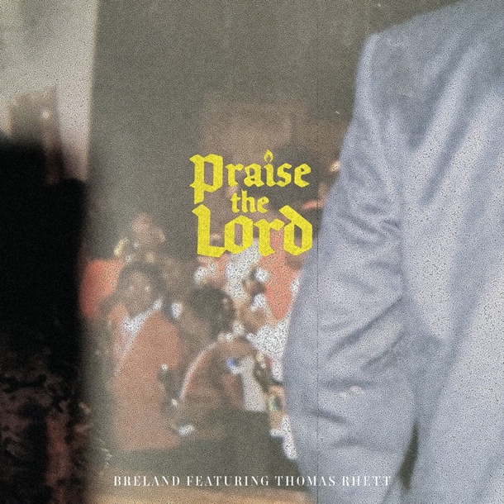
Download Press Asset Here

LOS ANGELES, CA. (March 7, 2022) – Bad Realm Records/ Atlantic Records/ Warner Music Nashville artist BRELAND today releases his highly-anticipated new track “Praise The Lord (feat. Thomas Rhett).” Already accumulating critical acclaim, CMT praises “the breakout star pulled from his diverse musical palette to create country-gospel anthem…”

LISTEN TO “PRAISE THE LORD” HERE WHEREVER YOU STREAM OR DOWNLOAD MUSIC

In conjunction with the release of this clap-and-stomp track, BRELAND also reveals that his debut album, CROSS COUNTRY, is set to release early summer. The title of this album is derivative of the ‘Cross-Country’ genre BRELAND has created to describe his unique musical style. Pre-save/pre-add CROSS COUNTRY here now.

Hailed as “a streaming-music star” by Rolling Stone, BRELAND has been named a Breakthrough Artist for Amazon Music. He joins the short list of artists earning this coveted all-genre nod aimed at “amplifying and championing” the best new talent. Only the second Country artist in the program’s history, previous Breakthrough Artists include Gabby Barrett, Blxst, Remi Wolf, Arlo Parks, and more.

Tonight, BRELAND will have another set of firsts as he debuts “Praise The Lord” with his first ever Academy of Country Music Awards performance. With special guest and collaborator Thomas Rhett, the pair will take the stage for the can’t-miss Amazon Music Breakthrough performance. Tune in to watch their performance LIVE on Prime Video at Allegiant Stadium in Las Vegas, Nevada.

ABOUT BRELAND
With his PLATINUM debut “My Truck,” singer/songwriter/producer BRELAND has emerged as a bold new force on today’s music landscape. The newly named Breakthrough Artist by Amazon Music first popped off when the Hip-Hop and Country hybrid hit #1 on Spotify’s Global Viral 50 in 2019, and a remix featuring Sam Hunt landed on best-of-the-year lists from NPR to The New York Times. Now, the undeniable talent will debut his brand-new song “Praise The Lord” at the 2022 ACM Awards streaming live on Prime Video on March 7. Featured on Dierks Bentley’s Top 10 and rising single with HARDY, “Beers On Me,” BRELAND also teamed up with Keith Urban for the buzzy track “Throw It Back.” Since signing to Bad Realm Records/Atlantic Records/Warner Music Nashville, he has collaborated with heavy-hitters such as Gary LeVox of Rascal Flatts, Nelly, Blanco Brown, Lauren Alaina, and Chase Rice, and scored high profile looks on The Kelly Clarkson Show, ABC’s 2021 CMA Awards, ABC’s CMA Summer Jam, CMT Crossroads, ABC’s Jimmy Kimmel Live!, ABC’s Good Morning America, CBS’ New Year’s Eve Live: Nashville’s Big Bash, YouTube’s Artist on The Rise, and a Chevy campaign that launched during NFL’s season opener. Coined “1,000 percent the whole package” by Rolling Stone, he’s out on the road for Russell Dickerson’s ALL YOURS, ALL NIGHT TOUR and is recognized in the Country Music Hall of Fame® and Museum’s brand-new exhibit, American Currents: State of the Music.

CONNECT WITH BRELAND
WEBSITE | INSTAGRAM | FACEBOOK | TWITTER | YOUTUBE | SOUNDCLOUD
PRESS CONTACTS
Fairley McCaskill / Fairley.McCaskill@atlanticrecords.com
Mary Catherine Rebrovick / marycatherine@wmg.com
Jensen Sussman / jensen@sweettalkpr.com

