FOR IMMEDIATE RELEASE
MARCH 18, 2022

RAVYN LENAE SHARES NEW SINGLE "LIGHT ME UP"
AVAILABLE NOW VIA ATLANTIC RECORDS

WATCH HERE | LISTEN HERE

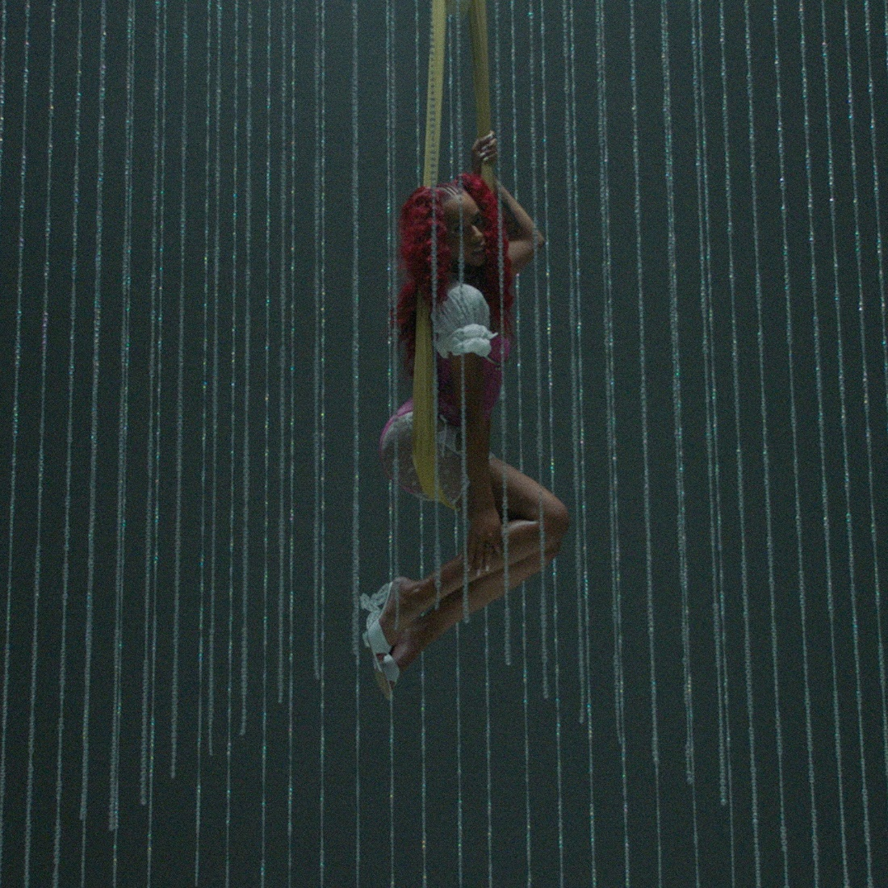
Download High-Res Artwork Here

Chicago-born Ravyn Lenae shares her new single and its accompanying video, "Light Me Up". The gentle, slow burning R&B ballad arrives alongside an Aliyah Otchere-directed video that sees Lenae perched on a swing over a canvas of hands as she performs the song. "Light Me Up" finds her collaborating with Steve Lacy on production once more, following their work together on Ravyn’s previous single “Skin Tight” and her 2018 EP Crush.

Speaking on the new song, she says, “Light Me Up is about exploring the unknown with a new love; leaning into those tingly feelings while letting your guards down. This song highlights the beauty of allowing someone to truly see through you.”

Watch "Light Me Up" here and stay tuned for more from Ravyn Lenae coming soon.

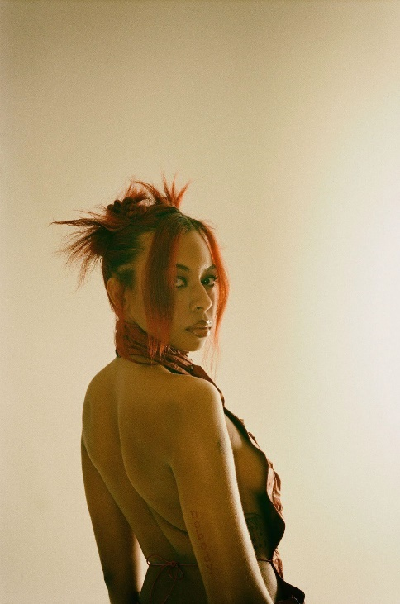

Download hi-res press photo(s), Credit: Jean Phillipe Joseph
About Ravyn Lenae:
Now boasting over 100M worldwide streams and counting, Ravyn Lenae honed her voice through intense classical training at Chicago’s High School For The Arts, inspired by a broad range of artists, from India.Arie and OutKast to Antonio Vivaldi and Reynaldo Hahn.

The young artist immediately made waves with her breakthrough debut EP, 2016’s Moon Shoes, earning over 12M individual plays while also reaching the top 25 on the iTunes Store’s “Top R&B/Soul Albums” chart.

Crush followed in 2018 and instantly established Lenae as a fan favorite and critical darling, with its sultry lead single, “Sticky,” amassing over 32M global streams while drawing praise from such national publications as Pitchfork, The FADER, and Billboard, which declared it to be “one of the most sumptuous, supple, meditative and detailed dispatches from a soulful young singer’s mind in recent memory.”

Widely praised as a sensational live performer – including headline shows and a blockbuster U.S. tour alongside fellow R&B sensation SZA – Lenae was among the top stars and rising artists featured on Raedio/Atlantic Record’s Insecure: Music From The HBO Original Series, with her “Rewind” prominently featured in one of Season 4’s key moments.

“When you listen to the music, I hope you have a better understanding of me and even catch a better understanding of yourself,” Lenae says. “As artists, we make music as a pathway to help other people understand certain aspects of their lives. I’ve gone through the tunnels and seen the light on the other side. I’m finding my way. I’m clearer on who I am and my power through music and lyricism. I’m pouring more into me, friendships, family, and music. Through all of that, I’m fulfilled.”

# # #

CONNECT WITH RAVYN LENAE
WEBSITE | TWITTER | INSTAGRAM | FACEBOOK | YOUTUBE

PRESS CONTACTS
Fairley McCaskill | Fairley.McCaskill@atlanticrecords.com
Nick Dierl |Nick@orienteer.us

