FOR IMMEDIATE RELEASE
APRIL 19, 2022

RAVYN LENAE ANNOUNCES DEBUT ALBUM HYPNOS
DUE MAY 20TH VIA ATLANTIC RECORDS
PREORDER HERE

SHARES NEW SINGLE "M.I.A"
STREAM HERE

REVEALS SPRING/SUMMER 2022 HEADLINE TOUR DATES
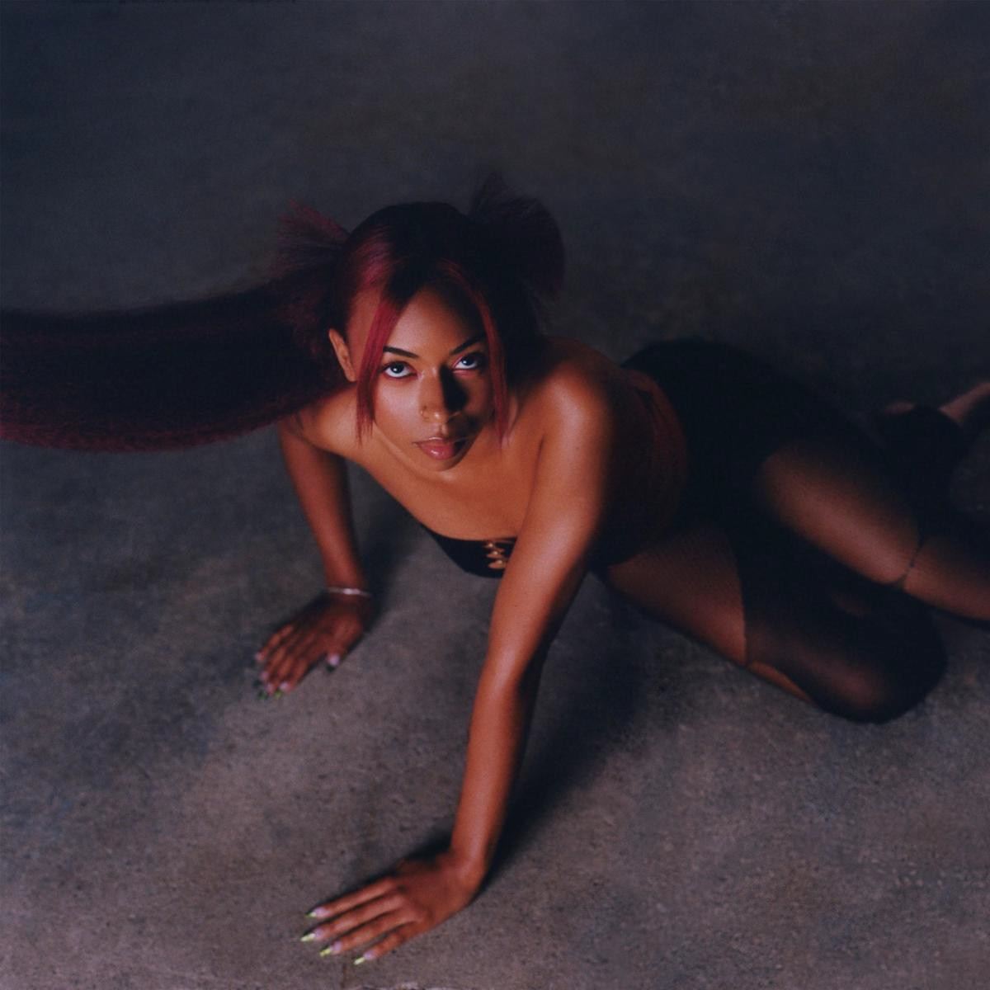
Download High-Res Artwork Here

"Ravyn Lenae is always a step ahead"
- OkayPlayer

“One of the most exciting emerging forces in modern R&B is ready to make a lasting mark.”
- Uproxx

“Sensual, hard-hitting and spellbinding in equal parts, “Light Me Up” encapsulates the effortless allure of Raven Lenae’s artistry.”
- Wonderland

Chicago-born Ravyn Lenae officially announces her debut album, Hypnos, due May 20th via Atlantic Records. Alongside the announcement, she shares the project's newest single, "M.I.A" which finds Ravyn at home of a bouncy, infectious Sango production that stands in stark contrast to the album's previously released tracks "Light Me Up" and "Skin Tight" sonically while still retaining her signature vocal style and a seductive refrain.

Speaking about the song, Ravyn shares, "M.I.A is about feeling free and comfortable in your skin. It's a peak into my world - the duality of knowing the energy you bring to the world but also being confident in riding dolo."

In support of the forthcoming project's release, Ravyn Lenae also officially announces her headlining North American and EU/UK tour dates kicking off this summer. The run of shows launches on May 26th in Seattle and will see stops in Los Angeles, Atlanta, Washington D.C., New York City, Boston, Chicago, London, Paris and more featuring support from special guest Unusual Demont along the way at select dates. International presale tickets are now available for purchase here. Domestic ticket presales and international general sale will begin this Thursday, April 21st at 10am local time and general domestic tickets will be available for purchase on Friday, April 22nd at 10am local time.

Listen to "M.I.A" HERE, find additional album details and tour routing below and stay tuned for more from Ravyn Lenae coming soon.

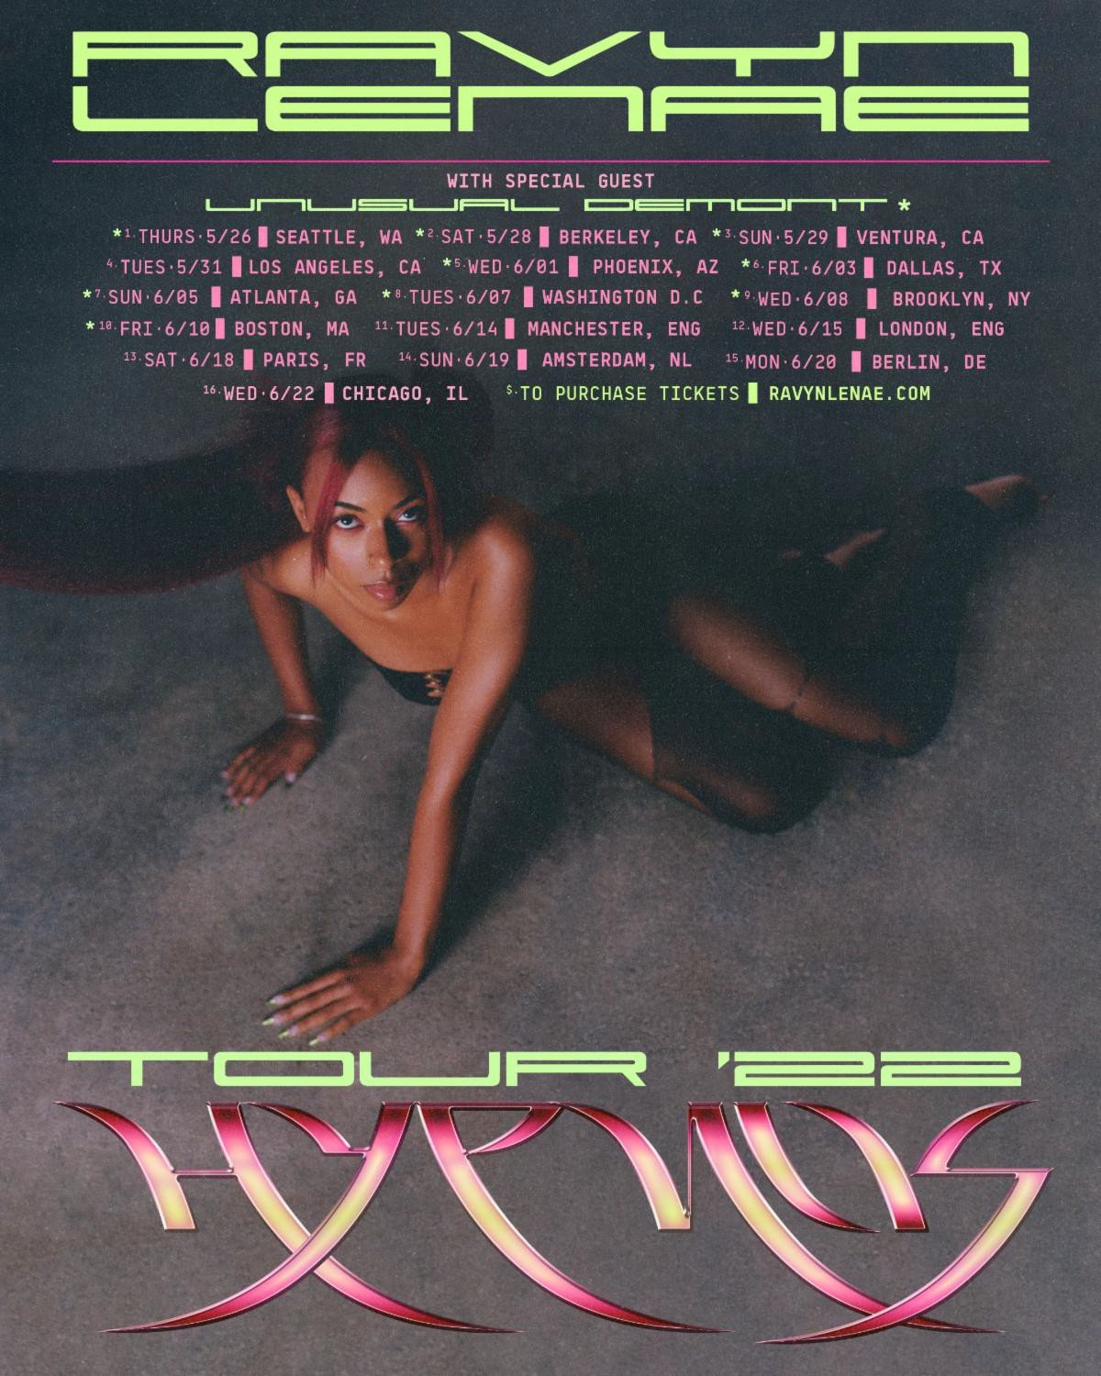

Upcoming Live Dates

North America
05/26 Seattle, WA @ Nuemos
05/28 - Berkley, CA @ Cornerstone
05/29 - Ventura, CA @ Ventura Music Hall
05/31 - Los Angeles, CA @ El Rey
06/01 - Phoenix, AZ @ Aura
06/03 - Dallas, TX @ Cambridge Room
06/05 - Atlanta, GA @ Vinyl
06/07 - Washington, D.C. @ City Winery
06/08 - Brooklyn, NY @ Prospect Park
06/10 - Boston, MA @ BMH
06/22 - Chicago, IL @ Metro

UK/EU
06/14 - Manchester, England @ Band on the Wall
06/15 - London, England @ Islington Assembly Hall
06/18 - Paris, France @ Badaboum
06/19 - Amsterdam, Netherlands @ Melkweg
06/20 - Berlin, Germany @ Berghain

About Ravyn Lenae:
Now boasting over 100M worldwide streams and counting, Ravyn Lenae honed her voice through intense classical training at Chicago’s High School For The Arts, inspired by a broad range of artists, from India.Arie and OutKast to Antonio Vivaldi and Reynaldo Hahn.

The young artist immediately made waves with her breakthrough debut EP, 2016’s Moon Shoes, earning over 12M individual plays while also reaching the top 25 on the iTunes Store’s “Top R&B/Soul Albums” chart.

Crush followed in 2018 and instantly established Lenae as a fan favorite and critical darling, with its sultry lead single, “Sticky,” amassing over 32M global streams while drawing praise from such national publications as Pitchfork, The FADER, and Billboard, which declared it to be “one of the most sumptuous, supple, meditative and detailed dispatches from a soulful young singer’s mind in recent memory.”

Widely praised as a sensational live performer – including headline shows and a blockbuster U.S. tour alongside fellow R&B sensation SZA – Lenae was among the top stars and rising artists featured on Raedio/Atlantic Record’s Insecure: Music From The HBO Original Series, with her “Rewind” prominently featured in one of Season 4’s key moments.

“When you listen to the music, I hope you have a better understanding of me and even catch a better understanding of yourself,” Lenae says. “As artists, we make music as a pathway to help other people understand certain aspects of their lives. I’ve gone through the tunnels and seen the light on the other side. I’m finding my way. I’m clearer on who I am and my power through music and lyricism. I’m pouring more into me, friendships, family, and music. Through all of that, I’m fulfilled.”

# # #

CONNECT WITH RAVYN LENAE
WEBSITE | TWITTER | INSTAGRAM | FACEBOOK | YOUTUBE

PRESS CONTACTS
Fairley McCaskill | Fairley.McCaskill@atlanticrecords.com
Nick Dierl |Nick@orienteer.us

