FOR IMMEDIATE RELEASE
May 20, 2022

RAVYN LENAE RELEASES DEBUT ALBUM
HYPNOS OUT NOW

STREAM HERE
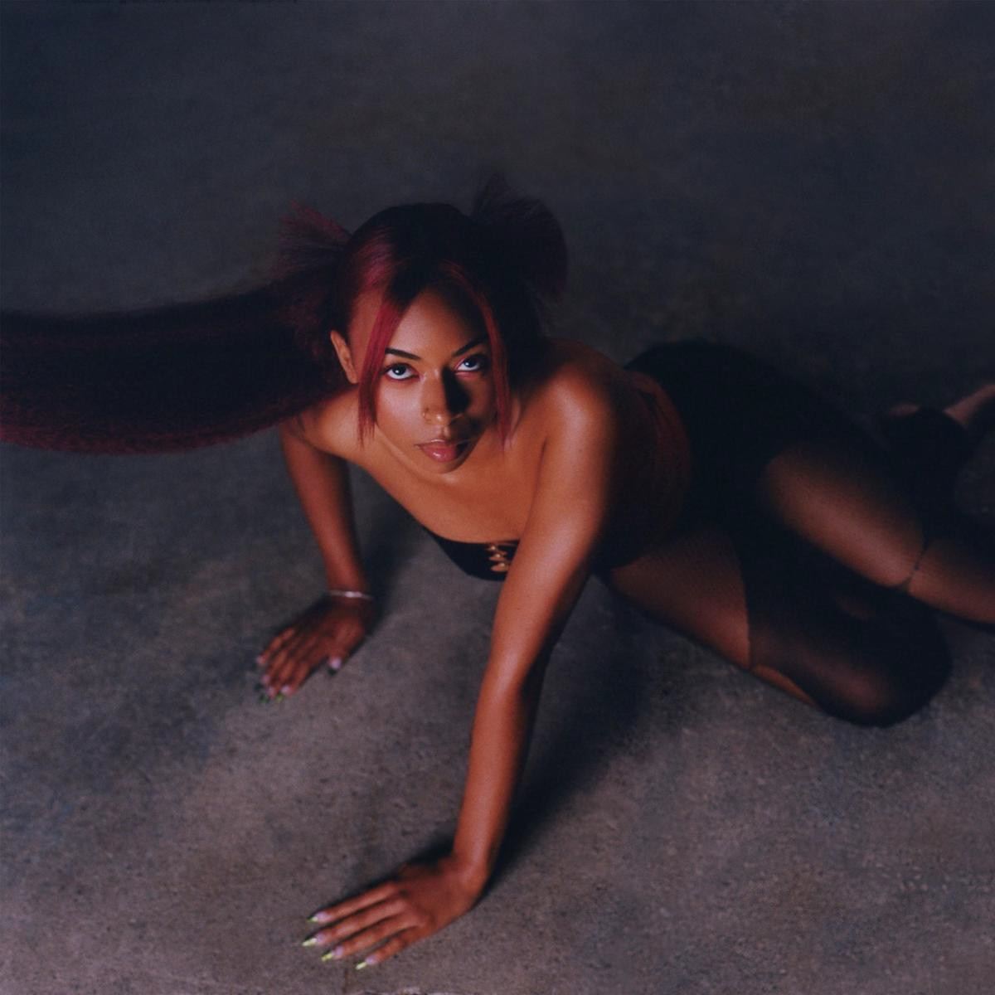
Download High-Res Artwork Here

"Ravyn Lenae is unstoppable"
-FLOOD Magazine

"sky-high vocals with funky bass lines and delicious electro-soul textures."
-New York Times
"Lenae strikes a balance between carefree and commanding."
-NPR
"Ravyn Lenae is always a step ahead"
-OkayPlayer
“One of the most exciting emerging forces in modern R&B is ready to make a lasting mark.”
- Uproxx

Chicago-born and Los Angeles-based singer and songwriter Ravyn Lenae officially releases her debut album, Hypnos, via Atlantic Records. The new album features producers and artists Kaytranada, Steve Lacy, Luke Titus, Monte Booker, Smino, Foushee, Phoelix, Mereba, Teo Halm and IAMNOBODI in addition to the previously released tracks "Xtasy," "M.I.A.," "Light Me Up" and "Skin Tight." Hypnos marks the first full-length release from Ravyn since her 2018 EP Crush.

Speaking about the project, Ravyn shares, “When you listen to the music, I hope you have a better understanding of me and even catch a better understanding of yourself... As artists, we make music as a pathway to help other people understand certain aspects of their lives. I’ve gone through the tunnels and seen the light on the other side. I’m finding my way. I’m clearer on who I am and my power through music and lyricism. I’m pouring more into me, friendships, family, and music. Through all of that, I’m fulfilled.”

In support of the project's release, Ravyn Lenae will also embark on her headlining North American and EU/UK tour dates kicking off next week. The run of shows launches on May 26th in Seattle and will see stops in Los Angeles, Atlanta, Washington D.C., New York City, Boston, Chicago, London, Paris and more featuring support from special guest Unusual Demont along the way at select dates. Tickets are now available for purchase here.

Listen to Hypnos above, find additional album details and tour routing below and stay tuned for more from Ravyn Lenae coming soon.

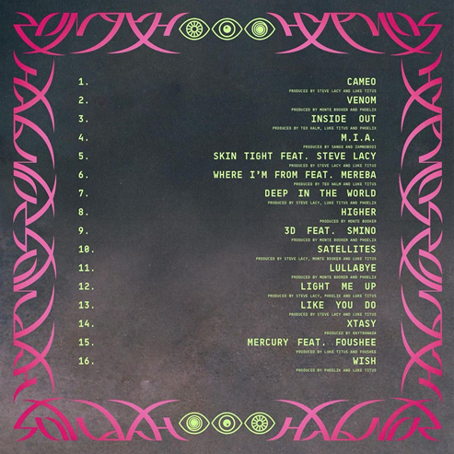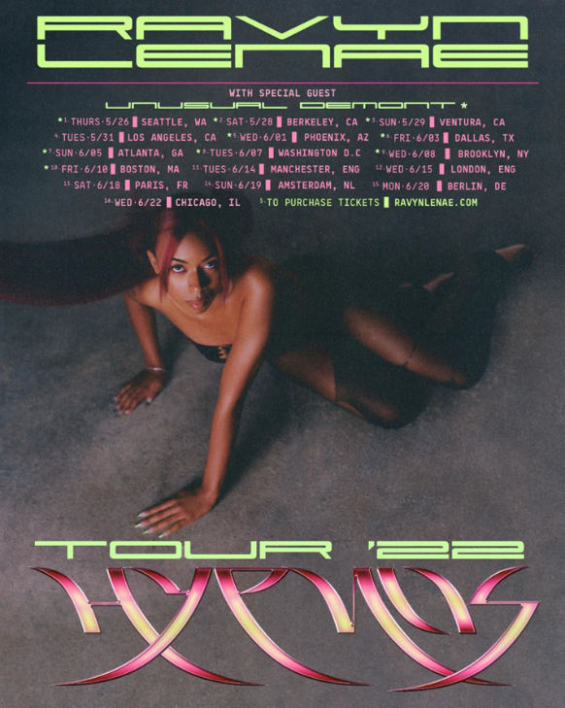

North America
05/26 Seattle, WA @ Nuemos
05/28 - Berkley, CA @ Cornerstone
05/29 - Ventura, CA @ Ventura Music Hall
05/31 - Los Angeles, CA @ El Rey
06/01 - Phoenix, AZ @ Aura
06/03 - Dallas, TX @ Cambridge Room
06/05 - Atlanta, GA @ Vinyl
SS
06/08 - Brooklyn, NY @ Prospect Park
06/10 - Boston, MA @ BMH
06/22 - Chicago, IL @ Metro

UK/EU
06/14 - Manchester, England @ Band on the Wall
06/15 - London, England @ Islington Assembly Hall
06/18 - Paris, France @ Badaboum
06/19 - Amsterdam, Netherlands @ Melkweg
06/20 - Berlin, Germany @ Berghain

About Ravyn Lenae:
Now boasting over 100M worldwide streams and counting, Ravyn Lenae honed her voice through intense classical training at Chicago’s High School For The Arts, inspired by a broad range of artists, from India.Arie and OutKast to Antonio Vivaldi and Reynaldo Hahn.

The young artist immediately made waves with her breakthrough debut EP, 2016’s Moon Shoes, earning over 12M individual plays while also reaching the top 25 on the iTunes Store’s “Top R&B/Soul Albums” chart.

Crush followed in 2018 and instantly established Lenae as a fan favorite and critical darling, with its sultry lead single, “Sticky,” amassing over 32M global streams while drawing praise from such national publications as Pitchfork, The FADER, and Billboard, which declared it to be “one of the most sumptuous, supple, meditative and detailed dispatches from a soulful young singer’s mind in recent memory.”

Widely praised as a sensational live performer – including headline shows and a blockbuster U.S. tour alongside fellow R&B sensation SZA – Lenae was among the top stars and rising artists featured on Raedio/Atlantic Record’s Insecure: Music From The HBO Original Series, with her “Rewind” prominently featured in one of Season 4’s key moments.

# # #
CONNECT WITH RAVYN LENAE
WEBSITE | TWITTER | INSTAGRAM | FACEBOOK | YOUTUBE

PRESS CONTACTS
Fairley McCaskill | Fairley.McCaskill@atlanticrecords.com
Nick Dierl |Nick@orienteer.us

