FOR IMMEDIATE RELEASE
JUNE 24, 2022

RODDY RICCH IS BACK WITH THE BIG 3

DIAMOND CERTIFIED GRAMMY® AWARD-WINNING RAP SUPERSTAR LIGHTS UP SUMMER
WITH BRAND NEW THREE-TRACK EP

HIGHLIGHTS INCLUDE MUSTARD-PRODUCED NEW SINGLE, “REAL TALK”

RAP SUPERSTAR SLATED TO PERFORM WITH ELLA MAI DURING 2022 BET AWARDS THIS SUNDAY

SPECIAL GUEST RUN ALONGSIDE POST MALONE’S “TWELVE CARAT TOUR”
BEGINS SEPTEMBER 11 IN ST. PAUL, MN

STREAM/DOWNLOAD THE BIG 3 HERE | LISTEN TO “REAL TALK” HERE

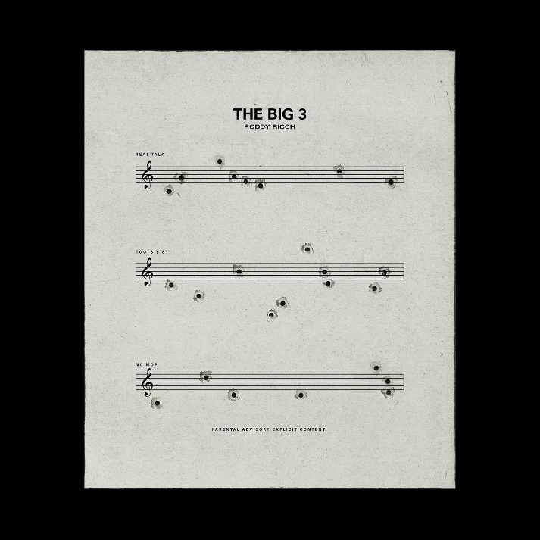
(DOWNLOAD HI-RES ARTWORK HERE)

Diamond certified, GRAMMY® Award-winning rap superstar Roddy Ricch has announced today’s premiere of THE BIG 3, a brand new three-track EP available now via Bird Vision/Atlantic Records at all DSPs and streaming services HERE.

THE BIG 3 – which marks Ricch’s first new solo music since last year’s chart-topping sophomore album, LIVE LIFE FAST – is highlighted by the new single, “Real Talk,” available for streaming and download HERE. An official music video is currently in production and will premiere soon.

Produced by longtime collaborator Mustard, “Real Talk” was heralded earlier this month during the GRAMMY® Award-winning (and 9x GRAMMY® Award-nominated) artist’s show-stopping performance at the annual HOT 97 Summer Jam at East Rutherford, NJ’s MetLife Stadium. This summer has also seen Ricch light up stages at such events as Washington, DC’s Something In The Water and Manchester, TN’s Bonnaroo Music & Arts Festival.

What’s more, an array of upcoming live appearances includes a performance at the KMEL Summer Jam tickets at Concord, CA’s Concord Pavilion on July 16 as well as an eagerly anticipated run as special guest on Post Malone’s “Twelve Carat Tour,” kicking off September 11 at St. Paul, MN’s Xcel Energy Center and then making stops across North America more before wrapping up at Los Angeles, CA’s Crypto.com Arena on November 15. The tour follows Ricch’s recent performance alongside Post Malone for their joint track, “Cooped Up,” on NBC’s Saturday Night Live (streaming HERE). The original version of “Cooped Up” – which is featured on Post Malone’s blockbuster new album, TWELVE CARAT HEARTACHE – is joined by an official music video, now boasting over 16M views via YouTube HERE.

Ricch has also teamed up with Ella Mai for “How (Feat. Roddy Ricch),” featured on her new album, HEART ON MY SLEEVE. The two artists will next unite for a very special live performance of “How” on the 2022 BET Awards, airing live from the Microsoft Theater in Los Angeles on June 26, exclusively on BET (check local listings).

LIVE LIFE FAST – which follows 2019’s 2x RIAA platinum, chart-topping debut album, PLEASE EXCUSE ME FOR BEING ANTISOCIAL, highlighted of course by the historic, 3x GRAMMY® Award-nominated, RIAA diamond certified #1 classic, “The Box” – arrived in December 2021 and made an explosive #1 debut on Billboard’s “Top R&B/Hip-Hop Albums” chart as well as at #4 on the overall Billboard 200. The album includes such smash singles as “Late At Night” and “25 million,” both joined by official music videos streaming now at YouTube.

RODDY RICCH
TOUR 2022

ALL DATES w/POST MALONE’s TWELVE CARAT TOUR

SEPTEMBER
11 – St. Paul, MN – Xcel Energy Center
14 – Chicago, IL – United Center
15 – Milwaukee, WI – Fiserv Forum
17 – St. Louis, MO – Enterprise Center
18 – Columbus, OH – Nationwide Arena

OCTOBER
4 – Washington, DC – Capital One Arena
6 – Philadelphia, PA – Wells Fargo Center
7 – Newark, NJ – Prudential Center
9 – Belmont Park, NY – UBS Arena
12 – New York, NY – Madison Square Garden
15 – Columbia, SC – Colonial Life Arena
16 – Nashville, TN – Bridgestone Arena
18 – Atlanta, GA – State Farm Arena
21 – Dallas, TX – American Airlines Center
22 – Austin, TX – Moody Center
25 – Houston, TX – Toyota Center
26 – Ft. Worth, TX – Dickies Arena
28 – Tulsa, OK – BOK Center
30 – Denver, CO – Ball Arena

NOVEMBER
1 – Salt Lake City, UT – Vivint Arena
3 – Portland, OR – Moda Center
5 – Seattle, WA – Climate Pledge Arena
6 – Vancouver, BC – Rogers Arena
10 – Los Angeles, CA – The Kia Forum
11 – Las Vegas, NV – T-Mobile Arena
15 – Los Angeles, CA – Crypto.com Arena

# # #

CONNECT WITH RODDY RICCH
OFFICIAL | FACEBOOK | INSTAGRAM | TWITTER | YOUTUBE

PRESS CONTACT
Brittany Bell | Brittany.Bell@atlanticrecords.com

