FOR IMMEDIATE RELEASE
APRIL 8, 2022

RISING SOUTH CENTRAL R&B ARTIST TRAETWOTHREE
SHARES NEW SINGLE + VISUAL “STUCK IN MY WAYS (FEAT. BLUEFACE)”
VIA NCREDIBLE / ART@WAR / ATLANTIC RECORDS
WATCH HERE | STREAM HERE

FORTHCOMING DEBUT MIXTAPE OUT THE DISTRICT SET FOR APRIL 29TH RELEASE

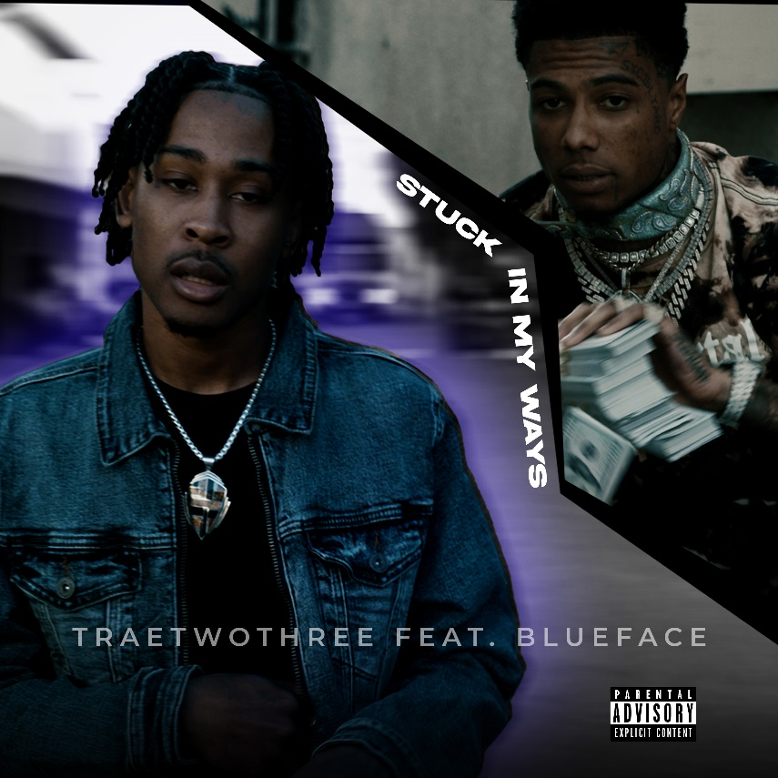
Download High-Res Artwork Here

Rising South Central R&B artist TRAETWOTHREE shares his latest bop + visual, “Stuck In My Ways (Ft. Blueface),” out now via Ncredible / ART@WAR / Atlantic Records. Watch HERE + stream HERE. His kickback melodious flow pairs well fellow LA rapper Blueface’s signature offbeat cadence. The visual directed by Okezie Kenneth Ndubuisi takes us on a journey through alleys and backways of South Central, LA.

“Stuck In My Ways was a time where I had someone by my side that saw better for me but I couldn’t see it for myself and was stuck in my ways.” says TRAETWOTHREE. “It was cool to work with Blueface. Real organic, it’s always dope when two of the hottest in LA come together. It’s a great win for LA!”

“Stuck In My Ways (Feat. Blueface)” follows TRAETWOTHREE’s previous releases—“Done Done“ and “Worth It (Ft. DDG)”—and will all appear on his forthcoming debut mixtape Out The District, set for an April 29th release. TRAETWOTHREE IS “South Central at nighttime”, a phrase that perfectly sums up his sound.

“My music sounds like South Central at nighttime,” says TRAETWOTHREE. “That’s the vibe I want to give people. If I’m going out after dark, I’m linking up with the homies and maybe some girls. We’re hanging out and living. It’s a different perspective. I’m not just singing about the streets. To me, it’s all love.”

Out The District Tracklist:
- Ride or Die
- 710 feat. DW Flame
- Keep Doing You
- Worth It feat DDG
- Stuck In My Ways feat. Blueface
- Vroom feat Justina Valentine
- Streets
- Done Done
- Nights
- Unsure
- Freaky
ABOUT TRAETWOTHREE
TRAETWOTHREE shows a different side of the South Central story in his music. After the divorce of his parents, he bounced back and forth between his mom, dad, and grandmother who lived just off Crenshaw Boulevard. Mom did real estate, and dad worked in the medical field, specializing in MRIs. As Jehovah’s Witnesses, both parents imparted spirituality upon their son, while encouraging music. Pops played saxophone, and TRAETWOTHREE followed suit, honing his chops on the instrument throughout middle school. As such, he listened to everyone from Gerald Albright, David Sanborn, and Candy Dulfer to Tank, Tyrese, Erykah Badu, and, of course, The Isley Brothers. Discovering Drake, J. Cole, and Nipsey Hussle, he picked up his first used microphone and downloaded Pro Tools at 16-years-old. He spent countless hours writing and recording in his bedroom. A chance encounter eventually changed everything. Holding down a part-time job at Dick’s Sporting Goods, he helped out members of team Ncredible with Air Jordan sneakers one day and got to talking. They listened to his demos and invited him to the studio. Three months later, he met Ncredible Entertainment founder Nick Cannon, who he brought into the fold, stating, “TRAETWOTHREE is a fresh new voice in R&B. I have the same feeling about him as I did when I found Kehlani.” A series of tracks – including “4am In The District” and “High Tec” - caught the attention of ART@WAR label head, James McMillan, leading to his current deal with Ncredible/ ART@WAR /Atlantic Records. Rising up out of Los Angeles, he pays homage to his roots through both music and name (TRAE = 3, TWOTHREE = 23: 323 = LA area code). He presents an unheard and unseen vision of his hometown with a combination of dusky R&B, hip-hop swagger, and West Coast spirit which will be heard on his forthcoming 2022 Ncredible / Art@War / Atlantic Records debut, Out The District.

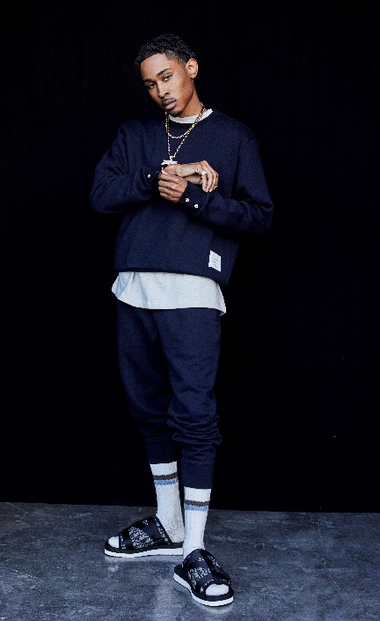

# # #
CONNECT WITH TRAETWOTHREE
INSTAGRAM | YOUTUBE | TWITTER | FACEBOOK

PRESS CONTACT
FAIRLEY MCCASKILL | FAIRLEY.MCCASKILL@ATLANTICRECORDS.COM

