ARDEN JONES RETURNS WITH age tape 6

LISTEN HERE

ARDEN CONTINUES TO RELEASE A NEW 3-TRACK EP
ON THE 1st THURSDAY OF EVERY MONTH OF 2022,
THIS RELEASE MARKING HIS 6TH

NORTH AMERICAN TOUR SUPPORTING CHELSEA CUTLER
BEGINS OCTOBER 13 IN LOUISVILLE, KY

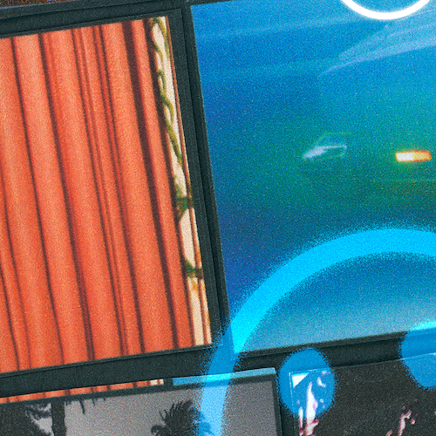
DOWNLOAD HI-RES ARTWORK

Rising California singer/songwriter/rapper/multi-instrumentalist Arden Jones is back with age tape 6, the latest installment in his ongoing series of monthly 3-song projects, available now via vnclm_ x Atlantic Records at all DSPs and streaming services.

age tape 6 includes a fresh trio of tracks recently teased on the 21-year-old Marin County, CA-born artist’s popular TikTok, including the fan favorite, “4 walls (with Sarcastic Sounds),” alongside the already popular “without me” and “bonnie & clyde.”

For this release Arden also announced his first-ever digital collectible that was available for free with the pre-save of “age tape 6”, powered by web3 firm, unsha.pe. The artist behind the collectible and Arden Jones’ Creative Director SJ Spreng says, "Creating the whole visual world of Arden Jones has been one of the most fun projects I’ve ever worked on. The idea of having my artwork in the hands of fans directly brings me so much joy. I’m insanely grateful to all of Arden’s fans for loving him and giving us the chance to do all the cool stuff we do together. I see this collectible as just a key to unlock all of the other amazing exclusives and projects we want to share with the whole age family. All in all, there are incredible things to come and all of this is just the very beginning.”
Currently boasting close to 1.5M monthly Spotify listeners, Jones has set himself on an ambitious path towards releasing three new songs on the first Thursday of every month for the rest of 2022. Thus far, the year has seen Jones sharing age tape 1, age tape 2 , age tape 3, age tape 4, and age tape 5, all of which are available now for streaming and download.

Known for an irresistible pop approach that bottles the sunshine of an endless California summer with elastic rhymes, radiant hooks, and euphoric, piano-laced beats, Jones has already earned over 75M worldwide streams for such hugely popular tracks as last year’s acclaimed vnclm_ x Atlantic Records debut single, “rollercoaster,” as well as the viral hit, “Parallel Parking.”

Hailed by EARMILK for his “joviality and a starry-eyed innocence,” Jones – who recently toured alongside fellow breakout pop stars Tai Verdes and Thomas Headon – will further share new music with his fans as special guest on Chelsea Cutler’s upcoming “When I Close My Eyes Tour,” with North American dates getting underway October 13 at Louisville, KY’s Mercury Ballroom and then traveling into mid-November.

ARDEN JONES
NORTH AMERICAN TOUR 2022

OCTOBER
13 - Louisville, KY - Mercury Ballroom
14 - Asheville, NC - The Orange Peel
15 - Raleigh, NC - The Ritz
18 - Nashville, TN - Marathon Music Works
20 - Philadelphia, PA - The Fillmore Philadelphia
21 - New York, NY - Hammerstein Ballroom
22 - New York, NY - Hammerstein Ballroom
23 - Portland, ME - State Theatre
25 - Harrisburg, PA - XL Live
27 - Grand Rapids, MI - The Intersection
29 - Cleveland, OH - House of Blues Cleveland
30 - Milwaukee, WI - The Rave

NOVEMBER
1 - Omaha, NE - The Admiral
4 - Bozeman, MT - Elm
5 - Spokane, WA - Knitting Factory
6 - Vancouver, BC - Commodore Ballroom
8 - Oakland, CA - Fox Theater
9 - Los Angeles, CA - The Wiltern
11 - San Diego, CA - Soma
15 - Tulsa, OK - Cain’s Ballroom
16 - Lawrence, KS - Granada Theater
17 - Columbia, MO - The Blue Note

All Dates w/Chelsea Cutler “When I Close My Eyes Tour”

# # #

DL Press photos here & here (credit SJ Spreng)

CONNECT WITH ARDEN JONES
INSTAGRAM | TIKTOK | YOUTUBE | SPOTIFY

For press inquiries, please contact:
Jessica Nall // Jessica.Nall@atlanticrecords.com
Gabrielle Reese // Gabrielle.Reese@atlanticrecords.com

