FOR IMMEDIATE RELEASE
JULY 14, 2022
breaking:
BRELAND’s INFECTIOUS COLLAB “THROW IT BACK” WITH KEITH URBAN IS CERTIFIED GOLD

NAMED OPRY NEXTSTAGE ARTIST FOR JULY

tune in: breland’s “brecap” show on AMP, THE NEW LIVE RADIO APP
wednesdays from 12 -1:30 pm CT
DEBUT ALBUM CROSS COUNTRY RELEASing SEPTEMBER 9

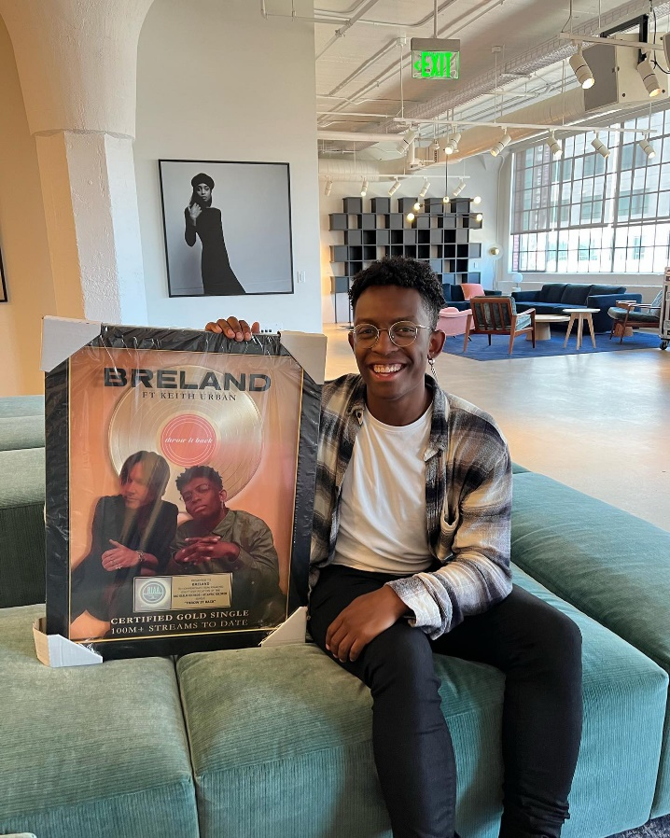
PHOTO CREDIT: @BRELAND ON INSTAGRAM

LOS ANGELES, CA. (July 14, 2022) – Bad Realm Records / Atlantic Records / Warner Music Nashville multi-talent BRELAND earns RIAA GOLD certification for his love-drunk collab with Keith Urban, “Throw It Back.” Accumulating much critical acclaim since its release, the music video amplified the buzzy song with Entertainment Tonight airing an exclusive behind-the-scenes look from the shoot in Nashville, TN.

“’Throw It Back’ is a showcase for BRELAND’s many and varied vocal talents.” – Rolling Stone
“Keith Urban and BRELAND are turning into the ultimate duet partners.” – ET Canada
“…country twerk party anthem’ – CMT
“ BRELAND continues to make waves in Country music…” – RESPECT
Adding to his accolades, BRELAND has been selected as the Opry NextStage artist for July. The coveted program invests in the discovery of new artists and highlights one up-and-coming artist per month with featured original content, an Opry performance and support across the brand’s platforms. Check out BRELAND’s NextStage videos here. The two previous NextStage classes have featured artists such as Parker McCollum, Lainey Wilson, Riley Green and Tenille Townes. The class of 2022 includes BRELAND alongside Elvie Shane, Morgan Wade and more to be announced. Fans can catch BRELAND as he returns to the Grand Ole Opry stage on July 26.

Recognized as a Breakthrough Artist by Amazon Music earlier this year, BRELAND has launched BRECAP, his new live radio show on Amp, the new live radio app from Amazon, where he discusses music, sports, culture, and more with friends. Tap in weekly HERE to listen to his take on everything.

To kick off July, BRELAND joined the USO, service members and local community at Fort Jackson’s Hilton Field in Columbia, SC, for an Independence Day celebration on July 2, performing a free concert to honor our nation’s history and express gratitude for all those who serve. Continuing on the road this summer, he’ll hit stages from coast to coast including the inaugural TidalWave Festival (8/12).

Tune in as the rapidly rising star will be featured on ABC’s “CMA Fest” special airing on Wednesday, August 3, with his highly anticipated debut album CROSS COUNTRY arriving on September 9. Named for the boundary-pushing, genre-bending style that defines all his music, CROSS COUNTRY firmly establishes BRELAND as a vital new force shaping the future of Country music.

ABOUT BRELAND:
With his PLATINUM debut “My Truck,” singer / songwriter / producer BRELAND has emerged as a bold new force on today’s music landscape. The Breakthrough Artist by Amazon Music first popped off when the Hip-Hop and Country hybrid hit #1 on Spotify’s Global Viral 50 in 2019, and a remix featuring Sam Hunt landed on best-of-the-year lists from NPR to The New York Times. Hailed as the “symbol of Country music’s ongoing evolution” (Rolling Stone), BRELAND debuted his new track “Natural” live on NBC’s TODAY with Hoda & Jenna while simultaneously announcing his highly anticipated debut album CROSS COUNTRY is slated for release September 9, 2022. With the title track’s official music video recently recognized at 2022 Tribeca Film Festival, the album will feature the “Cross Country” collaboration with Mickey Guyton, his buzzy track with Keith Urban “Throw It Back,” and his vivacious “Praise The Lord (feat. Thomas Rhett).” Featured on Dierks Bentley’s #1 single with HARDY, “Beers On Me,” the Bad Realm Records / Atlantic Records / Warner Music Nashville recording artist has collaborated with heavy-hitters such as Nelly, Lauren Alaina, and Chase Rice, and scored high profile looks on The Kelly Clarkson Show, ABC’s 2021 CMA Awards, ABC’s CMA Summer Jam, CMT Crossroads, ABC’s Jimmy Kimmel Live!, ABC’s Good Morning America, CBS’ New Year’s Eve Live: Nashville’s Big Bash, YouTube’s Artist on The Rise, 2022 ACM Awards, and 2022 CMT Awards. He is on the road this summer hitting stages from coast to coast including the inaugural TidalWave Festival (8/12). BRELAND is also recognized in the Country Music Hall of Fame® and Museum’s brand-new exhibit, American Currents: State of the Music.

CONNECT WITH BRELAND
WEBSITE | INSTAGRAM | FACEBOOK | TWITTER | YOUTUBE | SOUNDCLOUD

FOR BRELAND
Fairley McCaskill / Fairley.McCaskill@atlanticrecords.com
Jensen Sussman / jensen@sweettalkpr.com
Mary Catherine Rebrovick / MaryCatherine@wmg.com

