FOR IMMEDIATE RELEASE
JULY 1, 2022

BAZZI CELEBRATES SUMMER WITH “MISS AMERICA”

CHART-TOPPING MULTI-PLATINUM PHENOMENON SETS OFF FIREWORKS
WITH DAZZLING NEW POP ANTHEM

LISTEN TO “MISS AMERICA” HERE | WATCH OFFICIAL MUSIC VIDEO HERE

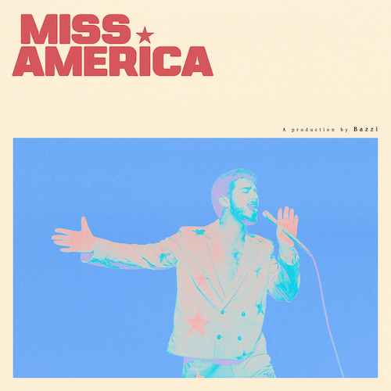
DOWNLOAD HI-RES ARTWORK

Chart-topping, multi-platinum phenomenon Bazzi is celebrating the start of summer with today’s premiere of a dazzling new pop anthem. “Miss America” is available now via Atlantic Records at all DSPs and streaming services HERE. Co-written with longtime collaborator Kevin White of multiple GRAMMY® Award nominated production and songwriting duo Rice N’ Peas (G-Eazy, Jason Derulo), the explosively charged track is joined by an official music video starring Bazzi along with Barbara Palvin, Dylan Sprouse and Yovanna Ventura. The video is streaming now at YouTube HERE.

"’Miss America’ is exciting for me because it’s the first piece of music I’m putting out in years that really represents where I am in this moment,” says Bazzi about the new single. “I’d be lying if I said I wrote this song from some calculated approach and went into it knowing what I wanted it to mean lyrically, but looking back on it, something really beautiful happened. There’s an optimism in this song that encourages us to take the broken pieces of the things we once stood on and put them back together in a way that makes sense to us. I can’t wait to watch people enjoy this record and find all of their own personal meaning inside of it."

“Miss America” follows the release earlier this year of the deeply personal “Will It Ever Feel The Same?,” available for streaming and download HERE. Praised by PEOPLE in an exclusive interview as a “new breakup ballad (that is) sure to strike a chord,” the emotionally vulnerable single arrived alongside an official music video, directed by Los Angeles-based photographer/filmmaker Bradley Calder and streaming now HERE.

Born to a Lebanese immigrant father and American mother in Canton, MI, Bazzi and his dad moved to California during his senior year where he single-handedly wrote and produced a series of viral smashes like “Alone” and “Beautiful,” earning millions of worldwide streams and top 10 placement on a variety of influential playlists. Now with over 1.9 billion streams to date, 2018’s 5x RIAA platinum certified “Mine” proved Bazzi’s true breakthrough, ascending to #1 at CHR/Top 40 and making the top 20 on Billboard’s “Hot 100” after reaching #1 on virtually all streaming platforms. As if all that weren’t enough, the “Mine” companion video boasts over 192 million views via YouTube alone. Praised by Playboy for its “genre-bending…warts-and-all approach to songwriting,” Bazzi’s RIAA platinum certified debut album, COSMIC, debuted among the top 15 on the SoundScan/Billboard 200 upon its 2018 release, earning over 4.3 billion global streams with hits like the 4x platinum certified, top 40 hit duet version of “Beautiful (Ft. Camila Cabello),” accompanied by a spectacular companion visual now with over 188 million views. In 2019, Bazzi unveiled his first ever mixtape, SOUL SEARCHING, collecting over 1.8 billion streams on the strength of such RIAA platinum certified singles as “I.F.L.Y.” and “Paradise.” Hailed by Billboard as “his most personal work to date,” the project made a top 20 debut on the Billboard 200, while “Paradise” proved one of Bazzi’s biggest hits with over 675 million global streams and counting.

Bazzi made the most of his 2020, releasing a string of intimate and deeply confessional tracks – including “Young & Alive,” “Renee’s Song,” “I Got You,” “I Don’t Think I’m Okay,” and “Crazy” – all of which drew millions of streams around the world. Bazzi followed the impressive singles run with his 2021 hit “I Like That,” which was joined by a colorful official music video directed by Christian Breslauer (Roddy Ricch, Doja Cat, Yungblud) and co-starring such close personal friends as high profile influencers Luca Sabbat, Scarlett Rose Leithold, Charlotte D’Alessio, Valentina Bilbao, Bruna Lirio, Chandler Lovelle, Duke Nicholson, and more.

Currently boasting over 9 billion catalogue streams worldwide, Bazzi is fully focused on the future and is hard at work writing and recording new music, now as always cross-pollinating modern pop with more traditional aspects of craft and performance.

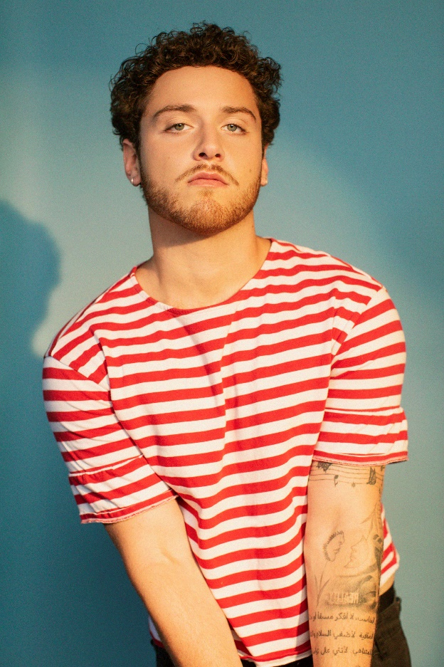

DOWNLOAD PRESS PHOTO HERE

CONNECT WITH BAZZI
BAZZIOFFICIAL.COM | FACEBOOK| INSTAGRAM| TWITTER| YOUTUBE

For press inquiries, please contact:
Kelly McWilliam // Kelly.McWilliam@atlanticrecords.com

