BURNA BOY’S LOVE, DAMINI BECOMES HIGHEST CHARTING NIGERIAN ALBUM IN HISTORY
#1 ON APPLE MUSIC IN 47 COUNTRIES
#2 ON UK’S OFFICIAL ALBUMS CHART
#14 ON BILLBOARD 200 CHART

SONG OF THE SUMMER CONTENDER “LAST, LAST” OFFICALLY ARRIVES ON BILLBOARD’S HOT 100 CHART (A FIRST FOR BURNA BOY) & TODAY’S TOP HITS ON SPOTIFY + TOPS BILLBOARD’S U.S. AFROBEATS SONGS CHART
BURNA BOY KICKED OFF HIS LOVE, DAMINI SUMMER TOUR IN BARBADOS ON JULY 17TH CLICK HERE FOR FOOTAGE OF “LAST, LAST” FROM THE SHOW
“FOR MY HAND” FEAT. ED SHEERAN DEBUTS AT #13 ON BILLBOARD’S BUBBLING UNDER HOT 100 CHART

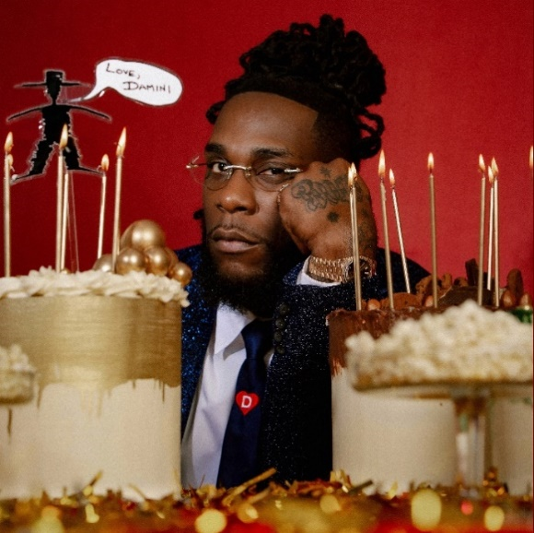
DOWNLOAD/STREAM LOVE, DAMINI NOW
DOWNLOAD HI-RES ARTWORK FOR "LOVE, DAMINI" HERE [MIKEY OSHAI]

* * *
“Abetted by some of Africa’s most inventive producers, Burna Boy connects Afrobeats to its worldwide kin: R&B, Jamaican dancehall, reggaeton, Congolese rumba, hip-hop and more. His voice, a velvety baritone, has a suave composure that can hint at easy assurance or a melancholy reticence, and while his melodies don’t immediately seem sharp-edged, he places each note to add yet another layer of polyrhythm.”

“Burna Boy’s unique marriage of afrobeats, dancehall, and hip-hop feels earthy, alive, and innately spiritual; each cut (about love, lust, and stunting on haters) is somehow fortifying—like an aural amulet.”

“As the biggest Afrobeats musician to cross over to Western markets, Burna Boy has been on a near-constant upward rise — one that shows no signs of stopping now with the release of his sixth album, Love, Damini.”

***
GRAMMY-award-winning Burna Boy is reaching new heights with his sixth studio album “LOVE, DAMINI” debuting at #14 on the Billboard Top 200 – marking his highest U.S. debut to date. The album also continues to grow internationally as it finished at #2 in the UK and Netherlands becoming his highest charting album in those territories it and it also became the #1 album on Apple Music in 47 countries. LOVE, DAMINI was selected as a The New York Times’ Critics Pick and while receiving praise from several including Rolling Stone, Billboard, Vulture, Variety and many more.
Standout single, “Last Last,” continues to make waves as it sits at #1 on the Billboard U.S. Afrobeat Songs chart with over 93.5M global streams to date. The recently released visual for “For My Hand” ft Ed Sheeran was quickly trending in over 15 countries.
This past weekend, Burna has officially kicked off his Love, Damini Summer 2022 tour in Barbados. The tour is continuing through the month of July visiting Chicago, Houston Boston and more before wrapping on July 31st in Atlanta. For more information and ticket purchases please visit www.onaspaceship.com.
***
LOVE, DAMINI SUMMER 2022 TOUR
July 21, 2022 - Detroit, MI - Aretha Franklin Amphitheater
July 22, 2022 - Minneapolis, MN - Armory
July 23, 2022 - Chicago, IL - Huntington Bank Pavilion at Northerly Island
July 24, 2022 - Houston, TX - Toyota Center
July 27, 2022 - Irving, TX - The Pavilion at Toyota Music Factory
July 29, 2022 - Boston, MA - Leader Bank Pavilion
July 30, 2022 – Montreal, QC – Osheaga (Festival)
July 31, 2022 - Atlanta, GA - State Farm Arena
# # #
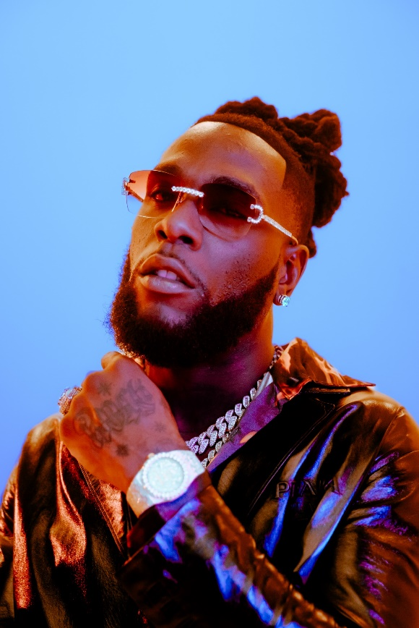
DOWNLOAD HI-RES IMAGES
CONNECT WITH BURNA BOY
TWITTER | FACEBOOK | INSTAGRAM | YOUTUBE
PRESS CONTACTS
Corey Brewer | Corey.Brewer@atlanticrecords.com
Selam Belay | Selam.Belay@atlanticrecords.com

