FOR IMMEDIATE RELEASE
JULY 20, 2022

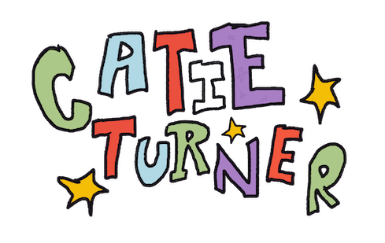

CATIE TURNER STEALS HER EX’S DAD IN NEW “STEP MOM” MUSIC VIDEO

WATCH OFFICIAL MUSIC VIDEO HERE | LISTEN TO “STEP MOM” HERE

“Turner’s bubbly, unafraid personality separates her from the other pop singers right now; with the brazen hook “I’m gonna steal your dad / Be the best he ever had,” there’s no competition.”
– UPROXX

“‘Step Mom’ is a funny, fresh take on a breakup song, highlighting Turner's unique and powerful vocals.” – V Magazine

Critically acclaimed singer-songwriter Catie Turner has unconventional motives to exact psychological torture on her ex by stealing his dad in her new music video for her most recent single, “Step Mom,” available HERE. The quirky and playful video, directed by Joe DeSantis, made its broadcast premiere on MTV Live, MTVU, MTV Biggest Pop and on the Paramount Times Square billboards. Singer/songwriter Miki Ratsula stars alongside Catie, playing both the role of Catie’s ex and his dad, sporting a variety of comical costumes and wigs, including a silver fox mustache. Catie performed the song throughout her recent tour with Léon and it quickly became a fan favorite. Listen to the track HERE and watch the official lyric video HERE.

“The Step Mom video was so much fun to make,” says Catie. “Huge thanks to Miki Ratsula for donning the mustache to make my twisted, dad-stealing psycho fantasy a reality.”
A self-proclaimed “overthinking, overwhelmed musician with a talent in overcomplicating situations,” Catie’s heart-wrenching breakthrough hit single, “God Must Hate Me,” proved a viral phenomenon upon its November 2021 release. “God Must Hate Me” is Catie’s top streaming record to date with 52.9M global streams. In the first 3 days, the single earned 173K streams and 1.2M streams in the first week. Applauded by American Songwriter as “a platform for all sorts of reflections and interpretations…one of (Turner’s) most successful songs to date,” and named People Magazine’s Top 25 Emerging Musical Artists You Should Add To Your Playlist This Fall, the track landed Catie on the cover Spotify’s “Next Gen Singer Songwriters” playlist and while earning over 38M streams. A powerful performance video, filmed live at the historic St. Ann’s Church in Brooklyn, NY.
This year has seen Catie spending even more time on the road, including a major US run supporting Canadian pop band Valley and a just-wrapped series of dates as special guest on Léon’s Fade Into A Dream: The North American Tour. For updates, please visit www.catieturner.com.

# # #

DOWNLOAD HI-RES IMAGE // PHOTO CREDIT: AMANDA ELMAN

ABOUT CATIE TURNER:
You don’t ever have to worry about what Catie Turner is thinking. She’ll tell you within seconds. Besides being a singer and songwriter, she prides herself as “an overly emotional and anxious attachment-style musician with a lot of over-sharing to do.” However, that over-sharing continues to click with listeners. The Langhorne, PA native went from placing 7th on American Idol in 2018 to releasing “teenage crisis” anthems such as “Prom Queen” and “i luv him.” in 2019. Beyond piling up over 120 million streams, she’s reeled in critical acclaim from TIME, Billboard, American Songwriter, People and more. She took all of her heartbreak from a breakup and turned it into the bops, ballads, and confessions on her 2021 EP, Heartbroken and Milking It, introduced by the single “Therapy.” She describes her ex’s response to these bops as “not appreciative.” Most recently, Catie has been touring the US with the likes of Valley and LEON and releasing music like high-energy bop “Nothing” and “God Must Hate Me,” which has nearly 60 million global streams. Now, she has her sights set on stealing your dad with new single “Step Mom.” She just hopes you think she’s pretty cool, because she doesn’t have a plan B.

# # #

CONNECT WITH CATIE TURNER
OFFICIAL | FACEBOOK | INSTAGRAM |TIK TOK | TWITTER | YOUTUBE

For press inquiries, please contact:
Kelly McWilliam, Kelly.McWilliam@atlanticrecords.com
Paige Rosoff, Paige.Rosoff@atlanticrecords.com

