DEATH CAB FOR CUTIE RELEASES NEW SINGLE “HERE TO FOREVER”
WITH OFFICIAL MUSIC VIDEO WRITTEN AND DIRECTED BY FILMMAKER LANCE BANGS

APPEARING ON CBS SATURDAY MORNING ON JULY 30TH

8X GRAMMY® AWARD-NOMINATED BAND’S HIGHLY-ANTICIPATED TENTH STUDIO ALBUM
ASPHALT MEADOWS – ARRIVING SEPTEMBER 16TH

FALL HEADLINE TOUR BEGINS SEPTEMBER 22ND IN MADISON, WI

WATCH HERE
BUY/STREAM “HERE TO FOREVER” HERE
PRE-ORDER ASPHALT MEADOWS HERE

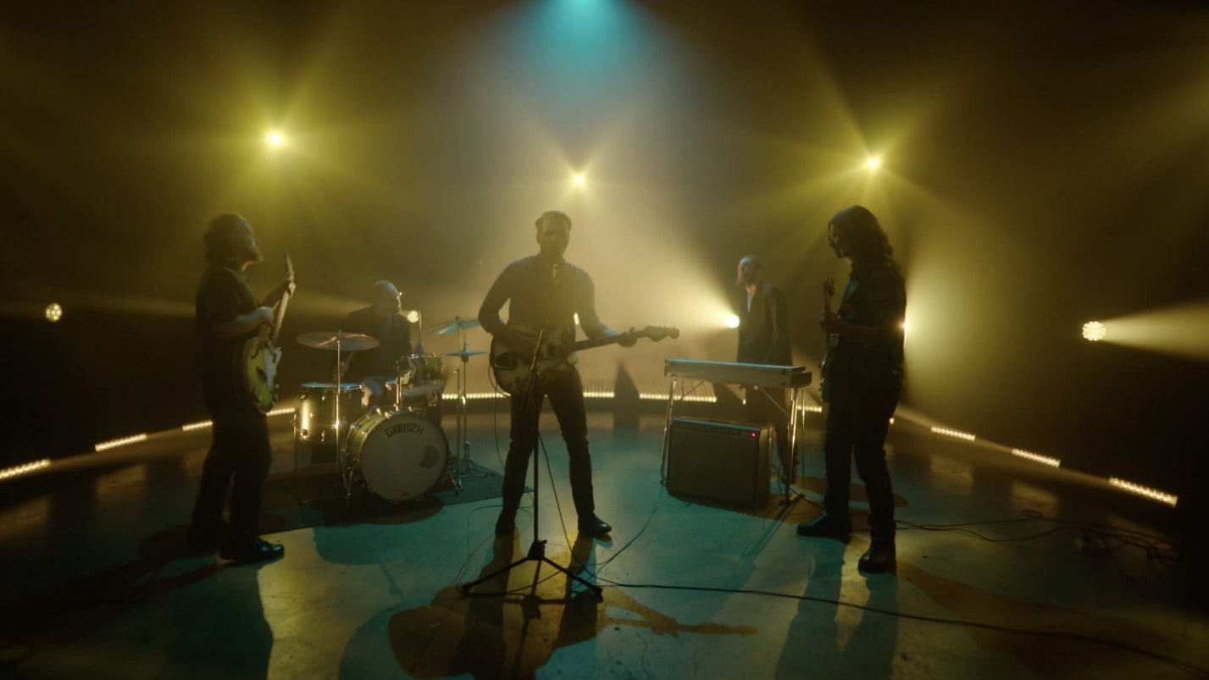

8x GRAMMY® Award-nominated rock band Death Cab for Cutie have today released new single
“Here to Forever,” accompanied by an official music video written and directed by filmmaker Lance Bangs (Sonic Youth, Nirvana, Kanye West). The visual shows lead vocalist and guitarist Ben Gibbard take the reins on packaging the band’s vinyl – after a conversation with two pressing plant employees, played by comedians Natalie Palamides and Courtney Pauroso – cut between clips of the five-piece performing the new song.

WATCH “HERE TO FOREVER” OFFICIAL VIDEO HERE

Of “Here to Forever,” Ben Gibbard shares:
“It’s a song both about our impermanence and the anxiety of these times. It’s also about wanting to believe in something bigger even when it feels like nothing is out there.”

“Here to Forever” follows “Roman Candles,” the first track released off Death Cab for Cutie’s highly-anticipated tenth studio album Asphalt Meadows, due out September 16th (tracklist enclosed). Pre-orders are available now here. On July 30th, the band will appear on CBS Saturday Morning to perform and discuss the new record.

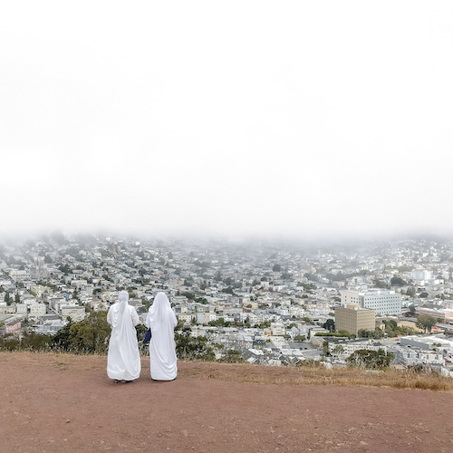
(download hi-res album artwork; photo credit: Benjamin Gibbard)

Asphalt Meadows was produced by GRAMMY® Award-winner John Congleton (St. Vincent, Sharon Van Etten, Wallows). Alongside news of the forthcoming album, the band also unveiled plans for their wide-ranging fall US headline tour. The run kicks off September 22 at The Sylvee in Madison, WI and culminates with a two-night hometown finale at Seattle, WA’s Paramount Theatre on October 26 and 27 (full routing enclosed). The tour will feature support from Low and Yo La Tengo on select dates and includes a much anticipated return to NY’s Forest Hills Stadium on September 30.

The band is currently in the midst of their headlining US summer tour, featuring support from illuminati hotties. All upcoming dates are noted below.

Death Cab for Cutie’s ninth studio album Thank You for Today was released in 2018. That album saw the band entering its second decade by both expanding and refining its signature sound, with highlights including lead single, “Gold Rush,” which reached #1 on Billboard’s “Adult Alternative Songs” chart.

The band continued to affirm their lasting artistic legacy with a wide range of creative activity in the years that followed, including diverse collaborations such as Chance the Rapper’s 2019 album track, “Do You Remember (ft. Death Cab for Cutie),” and Tycho & Gibbard’s acclaimed 2021 single, “Only Love.”

Gibbard presented a series of “Live From Home” livestreams throughout the duration of the COVID-19 pandemic, helping raise over $250K in donations and supplies for various Seattle-area relief organizations. The livestreams – which showcased songs from Death Cab for Cutie, The Postal Service and his solo material, along with covers and other surprises – drew over 4.5 million total views as well as high profile media attention from The New York Times, The New Yorker, Rolling Stone, Newsweek, Variety, NPR, and Stereogum, the latter of which pondered, “Is Ben Gibbard going to single-handedly get us all through quarantine?”

December 2020 saw Death Cab for Cutie release The Georgia EP, initially offered as a 24-hour Bandcamp exclusive in advance of the crucial Georgia runoff elections that ultimately turned the state blue and secured Democratic control of the US Senate. The five-song project – which features covers of iconic artists from the great state of Georgia – raised over $100K for Fair Fight Action, the national voting rights organization founded by Stacy Abrams to promote fair elections around the country through voter education, election reform, and combating voter suppression. “Fair Fight is grateful for the support of Death Cab for Cutie in our fight for free and fair elections in Georgia and nationwide,” Abrams said later. “The Georgia EP helps tell the story of Georgia just as their contributions have helped us write the next chapter.”

In February of this year, Gibbard conceived, curated, and executive produced Ocean Child: Songs of Yoko Ono, an acclaimed tribute to the groundbreaking singer, songwriter, multimedia artist, and activist released in celebration of her 89th birthday. The collection – which includes Death Cab for Cutie’s own cover of “Waiting For The Sunrise” – also features contributions from a stunning range of diverse artists, including David Byrne, Japanese Breakfast, The Flaming Lips, and Sharon Van Etten. Ocean Child earned worldwide critical acclaim spanning The New York Times, Rolling Stone, NPR, The Guardian and more.

Formed in Bellingham, WA in 1997, Death Cab for Cutie almost immediately entered the ranks of the era’s definitive bands, fueled in large part by the remarkable power of co-founder, vocalist, guitarist, and lead songwriter Benjamin Gibbard’s complex, often bittersweet songcraft. The band made their worldwide popular breakthrough with 2003’s RIAA gold certified Transatlanticism, later named by NPR as one of “The Decade's 50 Most Important Recordings.” Plans, their 2005 Atlantic Records debut release, saw Death Cab for Cutie ascending to even greater heights, earning RIAA platinum certification and a GRAMMY® Award nomination for “Best Alternative Album” while spawning the chart-topping singles, “Soul Meets Body” and “I Will Follow You into the Dark,” the latter of which was honored with a GRAMMY® nod for “Best Pop Performance By Duo Or Group With Vocals.” Their following albums – including Narrow Stairs (2008), The Open Door (2009), Codes and Keys (2011), and Kintsugi (2015) – all received various GRAMMY® Award nominations, bringing their total career nominations to eight overall.

ASPHALT MEADOWS TRACKLISTING:
- I Don’t Know How I Survive
- Roman Candles
- Asphalt Meadows
- Rand McNally
- Here to Forever
- Foxglove Through the Clearcut
- Pepper
- I Miss Strangers
- Wheat Like Waves
- Fragments From the Decade
- I’ll Never Give Up On You

###

DEATH CAB FOR CUTIE
TOUR 2022

JULY
14 – Harrisburg, PA – Harrisburg University at Riverfront Park †
15 – Uncasville, CT – Mohegan Sun Arena †
16 – Poughkeepsie, NY – MJN Convention Center †

SEPTEMBER
3-4 – All IN Festival – Indianapolis, IN *
22 – Madison, WI – The Sylvee ^
23 – Minneapolis, MN – Surly Brewing Festival Field
24 – Chicago, IL – The Salt Shed
26 – Columbus, OH – KEMBA Live! ^
27 – Washington, DC – The Anthem ^
29 – Philadelphia, PA – The Met ^
30 – New York, NY – Forest Hills Stadium ^

OCTOBER
1 – Boston, MA – Leader Bank Pavilion ^
3 – Raleigh, NC – Red Hat Amphitheater ^
4 – Atlanta, GA – Coca-Cola Roxy ^
6 – Richmond, VA – Virginia Credit Union LIVE! ^
7 – Asheville, NC – Rabbit Rabbit ^
8 – Charleston, SC – Firefly Distillery ^
10 – Pittsburgh, PA – Stage AE ^
11 – Detroit, MI – The Masonic ^
13 – St. Louis, MO – The Factory ^
14-16 – Austin, TX – Austin City Limits Music Festival *
14 – Kansas City, MO – Arvest Bank Theatre at The Midland ^
15 – Tulsa, OK – Cain’s Ballroom
17 – Phoenix, AZ – The Van Buren – SOLD OUT
18 – Anaheim, CA – House of Blues Anaheim # - SOLD OUT
19 – Santa Barbara, CA – Santa Barbara Bowl #
21 – Los Angeles, CA – The Greek Theatre #
22 – San Diego, CA – Epstein Family Amphitheater @ UC San Diego # - SOLD OUT
23 – Oakland, CA – Fox Theater #
24 – Oakland, CA – Fox Theater #
26 – Seattle, WA – Paramount Theatre
27 – Seattle, WA – Paramount Theatre

* Festival Performance
† w/Special Guests illuminati hotties
^ w/Special Guests Low
# w/ Special Guests Yo La Tengo

# # #

CONNECT WITH DEATH CAB FOR CUTIE
DEATHCABFORCUTIE.COM | FACEBOOK | TWITTER | INSTAGRAM | YOUTUBE | TIKTOK

Press Inquiries:
Libby Kober | libby.kober@atlanticrecords.com

