ENCHANTING TAPS JACQUEES FOR “WHAT I WANT”
RISING 1017 GLOBAL MUSIC STAR SHARES NEW SONG AND VIDEO
WATCH “WHAT I WANT” | LISTEN TO “WHAT I WANT”
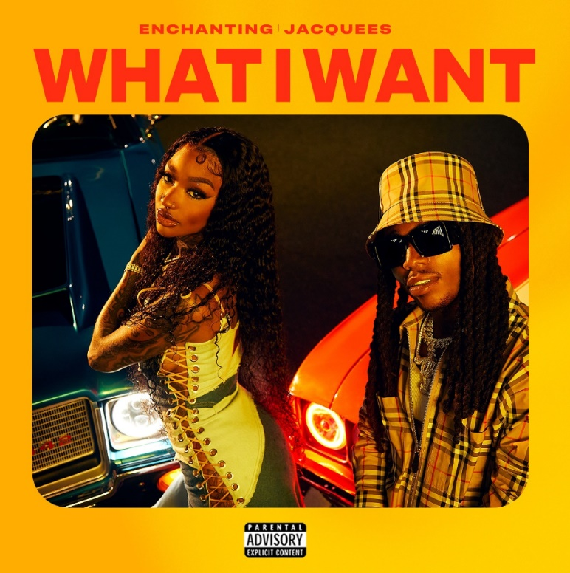
1017 Global Music’s Rap and R&B princess Enchanting has tapped multi-Platinum certified R&B singer Jacquees for breezy summer jam “What I Want.” Enchanting is showing off her vocals with another dive into the R&B side of her talent, complementing the signature raspy rap style she’s often praised for. “What I Want” is joined by an official music video streaming now via YouTube HERE, directed by Brittany Bowman Harris (Rick Ross, Latto, Kali) and premiered via Revolt TV earlier today, airing at the top of every music video hour for 24 hours.

DOWNLOAD PRESS PHOTO HERE

“What I Want” precedes an upcoming project from Enchanting and comes on the heels of her appearance on the 1017 compilation deluxe extension SO ICY GANG: THE REUP with “Large Amounts (ft. Gucci Mane).” Earlier this year, Chant shared the vulnerable “Take It Back” after a series of hard-hitting collabs in 2021 including “Track & Field (Feat. Kali)” and “Freaky Deaky (Feat. Coi Leray),” adding to her combined 90M global streams to date. Both followed Enchanting’s release of “Want Sum,” a fan favorite that’s surpassed 2.5M official video views and 8M streams to date.

ABOUT ENCHANTING
Enchanting’s stage name speaks for itself. Pressing play on an Enchanting verse, you’re instantly mesmerized by the ethereal textures the 23-year-old songstress brings to the mic. Coming out of Fort Worth, Texas, Enchanting began to pursue music around the age of 18. She defines her style as something chill with a dash of neo-Soul, a twinge of old school R&B, with some modern trap flavor sprinkled in. “It’s like Trap-n-Blues,” Enchanting expresses. The genre blend is perfect for Enchanting, who uses music as a vehicle of expression, not only for herself but for others.
Enchanting has appeared alongside her 1017 Global Music labelmates on Gucci Mane’s compilation tape Gucci Mane Presents: So Icy Summer, So Icy Christmas, and more. Enchanting credits Dallas’ superproducer J. White Did It for making the connection between herself and Atlanta rap icon Gucci Mane. “I guess he told Gucci about me,” Enchanting explains with excitement and gratitude; “Gucci called me the next day.” Working on her upcoming mixtape, her legacy is one of showing other aspiring artists from her city they can do it too- more than a natural artist, she’s a natural-born motivator with a sterling personality.

###
CONNECT WITH ENCHANTING
TWITTER
INSTAGRAM
YOUTUBE

PRESS CONTACTS
Ted Sullivan | Ted.Sullivan@atlanticrecords.com
Ashley Kalmanowitz | Ashley.Kalmanowitz@atlanticrecords.com

