FOR IMMEDIATE RELEASE
AUGUST 4, 2021

FRED AGAIN.. ANNOUNCES DEBUT HEADLINE SHOWS
IN LONDON, LOS ANGELES AND NEW YORK

RELEASES "BAXTER (THESE ARE MY FRIENDS)"

NEW TRACK OUT TODAY FEATURING BAXTER DURY

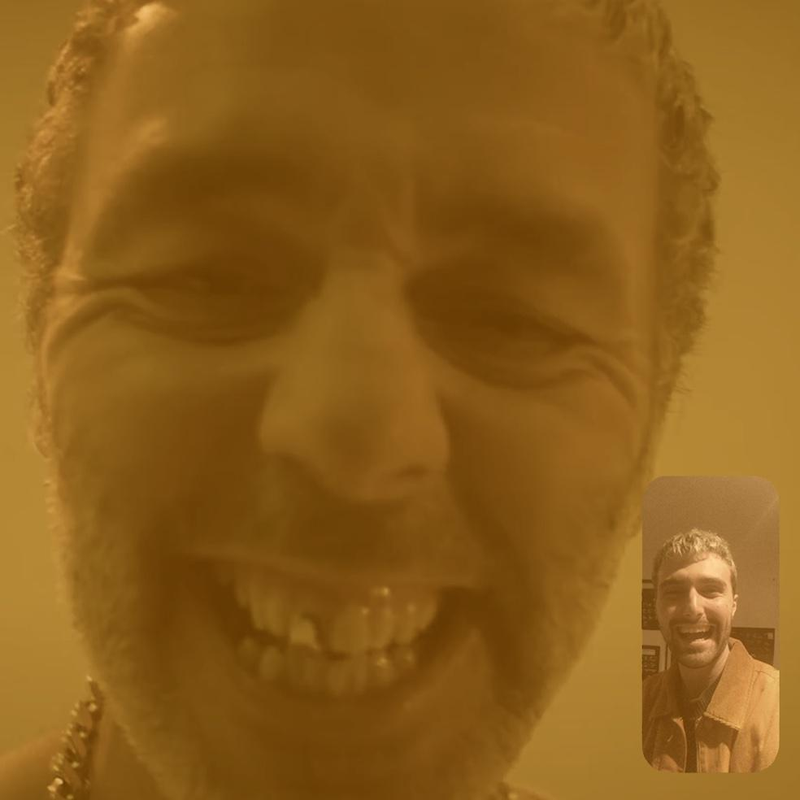
(download high res single art here)

Having firmly established himself as one of 2021's most exciting new artists with the release of his acclaimed debut album Actual Life (April 14 - December 17 2020), Fred again.. today announces his debut headline live shows.

On 7th September he'll play a hometown show at London's Village Underground before heading to the US in December for dates at Los Angeles' Roxy Theatre and New York’s Bowery Ballroom. Having already given a glimpse of just how special the live show will be via April's much hyped "Fred again.. Studio Live (London, April 2021" livestream, and with UK festival appearances (All Points East, Parklife) on the horizon, demand for tickets is sure to be huge. Fans can sign up for pre-sale tickets now via www.fredagain.com with tickets going on general sale Friday 6th August.

Fred again.. Live Headline Shows 2021

7th September - Village Underground, London, UK
2nd December - Roxy Theatre, LA, USA
7th December - The Bowery Ballroom, New York, USA

Meanwhile, today also sees Fred again.. releasing his first new music since Actual Life. Whereas his 2021 crossover anthem "Marea (We Lost Dancing)" yearned for a return to the dancefloor ("if I can live through this... what comes next... will be marvellous"), "Baxter (These Are My Friends)" puts us right back in the middle of the club. Simultaneously nostalgic and totally modern, it features an evocative Baxter Dury vocal ("all the pain, and all the Cartier you can wear. I want to give you a big kiss on your sweaty forehead. These are my friends. These are my friends. I love you. Let's dance again shall we?")

Listen to "Baxter (These Are My Friends)" HERE

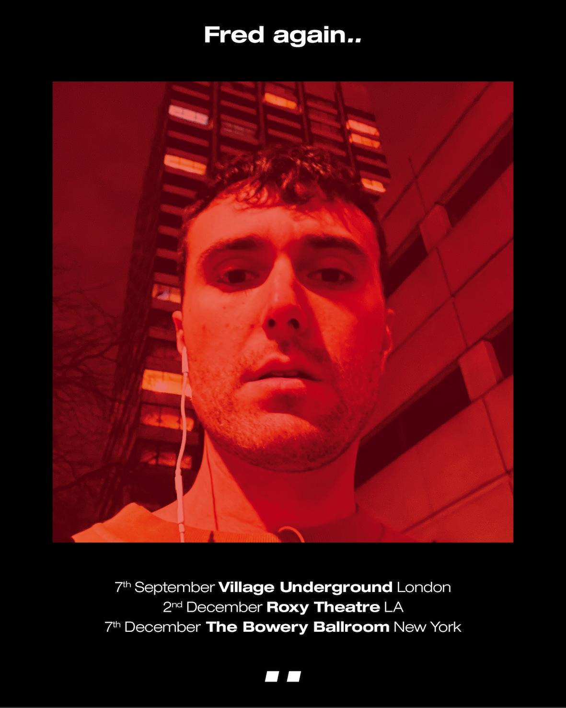
(download high res live artwork here)

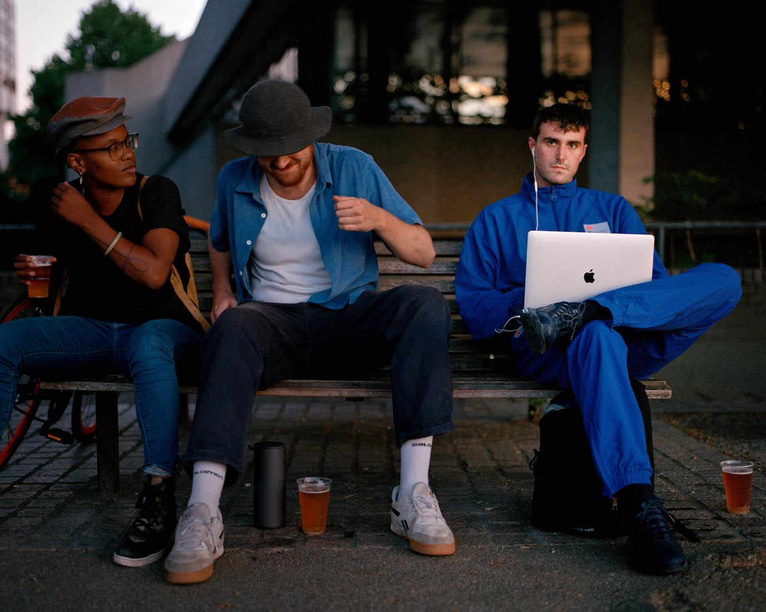
(download high res Fred again.. photo here)

"Fred again... is on fire this year." - THE FADER

“His debut solo album traverses the personal for an eclectic and electrifying snapshot of his travels and companions” - NME

“It’s the search for authenticity that makes Fred again.. so exciting – and makes us reckon he could be the real deal.” - MIXMAG

"Fred again.. is solidifying himself as the producer of the moment and, quite possibly, the future" - LOUD & QUIET

“Fred again.. is a British artist taking a unique approach to his mesmerizing dance tracks” - PIGEONS & PLANES

“Listening to Fred again..’s music feels like you’ve stumbled onto something very personal. In many ways, his oeuvre is a diary with multiple authors. Fred again.. is the producer behind some of the UK’s biggest tracks in recent years can count Stormzy, Headie One, and Ed Sheeran as collaborators. But it’s how he collaborates with the world outside music that makes his sound especially visceral” - HIGH SNOBIETY

“Fred’s approach to sampling is like no other” - NOTION

“His songs hover in the territory between the purest euphoria and gut-wrenching melancholy” – GRM DAILY

Fred again.. Instagram / Soundcloud

For publicity inquiries, please contact:
Kelly McWilliam // Kelly.McWilliam@atlanticrecords.com

