FOR IMMEDIATE RELEASE
JUNE 29, 2022

FRED AGAIN.. RELEASES NEW TRACK “JUNGLE”
OUT NOW VIA ATLANTIC RECORDS

LISTEN HERE

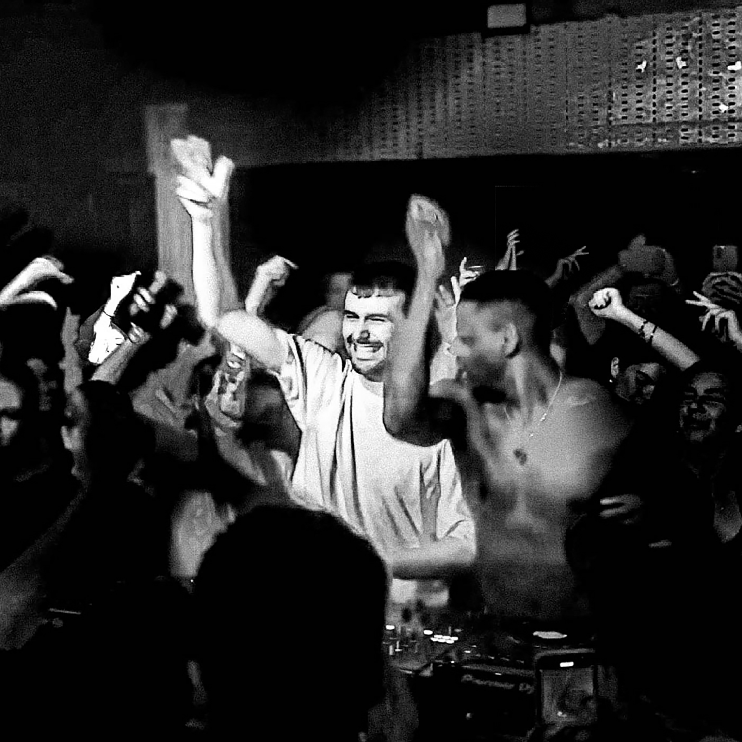
(download high res artwork here)

Following in the footsteps of his series of monthly, club-focused tracks and collaborations, today Fred again.. once again releases another landmark single, the thunderous “Jungle” – listen HERE. Having spent the last few weeks teasing the track and road testing it in front of festival audiences, today “Jungle” finally sees the light of day.

As alluded to through recent posts on social media, “Jungle” was the result of sessions with Kieran Hebden - in what feels like two artists exploring musical boundaries with no agendas or deadlines, the result is an unpredictable yet gripping track that sees the pair pushing each other into new musical territory.

The release of “Jungle” follows on from a run of acclaimed collaborative singles, January’s “Lights Out” with HAAi and Romy and March’s “Admit It (U Don’t Want 2)” with I. Jordan. Both are now fixtures in DJ sets around the world, as well as Fred’s own live performances - a stunningly honed show that takes crowds through material from the achingly beautiful moments of his Actual Life album series and unifying, standout tracks of last summer, “Marea (We’ve Lost Dancing)” and “Billie (Loving Arms)”. One of the places where this was experienced in all its glory was at Coachella – where Forbes noted, “Fred Again.. caught quite the Coachella buzz, and for good reason. The aesthetic of his vibrant set somehow perfectly encapsulated our collective nervous breakdown of the past two years and then set us all free.”

Fred again.. will continue his live ascendency with sold out shows around the world throughout 2022, including three nights at Los Angeles’ Hollywood Forever Cemetery and three nights at New York’s 3000 capacity Terminal 5 in the fall. Full US tour dates below with further information via https://www.fredagain.com/tour/.

FRED AGAIN.. – 2022 US TOUR DATES:
September 23rd - The Warfield, San Francisco, CA, US (SOLD OUT)
September 24th - Portola Festival, San Franciso, CA, US
September 28th - Hollywood Forever Cemetery, Los Angeles, CA, US (SOLD OUT)
September 29th - Hollywood Forever Cemetery, Los Angeles, CA, US (SOLD OUT)
September 30 - Hollywood Forever Cemetery, Los Angeles, CA, US
October 1st - Gorge Amphitheatre, George, WA, US
October 2nd - Mission Ballroom, Denver, CO, US
October 5th - Riviera Theater, Chicago, IL, US
October 6th - History, Toronto, Canada (SOLD OUT)
October 8th - 9:30 Club, Washington, DC, US (SOLD OUT)
October 11th - Roadrunner, Boston, MA, US
October 13th - Terminal 5, New York, NY, US (SOLD OUT)
October 14th - Terminal 5, New York, NY, US (SOLD OUT)
October 16th - Terminal 5, New York, NY, US
October 29th - Oakland Arena, Oakland, CA, US
October 30th - Oakland Arena, Oakland, CA, US

About Fred again..:
It's fair to say that 2021 was an incredible year for Fred again.. The prolific London-based artist, Fred again.., released two acclaimed, deeply personal albums in 2021 - his debut ‘Actual Life (April 14 - December 17 2020)’ and its companion follow up ‘Actual Life 2 (February 2 - October 15 2021).’ The projects were beloved by fans and critics alike and heralded by the likes of Rolling Stone, FADER, Pitchfork, HYPEBEAST, HighSnobiety and more. The albums were also included on many coveted “best of the year” lists including Billboard, NPR, Forbes, Ones to Watch and more. Fred rounded off the year with a 2022 GRAMMY nomination and BRIT Awards nomination.

Last year also saw Fred again.. become one of the year's most talked about live acts as he transformed his Actual Life records into an immersive, communal real-life experience for the first time. With shows selling out across the UK and USA, he was named one of Mixmag's "Top 10 Live Acts Of 2021". 2022 will see Fred continue his upwards trajectory with his biggest headline shows yet – three sold-out shows at LA’s Hollywood Forever Cemetery and three sold-out shows at NY’s Terminal 5 – in addition to festival appearances at the likes of Coachella, Primavera, Melt, Way Out West, Rock En Seine and All Points East.

More on:
Fred again.. OFFICIAL SITE / INSTAGRAM / TIKTOK / SOUNDCLOUD

Contact:
Kelly McWilliam / Atlantic Records
Kelly.McWilliam@AtlanticRecords.com

