FOR IMMEDIATE RELEASE
JUNE 15, 2021

DIPLO REMIXES FRED AGAIN..’S “MAREA (WE’VE LOST DANCING)”

LISTEN HERE

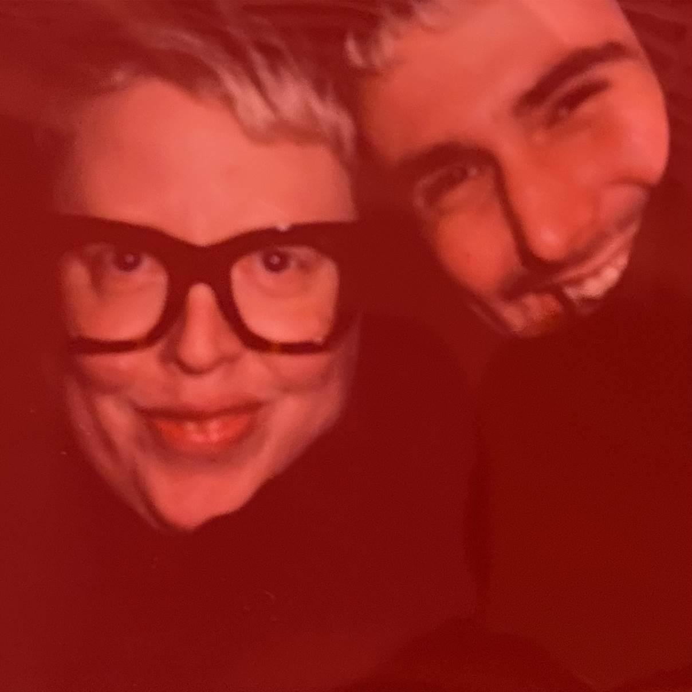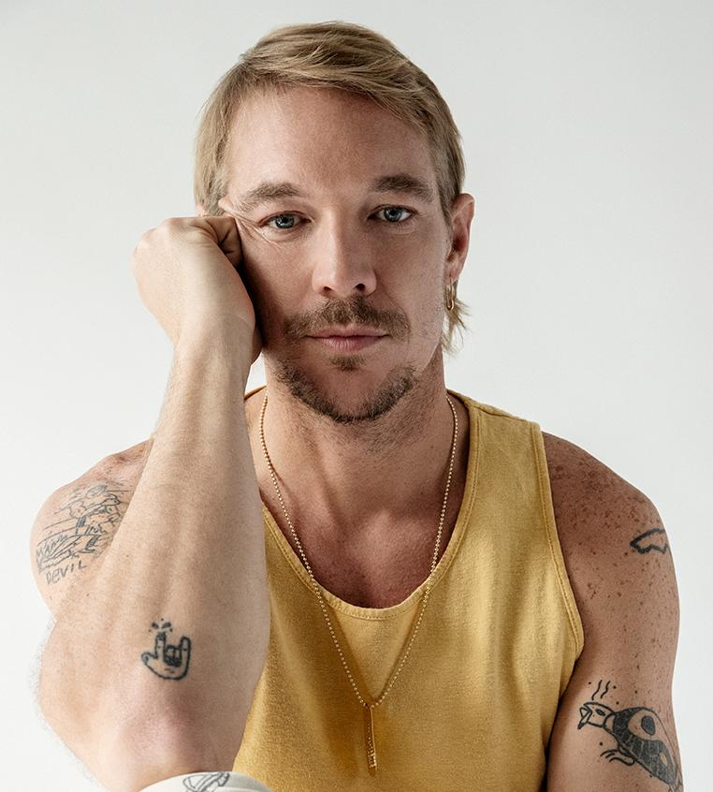

"Fred again... is on fire this year." - THE FADER

“It’s the search for authenticity that makes Fred again.. so exciting – and makes us reckon he could be the real deal.” - MIXMAG

"Fred again.. is solidifying himself as the producer of the moment and, quite possibly, the future" - LOUD & QUIET

“Fred again.. is a British artist taking a unique approach to his mesmerizing dance tracks” - PIGEONS & PLANES

“Listening to Fred again..’s music feels like you’ve stumbled onto something very personal. In many ways, his oeuvre is a diary with multiple authors. Fred again.. is the producer behind some of the UK’s biggest tracks in recent years can count Stormzy, Headie One, and Ed Sheeran as collaborators. But it’s how he collaborates with the world outside music that makes his sound especially visceral” - HIGH SNOBIETY

Few tracks have encapsulated the seismic impact the last 18 months has had on dance music culture better than Fred Again..’s single “Marea (We’ve Lost Dancing)”. Released in February, and featuring the voice of dance music icon Marea Stamper aka The Blessed Madonna on record for the very first time, the track is a eulogy to the dancefloor and to the things we used to take for granted. It’s simultaneously nostalgic, longing and hopeful with a sense of optimism best summed up in Marea’s own words on the record: “if I can live through this next six months / day by day / if I can live through this / what comes next will be… marvellous!”

Today it receives a remix from the internationally renowned DJ and producer Diplo. Lending his unique blend of stadium -sized house, the newly reworked version is sure to become a set-favourite on dancefloors across the globe as they begin to open up again.

STREAM / DOWNLOAD “MAREA (WE LOST DANCING) [Diplo Remix]” HERE

The remix follows the release of Fred again..’s acclaimed debut album. Titled “Actual Life (April 14 – December 17 2020)”, the album was released in April via again.. Records and features a collection of music released in his ‘Actual Life’ series: including “Julia (Deep Diving)”, “Jessie (I Miss You)” and “Kyle (I Found You)”. It’s a signature sound that sees him building tracks around vocals uncovered from the unlikeliest of sources; from obscure YouTube clips to personal FaceTime conversations, random Instagram accounts and iPhone video footage of half-remembered nights out

Over the last year, Fred has also added his production skills to tracks as diverse as Headie One, AJ Tracey and Stormzy’s “Aint It Different” and “Lifetime” the acclaimed debut solo single from The xx’s Romy. In 2020, he also released GANG, his project with Headie One that saw the two friends collaborating alongside features from some of the UK's most exciting and innovative artists including FKA twigs, Jamie xx, Sampha, Slowthai and Berwyn.

ABOUT DIPLO:

Born Thomas Wesley Pentz, Diplo is one of the most dynamic forces in music today. He is legend on his own; a member of the now iconic Major Lazer, which most recently released Music Is The Weapon, their first album in five years; one third of LSD, the psychedelic supergroup with Sia and Labrinth whose debut album has been streamed over three billion times; and half of Silk City with Mark Ronson, whose Platinum-certified “Electricity” with Dua Lipa topped charts worldwide and won a Grammy Award for Best Dance Recording.
The ten-time Grammy-nominated artist has worked closely with artists including Beyoncé, The Weeknd, Madonna and Bad Bunny; continues to helm his own long-running label Mad Decent and tours the world over. In 2020, Diplo debuted his first country album, Thomas Wesley Chapter 1: Snake Oil—now certified Gold—as well as his first ambient album, MMXX.
Diplo has recently refocused his efforts on Higher Ground, the deep house imprint he launched in 2019, with more music due imminently. The recently released "One By One" with Elderbrook and Andhim follows three US Dance #1s for Diplo and the label—the Grammy-nominated SIDEPIECE collaboration “On My Mind;” “Looking For Me” with Paul Wolford and Kareen Lomax; and “Turn Back Time” with Sonny Fodera.

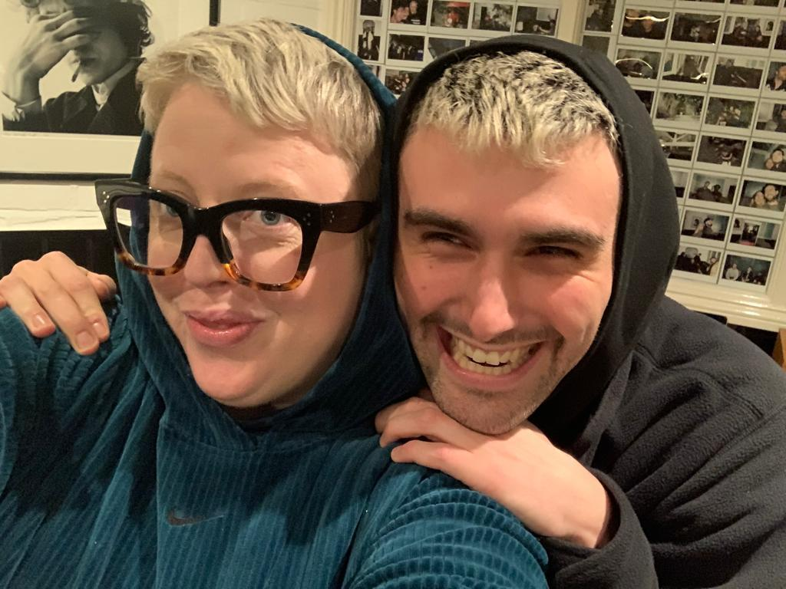

Fred again.. Instagram / Soundcloud

For press inquiries, please contact:
Kelly McWillaim // Kelly.McWilliam@atlanticrecords.com

