FOR IMMEDIATE RELEASE

MAY 3, 2022

**FRED AGAIN.. ANNOUNCES NORTH AMERICAN TOUR**

**NORTH AMERICAN TOUR DATES KICK OFF SEPTEMBER 23 IN SAN FRANCISCO AND INCLUDES STOPS AT LOS ANGELES’ FAMED HOLLYWOOD FOREVER CEMETERY + NEW YORK’S LEGENDARY TERMINAL 5**

**PRE-SALE REGISTRATION FOR TICKETS AVAILABLE NOW** [**HERE**](https://www.fredagain.com/tour/) **PRE-SALE BEGINS THURSDAY, MAY 5 + GENERAL TICKETS ON SALE FRIDAY, MAY 6**

**ANNOUNCEMENT FOLLOWS TWO INCREDIBLE SETS AT COACHELLA +**

**A SOLD-OUT SHOW AT LOS ANGELES’ FONDA THEATRE**

**NEW ACTUAL LIFE 2 PIANO EP (FEBRUARY 2 – OCTOBER 15 2021)’ AVAILABLE NOW** [**HERE**](https://fredagain.lnk.to/PianoEP2)

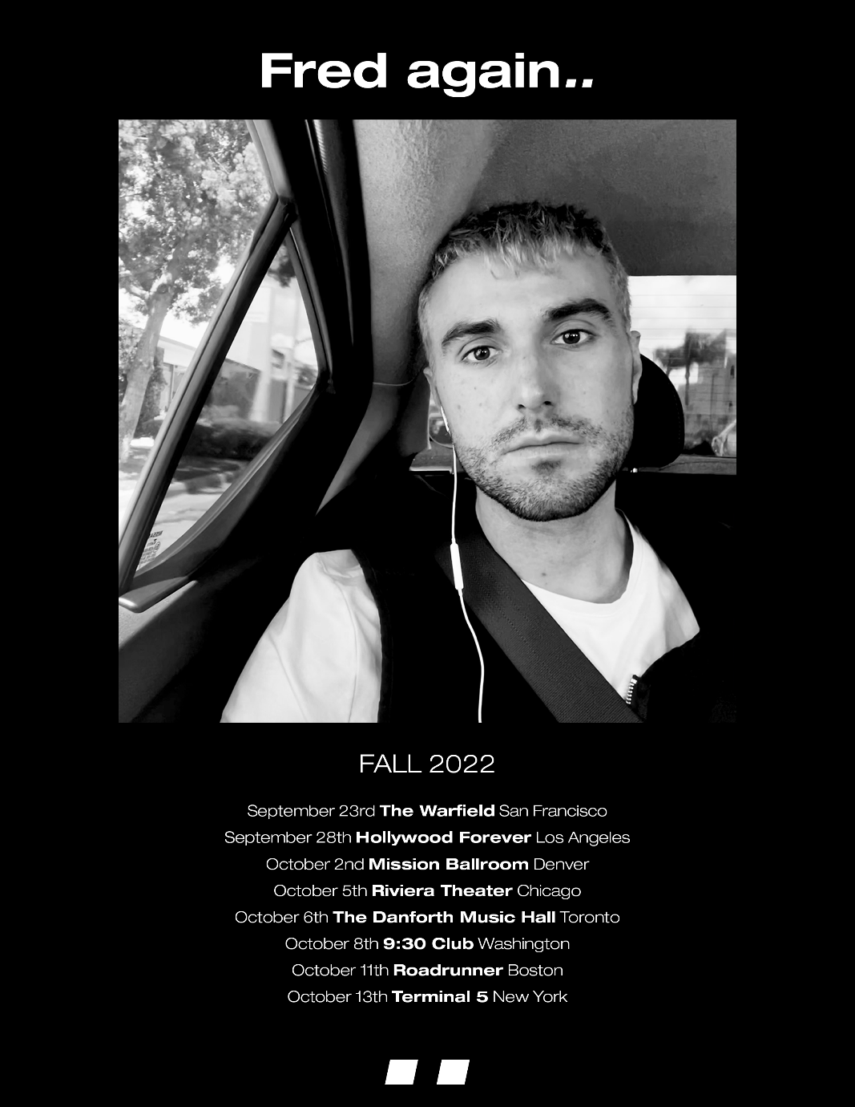

**Fred again..** has announced his first ever North American headline tour – kicking off Friday, September 23 in San Francisco, CA and including stops at Los Angeles’ Hollywood Forever Cemetery and New York’s Terminal 5. See full tour routing below. Pre-sale registration for tickets is available now [HERE](https://www.fredagain.com/tour/). Artist pre-sale begins Thursday, May 5 at 10AM local time and general tickets go on sale Friday, May 6 at 10AM local time. For all details and updates please visit, <https://www.fredagain.com/>.

The headline tour announcement follows two incredible performances at Coachella and a sold-out show at LA’s Fonda Theatre.Fred recapped his Coachella sets on his [Instagram](https://www.instagram.com/reel/Cci4-0yoCkb/?igshid=YmMyMTA2M2Y=) and [TikTok](https://www.tiktok.com/@fredagainagain/video/7088411124109987078?is_from_webapp=1&sender_device=pc&web_id=7086038133133723141) where you can see thousands of fans dancing outside of the completely packed tent. The electric sets were praised by Forbes which stated *“Fred again.. caught quite the Coachella buzz, and for good reason. The aesthetic of his vibrant set somehow perfectly encapsulated our collective nervous breakdown of the past two years and then set us all free.”* The sentiment was echoed by Ones to Watch which declared, *“Fred again.. delivers one of the best dance parties of the whole weekend.”*

The tour announcement also follows Fred again..’s stripped down project **Actual Life 2 Piano EP (February 2 – October 15 2021)’** – available now [HERE](https://fredagain.lnk.to/PianoEP2). Following this year’s earlier club-ready singles ‘Lights Out’ (w/ Romy & HAAi) and ‘Admit It (U Don’t Want 2) the project further highlights Fred’s musicianship and versatility as an artist.

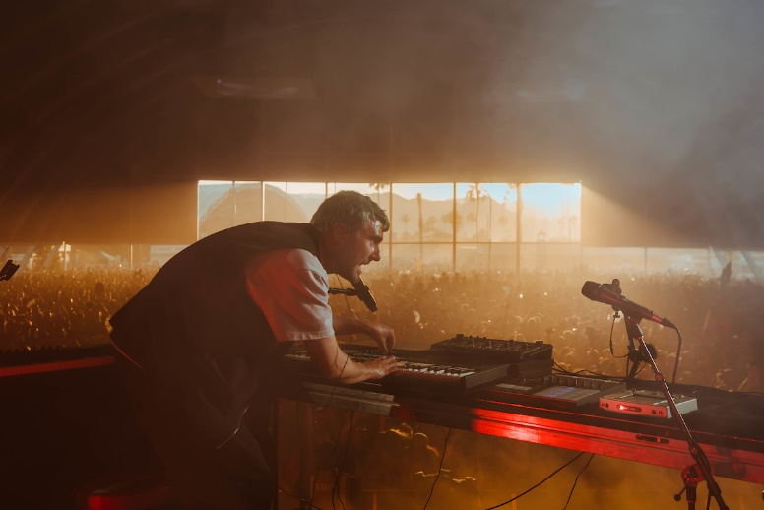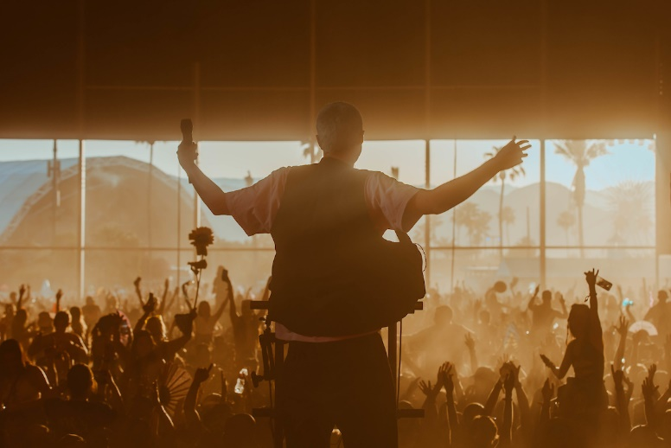

**Fred again.. North American Tour**

September 23rd - San Francisco, CA - The Warfield

September 28th - Los Angeles, CA - Hollywood Forever

October 2nd - Denver, CO - Mission Ballroom

October 5th - Chicago, IL - Riviera Theater

October 6th - Toronto, ON - The Danforth Music Hall

October 8th - Washington, DC - 9:30 Club

October 11th - Boston, MA - Roadrunner

October 13th - New York, NY - Terminal 5

**ABOUT FRED AGAIN..**

The prolific London-based artist, Fred again.., released two acclaimed, deeply personal albums in 2021 - his debut ‘[Actual Life (April 14 - December 17 2020)](https://nam04.safelinks.protection.outlook.com/?url=https%3A%2F%2Ffredagain.lnk.to%2FActualLife&data=04%7C01%7CMegan.Rasmussen%40atlanticrecords.com%7Cd4eef7b64494427aaa9208da1cc55482%7C8367939002ec4ba1ad3d69da3fdd637e%7C0%7C0%7C637853931101209693%7CUnknown%7CTWFpbGZsb3d8eyJWIjoiMC4wLjAwMDAiLCJQIjoiV2luMzIiLCJBTiI6Ik1haWwiLCJXVCI6Mn0%3D%7C3000&sdata=rapCbxRvyRYZMtZl01dNQ1pF6UTHV9cIRxtyrKtQiYI%3D&reserved=0)’ and its companion follow up ‘[Actual Life 2 (February 2 - October 15 2021)](https://nam04.safelinks.protection.outlook.com/?url=https%3A%2F%2Ffredagain.lnk.to%2FActualLife2-Presave&data=04%7C01%7CMegan.Rasmussen%40atlanticrecords.com%7Cd4eef7b64494427aaa9208da1cc55482%7C8367939002ec4ba1ad3d69da3fdd637e%7C0%7C0%7C637853931101209693%7CUnknown%7CTWFpbGZsb3d8eyJWIjoiMC4wLjAwMDAiLCJQIjoiV2luMzIiLCJBTiI6Ik1haWwiLCJXVCI6Mn0%3D%7C3000&sdata=nVWqyf2T6DmZxYFz9eVKO9jcjM8kjT7XPiQOTNUKzhk%3D&reserved=0).’ The projects were beloved by fans and saw widespread critical acclaim by the likes of Rolling Stone, FADER, Pitchfork, HYPEBEAST, HighSnobiety and more. The albums were also included on many coveted “best of the year” lists including Billboard, NPR, Forbes, Ones to Watch and more. Fred rounded off the year with a 2022 GRAMMY nomination and BRIT Awards nomination.

Fred again.. has quickly become one of the year's most talked about live acts as he transformed his Actual Life records into an immersive, communal real-life experience for the first time. With his headline shows selling out instantly, Fred will continue bring his live show to markets across the world in addition to festival appearances at the likes of Coachella, Primavera, Melt, Way Out West, Rock En Seine and All Points East.

“2021 breakout star Fred again.. keeps the white hot momentum*”* **- BILLBOARD**

"Fred again... is on fire this year." - **THE FADER**

“Fred again..’s second album beautifully chronicles snapshot moments of life while also examining the grief the artist faced following the death of a loved one…”**– FORBES**

“It’s the search for authenticity that makes Fred again.. so exciting – and makes us reckon he could be the real deal.” - **MIXMAG**

 “Fred again.. is a British artist taking a unique approach to his mesmerizing dance tracks” - **PIGEONS & PLANES**

“Listening to Fred again..’s music feels like you’ve stumbled onto something very personal. In many ways, his oeuvre is a diary with multiple authors. Fred again.. is the producer behind some of the UK’s biggest tracks in recent years can count Stormzy, Headie One, and Ed Sheeran as collaborators. But it’s how he collaborates with the world outside music that makes his sound especially visceral” - **HIGH SNOBIETY**

“If you're looking for a transcendent dance experience or simply for a new friend to dance with, look no further than Fred Again..” **– ONES TO WATCH**

“Fred again..’s growing body of work seems to strike a chord with a generation that broadly tends to gravitate towards digital social grounds more than its predecessors.”**- DANCING ASTRONAUT**

**Fred again..** [**Instagram**](https://www.instagram.com/fredagainagainagainagainagain/?hl=en) **/** [**TikTok**](https://www.tiktok.com/@fredagainagain?lang=en) **/** [**Soundcloud**](https://soundcloud.com/fredagain)

**For press inquiries, please contact:**

Kelly McWilliam / [Kelly.McWilliam@atlanticrecords.com](mailto:Kelly.McWilliam@atlanticrecords.com)