FOR IMMEDIATE RELEASE
JANUARY 20, 2022

FRED AGAIN.., ROMY AND HAAi COLLABORATE
ON NEW TRACK “LIGHTS OUT”

THE FIRST IN A SERIES OF MONTHLY FRED AGAIN.. CLUB-FOCUSED COLLABORATIONS

PROLIFIC PRODUCER NOMINATED AT 2022 GRAMMYS
+ PLAYING COACHELLA

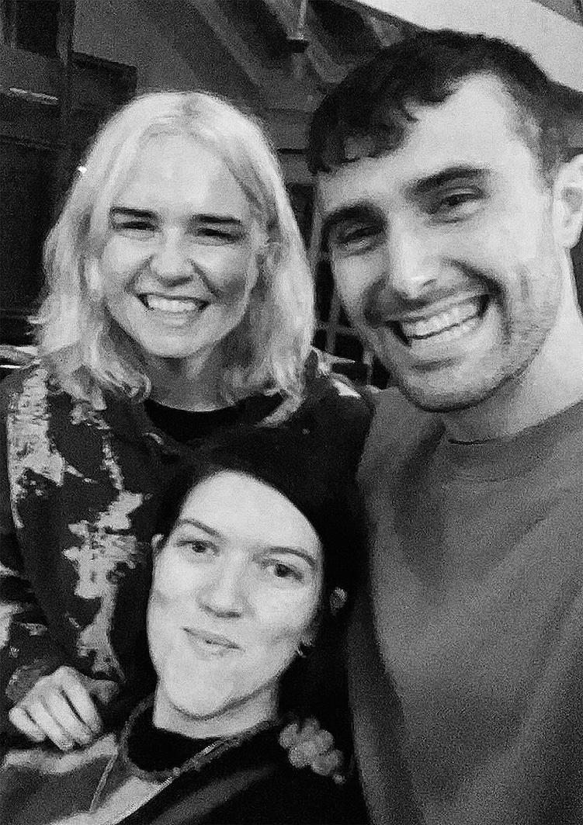
(high res photo here)

Today – Thursday, January 20th - Fred again.., Romy and HAAi come together for the release of new single “Lights Out”. A product of friendship and mutual artistic admiration, “Lights Out” is the first time the three artists have collaborated on a track (though they previously aligned on Romy’s 2020 debut solo single “Lifetime”, which Fred co-produced and HAAi remixed).

Part-inspired by a shared night out at the Warehouse Project at the end of 2019 (where HAAi performed), "Lights Out" was in part created with the aim of it becoming a song that each individual artist could end their sets with at the world famous Manchester clubbing institution and beyond. It's a track that's evolved over time; from an unheard song Romy wrote with The xx in mind to Fred creating the genesis of the final track on a train journey to the Scottish Highlands and HAAi road testing work-in-progress mixes during DJ appearances in late 2021. With the trio working together remotely and together in the studio throughout 2021, "Lights Out" sees the three artists pushing each other into fresh musical territory to brilliant effect. It's also the first in a run of Fred again.. artist collaborations that will see him joining forces with some of the most exciting names in electronic music for a series of monthly releases.

Talking about “Lights Out”, Fred again.. says: "I started this song on my laptop on a train up to the Scottish Highlands and immediately sent it to Romy and Teneil (HAAi) because it felt super special to me. Romy's lyrics and voice are just like a hug from a rave angel."

While HAAi adds: "I enjoyed every step of the process of making this track with Romy and Fred. Romy and I have been close pals for a while and shared a studio last year and had been wanting to work on something beyond my remix of ‘Lifetime’. I feel this track represents a special part of each of our musical selves. Fred is one of the most energetic and wildly talented people I’ve been in a studio with. This really was a dream collaboration"

Romy adds: "I’m so excited about this song - it came about really effortlessly and evolved so quickly. I first met Fred and Teneil through making music and DJing, as well as being big inspirations they’ve become 2 of my best friends. Working together with them was so joyful and I think you can really feel that when you listen to Lights Out"

LISTEN TO “LIGHTS OUT” HERE

About Fred again..:

It's fair to say that 2021 was an incredible year for Fred again.. The prolific London artist released two acclaimed, deeply personal albums - his debut ‘Actual Life (April 14 - December 17 2020)’ and its companion follow up ‘Actual Life 2 (February 2 - October 15 2021)’ - which were beloved of fans and critics alike and heralded by the likes of Billboard, Fader, NME and NPR as one of the year's best. Meanwhile Fred rounded off the year with a 2022 GRAMMY Award nomination and BRIT Awards nomination in the "Best Dance Act" category.

2021 also saw Fred again.. become one of the year's most talked about live acts as he transformed his Actual Life records into an immersive, communal real-life experience for the first time. With shows selling out across the UK and USA, he was named one of Mixmag's "Top 10 Live Acts Of 2021". 2022 will see Fred continue on his upwards trajectory with festival appearances already announced for the summer at the likes of Coachella, Primavera, Melt, Way Out West, Rock En Seine and All Points East.

About Romy:

First coming to prominence as one third The xx, Romy released her debut solo single "Lifetime" in 2020. It's a song that combines Romy's love of yearning, emotional club music with timeless, classic songwriting and perfectly captured the giddy euphoria of being together again post-lockdown. It was also the first glimpse of her highly anticipated debut album.

Having co-written The xx’s three acclaimed albums, Romy has also written songs for the likes of Mark Ronson, Jehnny Beth, Benny Blanco and Dua Lipa (including her GRAMMY winning hit single “Electricity”). At the same time as honing her craft as a songwriter, Romy has embraced a burgeoning DJing career. DJing since the age of 17 (when she got her first job playing records at a gay club in Soho), the last couple of years have seen her passion reignited, including appearances at Manchester’s Homobloc, Turin’s Club to Club, London's All Points East and a closing set at last year’s Pride Inside for Amnesty. She was also a key contributor to 2019’s BBC Radio 1 Residency series.

About HAAi:

Following a prestigious two-year residency at London’s Phonox that put her on the map as one of the country’s most talked about DJs as well as an early BBC Radio 1 Essential Mix of The Year win (previous alumni include Helena Hauff, Caribou, Flying Lotus and Nicolas Jaar) and Radio1 residency, singer, producer and DJ HAAi aka Teneil Throssell signed to legendary label Mute in 2019. Her first project on the label, 2019’s Systems Up, Windows Down, received acclaim across the board and was described by The Observer as “a bolshy collection of vibrant face-melters, taking in big-room breaks, shards of trance, playful samples inspired by her travels and punishing beats that could crack bones under a strobe light at 6am”. The project was quickly followed by a four-track EP Put Your Head Above the Parakeets last year which was rapturously received for its ability to push boundaries with its exploration and experimentation of new sounds and textures.

With two highly acclaimed projects under her belt, Teneil has already cemented her reputation as one of the most differentiated and exciting new voices in contemporary electronica. Along the way, she’s collaborated with heavy hitters such as Daniel Avery, The Chemical Brothers, Romy & Fraser T Smith, contributed the track Good Ol’Fashioned Rugs to Jayda G’s recent DJ-Kicks, played B2B sets with the likes of The Blessed Madonna, Mall Grab, Jayda G, Daniel Avery and headlined both her own sold-out show at Village Underground and the dance stage at this year’s All Points East. Along the way, HAAi has found the time to bring her cutting edge sets to festivals such as Primavera, Glastonbury, Sonar, Field Day, iconic dance institutions like Circo Loco and Printworks and most recently, Prada Extends at The Tate.

More on:
Fred again.. OFFICIAL SITE / INSTAGRAM

Romy OFFICIAL SITE / INSTAGRAM / TWITTER

HAAi: INSTAGRAM / TWITTER / FACEBOOK

For publicity inquiries, please contact:
Kelly McWilliam // Kelly.Mcwilliam@atlanticrecords.com

