FOR IMMEDIATE RELEASE
JULY 8, 2022

GARRETT NASH RELEASES EMOTIONAL NEW TRACK,
“MONEY, LOVE & DEATH”

MULTI-PLATINUM SINGER-SONGWRITER FORMERLY KNOWN AS gnash PENS AN ODE TO HIS FATHER
CO-WRITTEN AND CO-PRODUCED BY SEAN KENNEDY

LISTEN TO “MONEY, LOVE & DEATH” HERE

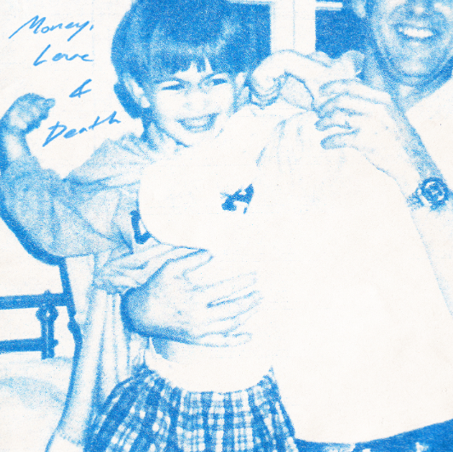
DOWNLOAD ARTWORK | DOWNLOAD PRESS PHOTOS

6x RIAA platinum certified Atlantic Records/Overall Recordings artist Garrett Nash has teamed up with renowned producer Sean Kennedy for the emotional acoustic track, “Money, Love & Death” – available everywhere now HERE.

“My Dad only really wants to talk about 3 things - “Money, Love & Death”, says Nash of the new single, “When Sean Kennedy played me this song I knew I needed it on my album. As we were cutting it, which took about 30 minutes total, he recalled that he had written the song 3 years prior, way before we were friends, as a response to a challenge from his publisher to “write something gnash would like”, but since had been struggling to finish it for his project, so then we knew it was a match made in song heaven. I have a fantastic relationship with my Dad & I know not everyone does but either way, we can all connect with people we love leaving us. Dying doesn’t happen to you, it happens to your family & friends.”

“The idea for ‘Money, Love & Death’ came from a phone call I had with my Dad where we talked about the weather and the economy and a bunch of other things that felt pretty meaningless,” says Kennedy, “I was desperate to tell him how much I loved him but I couldn’t find the right moment. I showed him the song idea the next day. he said he liked it, then asked me how the weather was…”

The new track follows a string of ethereal releases from Nash including his collaboration with Canadian singer/songwriter and 7x JUNO nominee Scott Helman, “Where The Sidewalk Ends,” the wistful, “The Middle Of Nowhere,” a nostalgic cover of his favorite childhood song, “Stacy’s Mom,” as well as three irresistible singles – the self-reflective, “Super Glue,” the touching ode to Nash’s upbringing in Los Angeles, “Palm Trees,” and a thoughtful collaboration with American rapper Shwayze, “Breathe In.” These recent tracks marked a new direction from the singer-songwriter formerly known as gnash. The name change reflects his remarkable growth as both an individual and artist over the past decade.

Photo Credit: Jimmy Fontaine
DOWNLOAD PRESS PHOTOS

ABOUT GARRETT NASH
Having won worldwide applause and triumphant popular success under his gnash moniker, Garrett Nash now takes a more matured, deeply personal approach to his genre-blurring brand of modern pop. gnash made his global breakthrough with 2016’s multi-platform blockbuster hit single, “i hate u, i love u.” The stripped-bare track reached the top 10 on Billboard’s “Hot 100” – where it spent an impressive 39 weeks – and singles charts around the world, earning 6x RIAA platinum certification and more than 2B global streams. Furthermore, the “i hate u, i love u” companion video is an unadulterated blockbuster, now with over 650M individual views via YouTube alone.

Along with his world-straddling popular success, gnash began receiving rapt attention from worldwide media, drawing critical acclaim from such top tier publications as the New York Times, Entertainment Weekly, Billboard, Vogue, and NYLON, to name but a few. 2019 saw gnash follow a series of EPs with his RIAA gold certified full-length debut album, we, drawing praise from such outlets as The Guardian for its “highly intimate confessionals about doubt, anxiety and insecurity…the combination of charming tunes and humbling insights are truly lovely.”

As charming and idiosyncratic on stage as in the studio, gnash traveled North America on a number of tours, including 2019’s 40-date “the broken hearts club tour,” while also finding time for high-profile TV performances on NBC’s TODAY and Late Night with Seth Meyers. A strong advocate for mental health, gnash has long been open about his struggles, publicly acknowledging the benefits of therapy while also encouraging fans to find their own unique way to express themselves.

CONNECT WITH GARRETT NASH
WEBSITE | TWITTER | INSTAGRAM | FACEBOOK | YOUTUBE | TIKTOK

For press inquiries, please contact:
Jessica Nall // Jessica.Nall@atlanticrecords.com

