FOR IMMEDIATE RELEASE

PRESS CONTACT:
Amanda Edwards, Assoc. Director of Communications
communications@inner-cityarts.org
213 627 9621 x 197

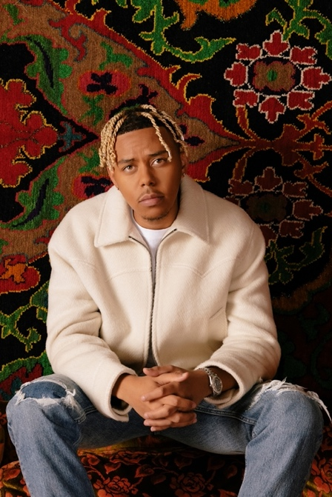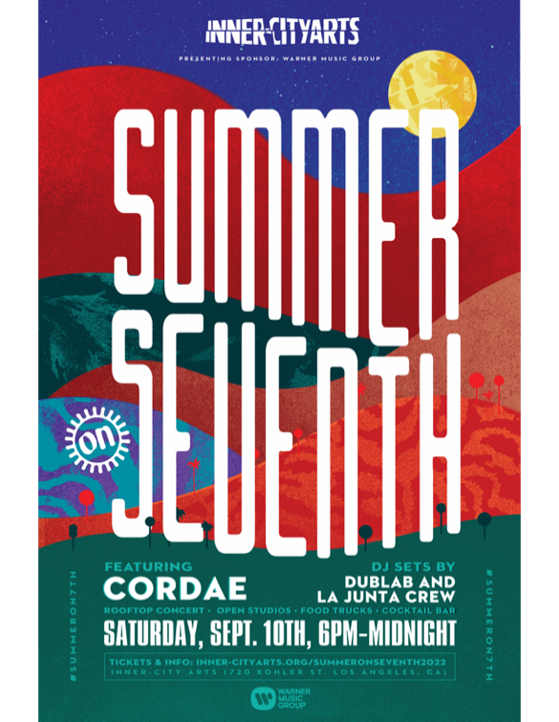

Multiplatinum Artist Cordae to Headline
Inner-City Arts Event “Summer On 7th,” Sept. 10

LOS ANGELES, Calif. (July 2022) — Grammy-nominated rapper and ART@WAR/Atlantic Records artist Cordae will headline “Summer on 7th,” Inner-City Arts’ tentpole fundraising event that is set to take place on Saturday, Sept. 10th in the heart of Downtown Los Angeles (DTLA).

The Inner-City Arts campus, a creative oasis of learning, achievement, and creativity in the heart of Skid Row, will host the dazzling event for the first time since 2019. With rooftop performances from world-renowned artists, local restaurants offering the best in LA food and beverage, and abundant opportunities to explore the Inner-City Arts studios, create your own artwork, and engage with local artists showcasing their work, the party and benefit will light up the Downtown Arts District with the nonprofit’s signature creative spirit.

Summer On 7th will be a night of inspiration packed with artistic talent, bringing the whole community together in support of the best arts programming for our city’s youth. In an ideal match of artist and arts organization, Cordae and ICA are both celebrating boundless new creativity, as Cordae gets ready to embark on his “From a Birds Eye View” UK/Europe Tour later in September, while Inner-City Arts jumps back into in-person programming for thousands of Los Angeles Unified School District students and families on its own campus and at district school sites.

Atlantic Records West Coast President, Kevin Weaver, said: “At Warner Music Group, we believe that every young person should have easy access to high quality music programs, and Inner-City Arts aligns perfectly with our goal of supporting local organizations that have an immeasurable impact on the students in our community. Cordae also values youth arts education, and we’re incredibly grateful to have him support the ICA community with a headlining performance at Summer on 7th!”

Inner-City Arts CEO and President Shelby Williams-González echoes that passion for encouraging artistic expression in the world. “I’m thrilled to have Cordae as our headliner. He’s activating our campus space with an ingredient of energy that will have a ripple effect on our programs and reintroduce our physical location as an artistic center for LA residents as a whole,” she says after ICA’s two years of remote programming. “This campus—its studios, gardens, and theater—are not only for our youth to learn, but a place for creativity for the entire community, regardless of your age.”

Other features of Summer On 7th include DJ sets by dublab and La Junta Crew, exhibits by emerging young artists, a celebration of new works by local established artists, hands-on activities in multiple studios, and a wide array of food vendors and beverage options.

EVENT DETAILS: Summer On 7th will take place on Saturday, September 10 from 6 PM to 12 AM. Tickets are currently available for $55 at: https://inner-cityarts.org/summeronseventh2022. Tickets and food/drink packages may also be purchased in-person the night of the event on our campus at 720 Kohler Street, Los Angeles, CA 90012. Valet parking will be at the corner of Merchant St. and 7th St. Rideshare drop-off at the main entrance at Kohler St. and 7th St.

PRESENTING SPONSOR: Warner Music Group
Friends of the Arts: Alison Miller / Reel Estate Partners

###

ABOUT INNER-CITY ARTS
Founded in 1989, Inner-City Arts is a learning oasis in the heart of Downtown Los Angeles. Under the guidance of professional teaching artists, Inner-City Arts’ students are immersed in a safe and supportive environment where they may engage in a variety of visual, media, and performing art forms in a virtual studio setting. Services include core classes during the instructional day for grade K-8 students, after-school and weekend workshops for teens, and creativity based professional development training for educators. Children who attend Inner-City Arts develop skills that are highly valued in the 21st century workforce such as collaboration, creativity, and critical thinking.

INNER-CITYARTS.ORG
Follow us on Instagram / Facebook / Twitter

ABOUT CORDAE
Cordae knows exactly what he wants to say. He chooses his words and phrases carefully. He speaks from a place of truth. That’s why the two-time GRAMMY® Award-nominated gold-selling Maryland-raised rapper has quietly become one of the modern generation’s most trusted narrators. A remarkable life has given him a lot to say. He went from trailer parks and public housing with his mom to stratospheric success. After a series of buzzing singles, he reached critical mass with his 2019 full-length debut, The Lost Boy. It bowed in the Top 15 of the Billboard Top 200 and included four gold-certified singles— “RNP” [feat. Anderson .Paak], “Have Mercy,” “Broke As Fuck,” and “Kung Fu.” Beyond unanimous praise from Billboard, Complex, High Snobiety, New York Times, Pitchfork, and Stereogum, he garnered a pair of GRAMMY® Award nominations in the categories of “Best Rap Album” for The Lost Boy and “Best Rap Song” for “Bad Idea” [feat. Chance the Rapper]. He’s the rare artist whose presence can be felt on-screen in a Super Bowl commercial alongside legendary Academy® Award-winning director Martin Scorsese and among XXL’s coveted “Freshman Class.” Along the way, he linked up with Roddy Ricch and Ant Clemons for “Gifted” as well as joining forces with Eminem for “Killer.” Absorbing wisdom from a life-changing trip to Africa, enduring the loss of a friend gone too soon, and evolving as an artist and a man, he tells this story in widescreen technicolor on his 2022 second full-length offering, From A Birds Eye View [ART@WAR/Atlantic Records]. Cordae followed up the release of his sophomore album with the Facebook exclusive premiere of his visual only, From A Birds Eye View (Live) album.

CONNECT WITH CORDAE
INSTAGRAM | YOUTUBE | TWITTER | FACEBOOK

ABOUT WARNER MUSIC GROUP
With a legacy extending back over 200 years, Warner Music Group (WMG) today brings together artists, songwriters, and entrepreneurs that are moving entertainment culture across the globe.

Operating in more than 70 countries through a network of affiliates and licensees, WMG’s Recorded Music division includes renowned labels such as 300 Entertainment, Asylum, Atlantic, Big Beat, Canvasback, Elektra, Erato, First Night, Fueled by Ramen, Nonesuch, Parlophone, Reprise, Rhino, Roadrunner, Sire, Spinnin’, Warner Records, Warner Classics, and Warner Music Nashville.

WMG’s music publishing arm, Warner Chappell Music, has a catalog of over one million copyrights spanning every musical genre, from the standards of the Great American Songbook to the biggest hits of the 21st century.

Warner Music Group is also home to ADA, the independent artist and label services company – as well as next gen artist services division WMX, which includes consumer brands such as Songkick, the live music app; EMP, the merchandise e-tailer; UPROXX, the youth culture destination; and HipHopDX, the hip-hop music news site. In addition, WMG counts storytelling powerhouse Warner Music Entertainment and social media content creator IMGN among its many brands.

Follow WMG on Instagram, Twitter, LinkedIn, and Facebook.

