SYMBA UNLEASHES “DON’T CONDONE 2”

BAY AREA NATIVE TO MAKE NATIONAL LATE-NIGHT TELEVISION DEBUT ON JIMMY KIMMEL LIVE!
SET TO AIR TOMORROW, FRIDAY JUNE 10 AT 11:35PM ET ON ABC

NEW PROJECT ‘RESULTS TAKE TIME’ DUE OUT THIS SUMMER

ACCOMPANIED BY OFFICIAL MUSIC VIDEO DIRECTED BY TOPANGA HILLS MAFIA

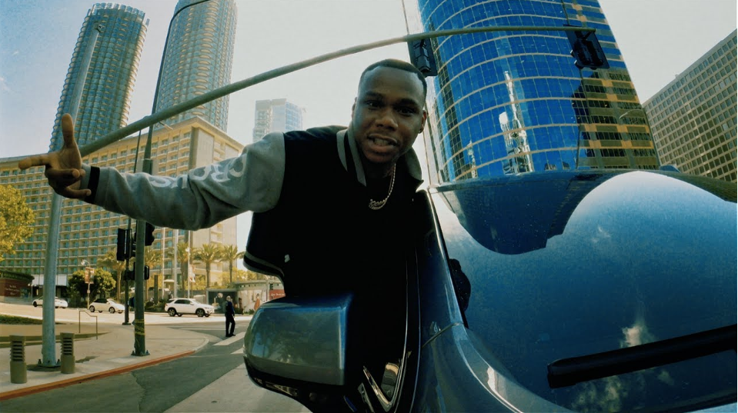
DOWNLOAD/STREAM "DON'T CONDONE 2"
DOWNLOAD/STREAM “DON’T CONDONE”

WATCH HERE

PRESS CONTACT:
JASON DAVIS | JASON.DAVIS@ATLANTICRECORDS.COM

CONNECT WITH SYMBA:
INSTAGRAM | TWITTER | FACEBOOK | YOUTUBE | WEBSITE


DOWNLOAD PRESS PHOTOS HERE

# # #

