SYMBA RELEASES “NEVER END UP BROKE”
PRODUCED BY DEM JOINTZ AND DR. DRE

NEW PROJECT ‘RESULTS TAKE TIME’ DUE OUT THIS SUMMER

LATEST SONG FROM BAY AREA-NATIVE ARRIVES ON THE HEELS OF
NATIONAL LATE-NIGHT TELEVISION DEBUT ON JIMMY KIMMEL LIVE! EARLIER THIS MONTH

DOWNLOAD/STREAM “NEVER END UP BROKE”

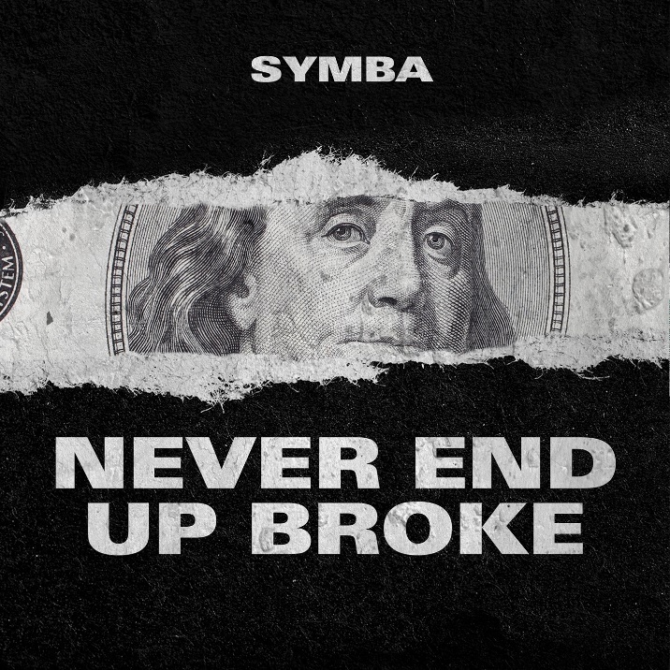
DOWNLOAD ARTWORK HERE

DOWNLOAD/STREAM “DON'T CONDONE 2"

DOWNLOAD/STREAM “GOAT”
WATCH SYMBA’S CHARLIE SLOTH FREESTYLE

* * *
PRESS CONTACT:
JASON DAVIS | JASON.DAVIS@ATLANTICRECORDS.COM

CONNECT WITH SYMBA:
INSTAGRAM | TWITTER | FACEBOOK | YOUTUBE | WEBSITE

DOWNLOAD PRESS PHOTOS HERE

# # #

