FOR IMMEDIATE RELEASE
JANUARY 12, 2022

TRAETWOTHREE IS BACK WITH FIRE NEW SINGLE + VISUAL “DONE DONE”
STREAM HERE
WATCH HERE

SECOND TRACK RELEASE VIA NCREDIBLE / ART@WAR / ATLANTIC RECORDS

“TraeTwoThree is a fresh new voice in R&B. Yet, I have the same feeling about him as I did when I found Kehlani.”
– Nick Cannon, Ncredible Founder / CEO

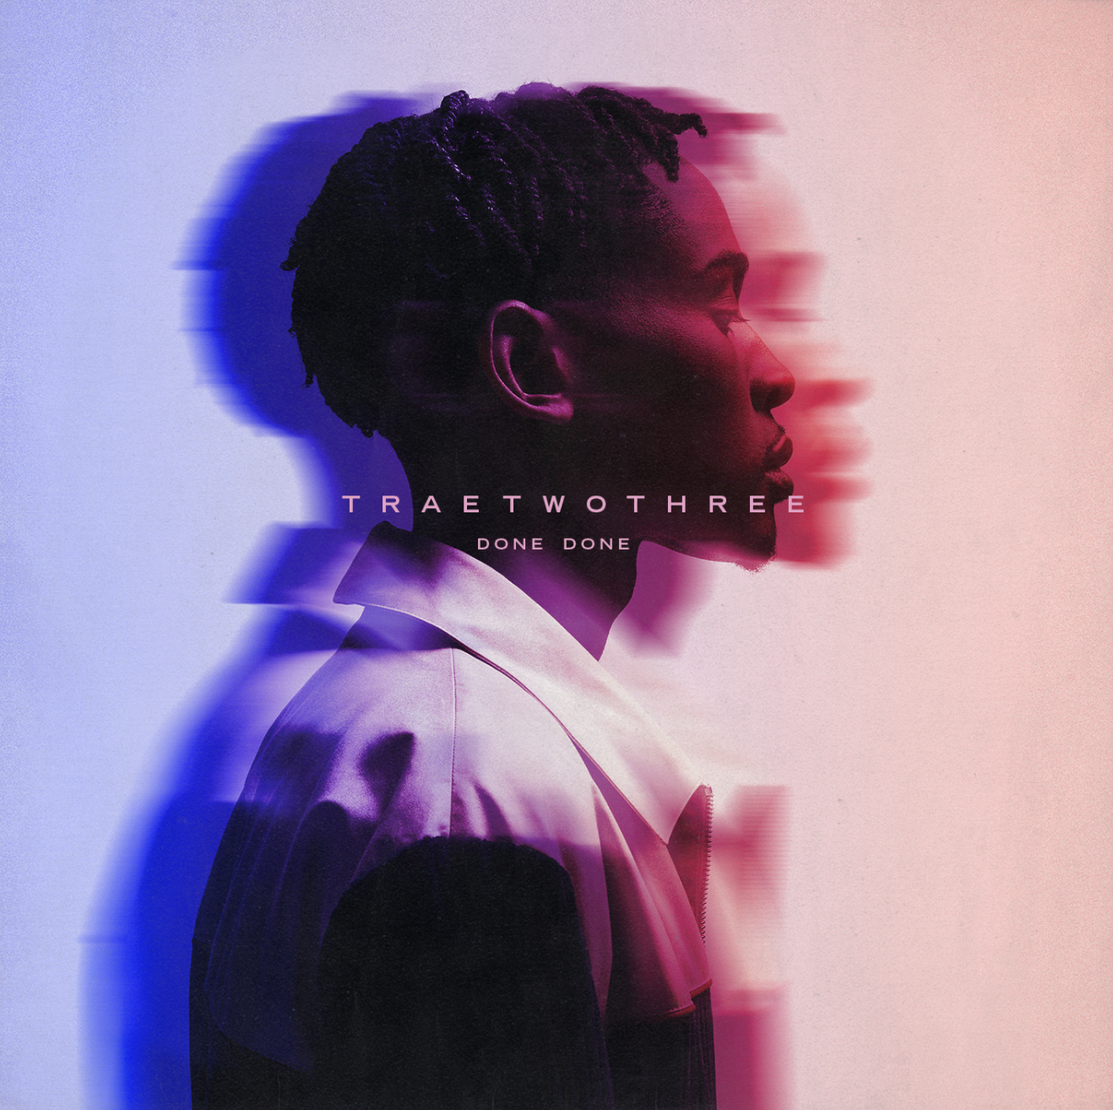
DOWNLOAD ARTWORK | DOWNLOAD PRESS PHOTOS, CRED: JIMMY FONTAINE

“Done Done” is the latest release from Ncredible / Art@War / Atlantic Records artist TraeTwoThree. “Done Done” drops alongside a beautiful visual, directed by Adam Taylor that features Trae pleading with a departing lover set against a desert backdrop and begging the question, “If another one comes along what would you do?” Produced by Retro1, this is the second single off the South Central artist’s forthcoming debut EP. “Done Done” quickly follows the release of his label debut, “Worth It” ft. DDG. The official visual, directed by Adam Taylor, is fast approaching 400k views! It was important for the LA artist to tap buzzing Michigan rapper DDG, AKA PontiacMadeDDG (“Arguments”, “Moonwalking in Calabasas”) to add some additional layers to this flavorful bop. TraeTwoThree presents an unheard-of melodic interpolation of his love for music inspired by the laid-back feel one gets while cruising through the streets of LA. On “Worth It”, he effortlessly fuses dusky R&B with hip-hop swagger all rolled into that West Coast vibe, ultimately creating his own unique sound.

TraeTwoThree shows a different side of the South Central story in his music. After the divorce of his parents, he bounced back and forth between his mom, dad, and grandmother who lived just off Crenshaw Boulevard. Mom did real estate, and dad worked in the medical field, specializing in MRIs. As Jehovah’s Witnesses, both parents imparted spirituality upon their son, while encouraging music. Pops played saxophone, and TraeTwoThree followed suit, honing his chops on the instrument throughout middle school. As such, he listened to everyone from Gerald Albright, David Sanborn, and Candy Dulfer to Tank, Tyrese, Erykah Badu, and, of course, The Isley Brothers. Discovering Drake, J. Cole, and Nipsey Hussle, he picked up his first used microphone and downloaded Pro Tools at 16-years-old. He spent countless hours writing and recording in his bedroom. A chance encounter eventually changed everything. Holding down a part-time job at Dick’s Sporting Goods, he helped out members of Team Ncredible with Air Jordan sneakers one day and got to talking. They listened to his demos and invited him to the studio. Three months later, he met Nick Cannon. “TraeTwoThree is a fresh new voice in R&B. Yet, I have the same feeling about him as I did when I found Kehlani,” says Cannon.

Between dropping “4am In The District” and “High Tec,” he inked a deal with Ncredible / Art@War / Atlantic Records, catching the attention of ART@WAR label head, James McMillan. Rising up out of Los Angeles, he pays homage to his roots through both music and name (Trae = 3, TwoThree = 23; 323 = LA area code).

“My music sounds like South Central at nighttime,” he explains. “That’s the vibe I want to give people. If I’m going out after dark, I’m linking up with the homies and maybe some girls. We’re hanging out and living. It’s a different perspective. I’m not just singing about the streets. To me, it’s all love.”

PRESS CONTACT
FAIRLEY MCCASKILL | FAIRLEY.MCCASKILL@ATLANTICRECORDS.COM

