FOR IMMEDIATE RELEASE
JUNE 1, 2022

VANCE JOY SHARES “EVERY SIDE OF YOU”

POIGNANT NEW TRACK ARRIVES AHEAD OF HIGHLY ANTICIPATED FORTHCOMING ALBUM,
IN OUR OWN SWEET TIME

LISTEN TO “EVERY SIDE OF YOU” HERE
WATCH OFFICIAL MUSIC VIDEO HERE

MULTI-PLATINUM GLOBAL POP SUPERSTAR’S THIRD STUDIO ALBUM
ALSO INCLUDES GLOBAL SMASH “MISSING PIECE” & RISING ALTERNATIVE RADIO SINGLE “CLARITY”

LONG-AWAITED NORTH AMERICAN LIVE SHOWS CONTINUE THIS WEEK
WITH SOLD-OUT SHOWS IN NASHVILLE AND NEW YORK CITY

ALBUM RELEASE TO BE CELEBRATED WITH LIVESTREAM FROM
SOLD-OUT TORONTO SHOW ON JUNE 9 [TIMING ENCLOSED BELOW]

SET TO PERFORM “CLARITY” ON THE TODAY SHOW MONDAY, JUNE 6TH

IN OUR OWN SWEET TIME ARRIVES EVERYWHERE FRIDAY, JUNE 10
PRE-ORDERS AVAILABLE NOW HERE

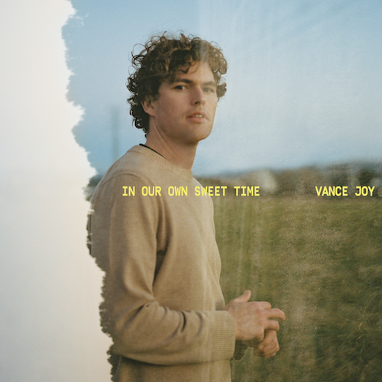
(DOWNLOAD HI-RES ARTWORK)

Multi-platinum singer-songwriter Vance Joy has shared his emotionally charged new track, “Every Side of You,” out today via Atlantic Records (listen). The track arrives alongside an equally poignant official music video, directed by Bill Bleakley (watch). “Every Side of You” heralds Joy’s highly anticipated third studio album, In Our Own Sweet Time, arriving everywhere on Friday, June 10th; pre-orders are available now HERE.

Now boasting over 5 billion worldwide streams and counting, Joy will celebrate In Our Own Sweet Time with an exclusive network television performance on The TODAY Show, set for Monday, June 6th (check local listings).

On Thursday, June 9th, Joy will perform a sold-out show at Toronto’s Budweiser Stage to an audience of over 17K people. In celebration of the album release that evening at midnight, the show will also be livestreamed – with fans around the world able to tune in HERE for a high-energy live performance of new tracks and old favorites alike.

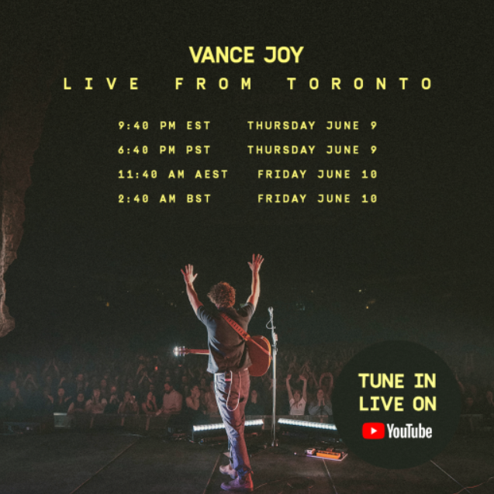
download hi-res graphic

Joy’s most creatively inventive and personal project thus far, In Our Own Sweet Time includes his recently released track “Clarity,” produced and co-written with GRAMMY® Award-winning songwriter Joel Little (Lorde, Taylor Swift) and joined by an official music video streaming HERE.

“Clarity” is fast proving another landmark success for Joy, currently ascending the top 25 at Alternative radio outlets nationwide after amassing critical acclaim from the likes of Rolling Stone and V Magazine, which raved, “‘Clarity’ is bubbly and bright…Groovy bass, sharp drums, and Joy’s usual guitar blend together with uplifting horn solos to create the perfect summer tune.” “The new track adds a world of depth to the folky indie-pop slant of Joy’s earlier material,” agreed NME, “supplementing his cool and cruisy acoustic strumming with deep bass grooves, crisp and lowkey yet duly impactful drums, and a soaring horn section.”

In Our Own Sweet Time also includes hit singles, “Missing Piece” and “Don’t Fade,” the latter of which arrived earlier this year and quickly earned more than 10 million worldwide streams alongside praise from Rolling Stone, Entertainment Tonight, and more.

Currently certified RIAA Gold in the US and 2x Platinum in Australia, “Missing Piece” proved a global sensation following its 2021 world premiere on ABC’s Grey’s Anatomy. Reaching #2 at Alternative radio, the single has gone on to earn over 130 million global streams as well as a massive 3 billion TikTok views (with 2.6 million user-created videos). Official music videos for both tracks are streaming now at YouTube HERE.

Recorded largely over the course of lockdown, In Our Own Sweet Time is fueled by old friends, new memories and finding love in a not-so-hopeless place. The eagerly awaited new album includes collaborations with hitmakers such as Little, Dan Wilson (Adele, Leon Bridges), Take a Day Trip (Miley Cyrus, Lil Nas X), and more.

“I’m always drawn to the idea of timelessness or that shared moment that takes you out of the chaos outside,” Joy says. “If the world is crazy, you can retreat somewhere. It’s always hard to think of the right title but I think that sums up the album perfectly.”

Having toured the world with Taylor Swift and P!nk – and made show-stopping festival appearances at Coachella, Firefly and Austin City Limits – Joy recently made his long awaited return to North American stages with performances at BeachLife Festival and BottleRock in California.

This week, he will perform a pair of sold out headline performances at Nashville TN’s historic Ryman Auditorium (June 2) and New York City’s Pier 17 (June 4). A full scale “In Our Own Sweet Time Tour” is set to travel the globe in 2023, with complete dates to be announced soon. For updates and ticket information, please visit www.vancejoy.com/tour.

(DOWNLOAD HI-RES IMAGE // PHOTO CREDIT: CELINA MARTINS)

VANCE JOY
NORTH AMERICA 2022

JUNE
2 – Nashville, TN – Ryman Auditorium (SOLD OUT)
4 – New York, NY – The Rooftop At Pier 17 (SOLD OUT)
9 – Toronto, ON – Budweiser Stage

# # #

VANCE JOY
IN OUR OWN SWEET TIME
(Atlantic Records)
Release Date: Friday, June 10

TRACKLIST
1. Don't Fade
2. Solid Ground
3. Missing Piece
4. Catalonia
5. Way That I'm Going
6. Every Side Of You
7. Clarity
8. Wavelength
9. Boardwalk
10. Looking at Me Like That
11. This One
12. Daylight

# # #

CONNECT WITH VANCE JOY:
WEBSITE | FACEBOOK | TWITTER | INSTAGRAM | YOUTUBE

For press inquiries, please contact:
Kelly McWilliam // Kelly.McWilliam@atlanticrecords.com
Libby Kober // Libby.Kober@atlanticrecords.com

