FOR IMMEDIATE RELEASE
MARCH 1, 2022

HALESTORM RETURNS TO US STAGES IN MAY;
“THE STEEPLE” RISING UP ROCK RADIO AFTER
VIDEO PREMIERE LAST WEEK;
BACK FROM THE DEAD OUT MAY 6TH
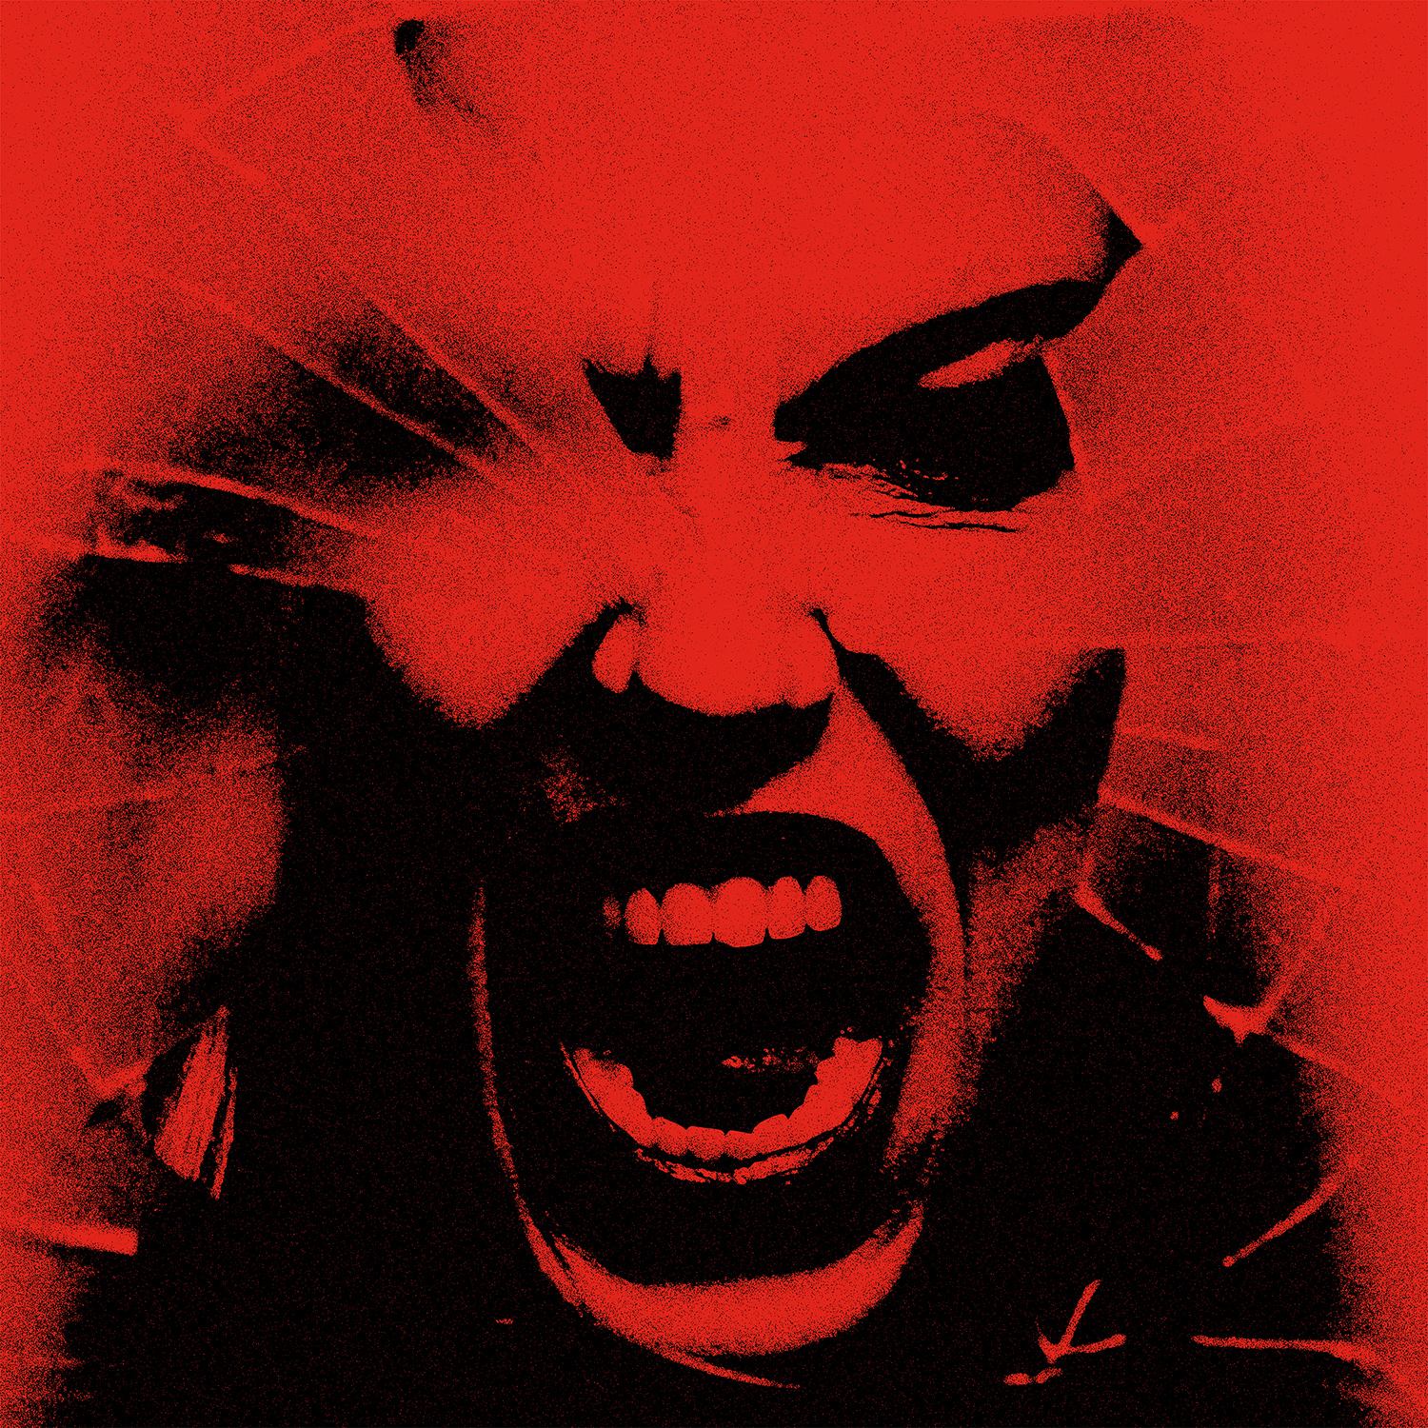

Hi res artwork and press materials available here.

Pre-save/pre-order Back From The Dead here: https://Halestorm.lnk.to/BFTDPR

Watch video for “The Steeple” here: https://Halestorm.lnk.to/TheSteepleVideoPR

Grammy-winning hard rock band Halestorm, who will release their fifth studio album, Back From The Dead, on May 6, today announced new US headline dates in May, their first US shows since the conclusion of their co-headline dates with Evanescence in January.

Kicking off May 10th in Billings, Montana, and running through May 30th in Missoula, the dates, which include festival stops at St. Louis’s Point Fest on May 21 and Daytona Beach’s Welcome to Rockville on May 22, will include various openers, including rock icons Stone Temple Pilots; Mammoth WVH, the hard rock band fronted by Wolfgang Van Halen; and Southern rock staples Black Stone Cherry. A full itinerary with support listed for each date is available below and on Halestorm’s site.

Last week, Halestorm premiered their video for “The Steeple,” the second single to be released from Back From The Dead now making its way up rock radio charts. To lead singer Lzzy Hale, the video, like the song itself, is “a reflection of the human connection music brings us.” The video is available here.

“The Steeple” immediately drew praise from rock media outlets:
- “A defiant redemption song that finds the band’s Lzzy Hale emerging from the wilderness of pandemic isolation” -- Rolling Stone
- “Lzzy Hale…sings of reclaiming her kingdom, cathedral and castle after going through "hell" against the backdrop of a wall of guitar crunch formidable enough to have an impact in the most distant nosebleed seats." – Guitar World
- “In addition to Lzzy’s mighty vocals, ‘The Steeple’ features some nifty guitar work from Joe Hottinger and some muscular playing from drummer Arejay Hale and bassist Josh Smith.” -- Consequence

In honor of Record Store Day, Halestorm will release a limited edition 7” die-cut version of the song “Back From The Dead” in the shape of a tombstone. Look for it at your favorite independent record store.

Back From The Dead, Halestorm’s newest full-length album, produced by Nick Raskulinecz (Foo Fighters, Mastodon, Alice in Chains) with co-production by Scott Stevens (Shinedown, Daughtry, New Years Day), will be available everywhere May 6th and is now available for pre-save/pre-order here. The band began writing the album pre-pandemic, but continued throughout lockdown, and the result “is the story of me carving myself out of that abyss,” said Lzzy Hale. “It is a journey of navigating mental health, debauchery, survival, redemption, rediscovery, and still maintaining faith in humanity.”

***
Halestorm has grown from a childhood dream of siblings Lzzy and Arejay Hale into one of the most celebrated rock bands of the last two decades. Halestorm’s music has surpassed a billion streams worldwide. Called a “muscular, adventurous, and especially relevant rock record” by Rolling Stone, Vicious earned the band their second Grammy nomination, for Best Hard Rock Performance for the song “Uncomfortable,” the band’s fourth #1 at rock radio, and led Loudwire to name Halestorm “Rock Artist of the Decade” in 2019. Fronted by the incomparable Lzzy Hale with drummer Arejay Hale, guitarist Joe Hottinger, and bass player Josh Smith, Halestorm has earned a reputation as a powerful live music force, headlining sold-out shows and topping festival bills around the world, and sharing the stage with icons including Heaven & Hell, Alice Cooper, and Joan Jett.
HALESTORM
May 2022 Tour

* denotes Stone Temple Pilots supporting
#denotes Mammoth WVH supporting
+denotes Black Stone Cherry supporting

MAY
10 Billings, MT First Interstate Arena*#+
11 Casper, WY Ford Wyoming Center*#+
13 Council Bluffs, IA Stir Cove at Harrah’s#+
14 Wichita, KS WAVE#
17 Pittsburgh, PA Stage AE*+
18 Columbus, OH Kemba Live!*+
21 St. Louis, MO Pointfest
22 Daytona Beach, FL Welcome to Rockville
24 Evansville, IN Ford Center*+
25 Tulsa, OK Tulsa Theater*+
28 Moorhead, MN Bluestem Amphitheater*+
30 Missoula, MT Kettlehouse Amphitheater*+

For more information on Halestorm, visit and follow:
https://www.halestormrocks.com/
https://www.facebook.com/halestormrocks
https://twitter.com/halestorm
https://www.instagram.com/halestormrocks/
https://www.youtube.com/user/HalestormRocks

# # #

Contact:
Ashley White
Ashley White Public Relations
ashley@ashleywhitepr.com
(512) 436-9260

