FOR IMMEDIATE RELEASE
JUNE 7, 2022

HALESTORM ANNOUNCE FALL TOUR WITH THE WARNING AND NEW YEARS DAY SUPPORTING;
BACK FROM THE DEAD DEBUTED TOP 5 ON ROCK AND HARD ROCK ALBUM CHART;
“THE STEEPLE” MARKS SECOND CONSECUTIVE #1 SINGLE FROM THE ALBUM;
THE STRANGE CASE OF… CERTIFIED RIAA PLATINUM

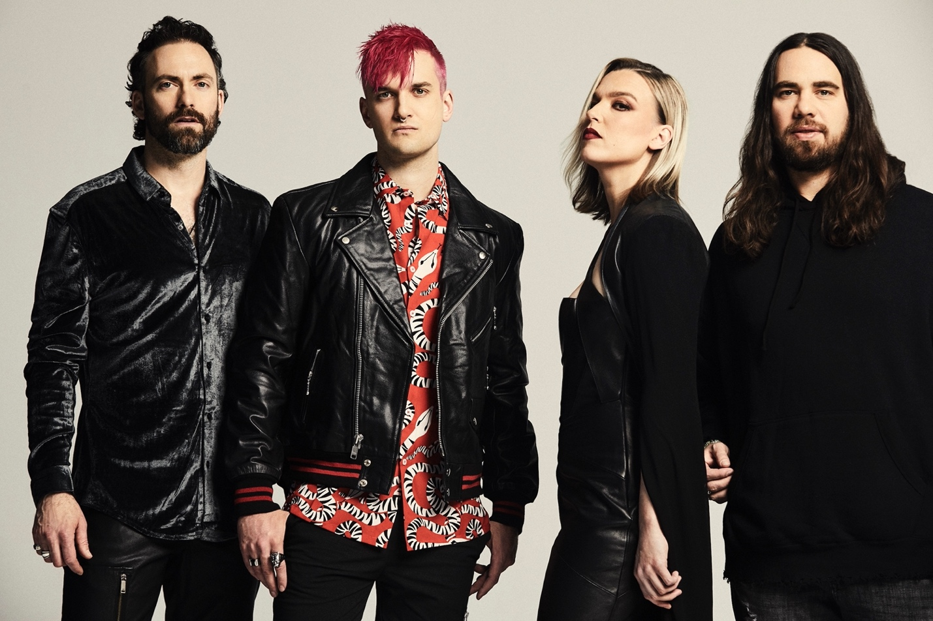

Photo credit: Jimmy Fontaine
Hi res artwork and press materials available here.

Back From The Dead available here: https://Halestorm.lnk.to/BFTDPR

On the heels of Back From The Dead, their fifth studio album which debuted top 5 on the Rock and Hard Rock Album Chart last month, Grammy-winning band Halestorm today announced US fall tour dates with fellow female-fronted bands The Warning and New Years Day.

Tickets for the run, which kicks off September 21 in Huntsville, AL, and runs through the band’s October 8 appearance at Aftershock Festival, are on-sale starting Tuesday, June 7. For more information and details, visit https://www.halestormrocks.com.

The fall trek follows a July headline run with The Pretty Reckless as direct support, along with The Warning and Lilith Czar. A full itinerary is listed below.

Last week, “The Steeple,” the second single from Back From The Dead, claimed the top spot at rock radio, marking the second consecutive single from the album to hit #1, and the band’s seventh career #1. Associated Press predicted Back From The Dead “will definitely be in the running for best hard rock/metal album of the year.”

Also last week, frontwoman Lzzy Hale debuted her newest Gibson Signature Guitar, the red Explorerbird. Hale, Gibson’s first female brand ambassador, debuted the guitar in a cheeky video concluding with an epic performance of the band’s song “Bombshell” from Back From The Dead. That video is available here.

In other news, The Strange Case Of…, Halestorm’s second album, was just certified Platinum® by the RIAA. Released ten years ago, The Strange Case Of… includes the Grammy-winning #1 rock song “Love Bites (So Do I)” and the Platinum® single “I Miss The Misery.”

Called “a deeply personal effort depicting the band’s personal struggles through the last few years of uncertainty” by Alternative Press, Back From The Dead, produced by Nick Raskulinecz (Foo Fighters, Mastodon, Alice in Chains) with co-production by Scott Stevens (Shinedown, Daughtry, New Years Day), “is a journey of navigating mental health, debauchery, survival, redemption, rediscovery, and still maintaining faith in humanity,” according to frontwoman Lzzy Hale, named by Revolver as “one of the most charismatic, powerful, and captivating vocalists of our time.”
***
Halestorm has grown from a childhood dream of siblings Lzzy and Arejay Hale into one of the most celebrated rock bands of the last two decades. Halestorm’s music has surpassed a billion streams worldwide. Called a “muscular, adventurous, and especially relevant rock record” by Rolling Stone, Vicious, the predecessor of Back From The Dead, earned the band their second Grammy nomination, for Best Hard Rock Performance for the song “Uncomfortable” and led Loudwire to name Halestorm “Rock Artist of the Decade” in 2019. Fronted by the incomparable Lzzy Hale with drummer Arejay Hale, guitarist Joe Hottinger, and bass player Josh Smith, Halestorm has earned a reputation as a powerful live music force, headlining sold-out shows and topping festival bills around the world, and sharing the stage with icons including Heaven & Hell, Alice Cooper, and Joan Jett.

HALESTORM
On Tour 2022

July 7-August 10:
With The Pretty Reckless, The Warning, and Lilith Czar except otherwise noted
September 21-October 6 with The Warning and New Years Day
Festival dates denoted by *

JULY
7 Milwaukee, WI – Summerfest*
8 Sterling Heights, MI – Michigan Lottery Amphitheatre at Freedom Hill
10 Kansas City, MO – Starlight Theatre
12 Indianapolis, IN – TCU Amphitheater at White River State Park
13 Cuyahoga Falls, OH – Blossom Music Center
15 Cadott, WI – Rock Fest*
17 Baltimore, MD – Pier Six Pavilion
19 Boston, MA – Leader Bank Pavilion
20 Bridgeport, CT – Hartford Health Care Amphitheater
22 Harrington, DE – Delaware State Fairgrounds*
23 Scranton, PA – Pavilion at Montage Mountain
25 Gilford, NH – Bank of New Hampshire Pavilion
27 Syracuse, NY – St. Joseph’s Health Amphitheater at Lakeview
28 Holmdel, NJ – PNC Bank Arts Center
30 Charlotte, NC – Charlotte Metro Credit Union Amphitheatre

AUGUST
2 Irving, TX – The Pavilion at Toyota Music Factory
4 Albuquerque, NM – Isleta Amphitheater
5 Phoenix, AZ – Arizona Federal Theatre
7 Grand Junction, CO – Los Colonias Park Amphitheater
9 Oklahoma City, OK – The Zoo Amphitheatre
10 Rogers, AR – Walmart Arkansas Music Pavilion
12 Portsmouth, VA – Atlantic Union Bank Pavilion
13 Hamburg, NY – Erie County Fair (on sale June 10)

SEPTEMBER
1 Costa Mesa, CA – OC Fair (with The Struts)
21 Huntsville, AL – Mars Music Hall
22 Louisville, KY – Louder Than Life Festival*
26 Atlanta, GA – The Eastern
28 New Orleans, LA – Fillmore
29 San Antonio, TX – Tech Port Center

OCTOBER
1 Corpus Christi, TX – Selena Auditorium
2 Lubbock, TX – Buddy Holly Hall
4 Colorado Springs, CO – Pikes Peak Center
6 Tucson, AZ – Linda Ronstadt Music Hall

8 Sacramento, CA – Aftershock Festival*

For more information on Halestorm, visit and follow:
https://www.halestormrocks.com/
https://www.tiktok.com/@halestormrocks
https://www.facebook.com/halestormrocks
https://twitter.com/halestorm
https://www.instagram.com/halestormrocks/
https://www.youtube.com/user/HalestormRocks

# # #

Contact:
Ashley White
Ashley White Public Relations
ashley@ashleywhitepr.com
(512) 436-9260

