**A BOOGIE WIT DA HOODIE TAPS H.E.R. & ELLA BANDS FOR 2-TRACK SINGLE “PLAYA”**

**MULTI-PLATINUM, BRONX-BRED ARTIST RELEASES TWO VERSIONS OF NEW SONG ALONG WITH BREEZY COMPANION VISUAL FEATURING ELLA BANDS**

[**STREAM/DOWNLOAD**](https://nam04.safelinks.protection.outlook.com/?url=https%3A%2F%2Faboogie.lnk.to%2FPlaya&data=04%7C01%7CTaylor.Apel%40atlanticrecords.com%7Cb7f36353db5546ab643a08da127c8288%7C8367939002ec4ba1ad3d69da3fdd637e%7C0%7C0%7C637842623230113758%7CUnknown%7CTWFpbGZsb3d8eyJWIjoiMC4wLjAwMDAiLCJQIjoiV2luMzIiLCJBTiI6Ik1haWwiLCJXVCI6Mn0%3D%7C3000&sdata=DW6dHPclp2DigFiyTN3JkfDgZiUjPQUq3oWj7S6CGXM%3D&reserved=0)

[**WATCH HERE**](https://ABoogie.lnk.to/PlayaVideo)

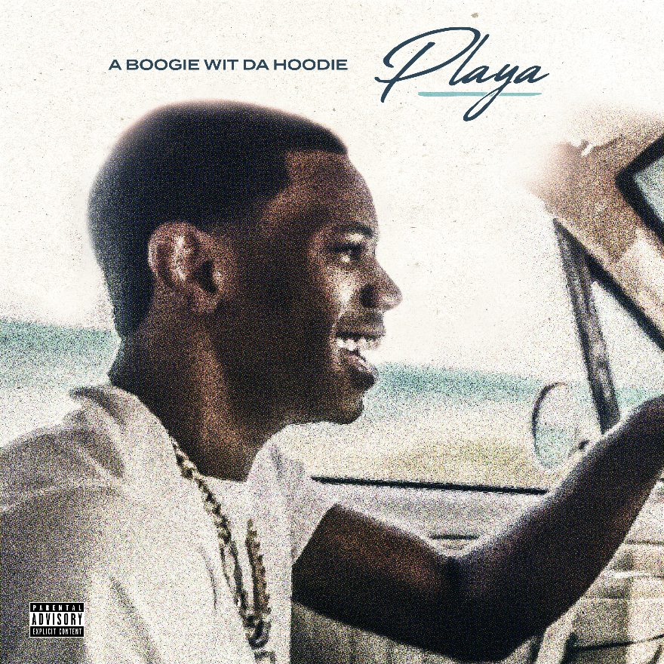

[DOWNLOAD ARTWORK HERE](https://warnermusicgroup.app.box.com/s/6abgvqbfusfub9iel91lq62qwct5zdtj)

**New York, NY – April 1, 2022–** Multiplatinum recording artist **A Boogie Wit Da Hoodie** released his latest single, **“Playa”** as a 2-track single; one featuring Grammy-award winning R&B singer **H.E.R** while the second features rising singer and muse, **Ella Bands**, which also arrives with a companion visual directed by **madebyJAMES** and shot in the Bahamas.

**“Playa”** follows A Boogie’s recent single, **“Hit Different”** featuring B-Lovee. The new track proceeds A Boogie’s ***B4 AVA*** and highly praised, third LP [*Artist 2.0*](https://nam04.safelinks.protection.outlook.com/?url=https%3A%2F%2Faboogie.lnk.to%2FArtist2&data=04%7C01%7CTaylor.Apel%40atlanticrecords.com%7Cb7f36353db5546ab643a08da127c8288%7C8367939002ec4ba1ad3d69da3fdd637e%7C0%7C0%7C637842623230113758%7CUnknown%7CTWFpbGZsb3d8eyJWIjoiMC4wLjAwMDAiLCJQIjoiV2luMzIiLCJBTiI6Ik1haWwiLCJXVCI6Mn0%3D%7C3000&sdata=2JqqaTg9I84CoSILHqIaMAbwwzT2oZTerIVNmqtO2N4%3D&reserved=0), which is certified platinum and debuted at **#1 on Billboard’s Top Rap Albums Chart** and **#2 on the Billboard 200 Albums Chart** with first-week streams exceeding 141 million. The album boasted a star-studded tracklist including features from**, Young Thug, Roddy Ricch, Summer Walker, Khalid, Lil Uzi Vert, Gunna, London On Da Track, Trap Manny** and more.

In addition to being one of music’s brightest stars, A Boogie is set to join the cast of the “**Proud Family**” revival alongside the likes of **Lizzo, Chance the Rapper, Lil Nas X** & more.

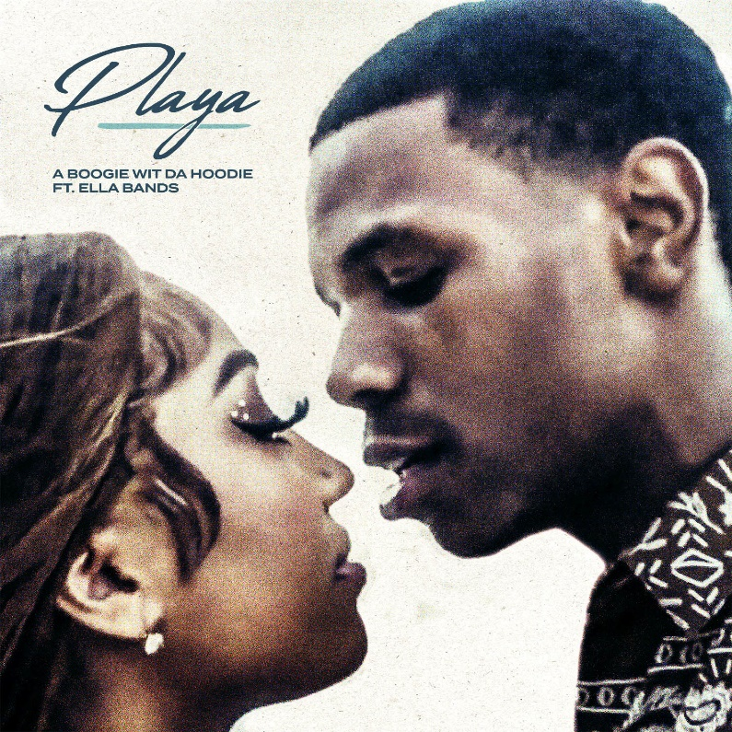  
[DOWNLOAD ARTWORK HERE](https://warnermusicgroup.app.box.com/s/ivwfbe1229591612xjz2uo4u0gbi972o)

**CONNECT WITH A BOOGIE WIT DA HOODIE:**

[TWITTER](https://nam04.safelinks.protection.outlook.com/?url=https%3A%2F%2Ftwitter.com%2FArtistHBTL&data=04%7C01%7CTaylor.Apel%40atlanticrecords.com%7Cb7f36353db5546ab643a08da127c8288%7C8367939002ec4ba1ad3d69da3fdd637e%7C0%7C0%7C637842623230113758%7CUnknown%7CTWFpbGZsb3d8eyJWIjoiMC4wLjAwMDAiLCJQIjoiV2luMzIiLCJBTiI6Ik1haWwiLCJXVCI6Mn0%3D%7C3000&sdata=mvADED1UqVrOwwLPS5PTtGylHjUceLlUOY14%2Bla6CSc%3D&reserved=0) | [FACEBOOK](https://nam04.safelinks.protection.outlook.com/?url=https%3A%2F%2Fwww.facebook.com%2FArtistHBTL%2F&data=04%7C01%7CTaylor.Apel%40atlanticrecords.com%7Cb7f36353db5546ab643a08da127c8288%7C8367939002ec4ba1ad3d69da3fdd637e%7C0%7C0%7C637842623230113758%7CUnknown%7CTWFpbGZsb3d8eyJWIjoiMC4wLjAwMDAiLCJQIjoiV2luMzIiLCJBTiI6Ik1haWwiLCJXVCI6Mn0%3D%7C3000&sdata=cf5lD8F7%2B5PafjE5V2pIx1dymIYoI8vklIk6Kc1Errw%3D&reserved=0) | [YOUTUBE](https://nam04.safelinks.protection.outlook.com/?url=https%3A%2F%2Fwww.youtube.com%2Fchannel%2FUCfgsFOdVScKetBXYrFNr5LQ&data=04%7C01%7CTaylor.Apel%40atlanticrecords.com%7Cb7f36353db5546ab643a08da127c8288%7C8367939002ec4ba1ad3d69da3fdd637e%7C0%7C0%7C637842623230113758%7CUnknown%7CTWFpbGZsb3d8eyJWIjoiMC4wLjAwMDAiLCJQIjoiV2luMzIiLCJBTiI6Ik1haWwiLCJXVCI6Mn0%3D%7C3000&sdata=wqLIizXu%2F8BqoY4u6YPvFLaL4HaAHxwQDwSgDHcISyg%3D&reserved=0)

**PRESS CONTACT:**

JASON DAVIS | [JASON.DAVIS@ATLANTICRECORDS.COM](mailto:JASON.DAVIS@ATLANTICRECORDS.COM)