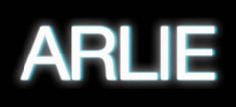

VISIONARY INDIE-POP ACT ARLIE RELEASE HIGHLY ANTICIPATED DEBUT ALBUM BREAK THE CURSE

HEADLINE TOUR KICKS OFF JUNE 17
INCLUDING JUNE 24 SHOW AT MERCURY LOUNGE
TICKETS ON SALE HERE

“The indie-pop song ‘landline’ expands upon the band’s saturated sound heard on their 2018 EP ‘Wait,’ taking them to a groovier and more upbeat level.” – V MAGAZINE

“A true collage of everything from pop to alternative, pulled together with a squelching kaleidoscopic flare… beaming with lyrical savviness that exudes alternative infatuation.” – ONES TO WATCH

***

BREAK THE CURSE – BUY/STREAM

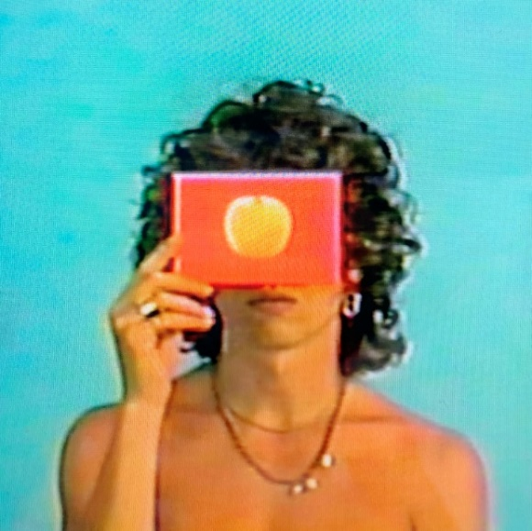
download artwork here

Visionary indie-pop act Arlie has released their highly anticipated debut full-length BREAK THE CURSE –out today via Atlantic Records (listen here).

The Nashville-based outfit’s freshman LP is an unabashedly joyful, artfully minded indie-pop album conceived by Banks and co-produced by band members Ryan Savage and Adam Lochemes. Taking flight from where their 2018 debut EP ‘Wait’ left off, the full-length finds Arlie drawing on timeless pop influences to make music that is at once nostalgic and forward-thinking.

Laced with unforgettable hooks, deliberately naive sentiments, and winking self-awareness set against a genuine grappling with the weight of existential despair, the album is ultimately a journey centered around the theme of transcending societal, cultural, and generational traumas – ‘breaking the curse’ in order to blossom into one’s true authentic self and genuinely connect with others.

Lead singer, songwriter, multi-instrumentalist, and producer Nathaniel Banks shares of the project:

“This album is called BREAK THE CURSE, which I found to be the common thread between all the songs on this record, and what they mean to me. That is, through this realization of how cycles of hurt are repeated through generations and realizing the parallel between my relationship with my dad and my relationship with other people in my life, like friends and romantic interests. Hitting on the same issues that prevent true connection with those people as my dad did with me and likely his father did with him.

This album brought in more collaborators in more significant ways than I have in the past. That also helped with me learning how to overcome obstacles in relationships, in the collaborative process itself. A representation of a chapter in life and feels really good to be putting out into the world.”

To celebrate the album, the band will embark on a US headline tour, set to kick off at Durham’s Motorco Music Hall on June 17th and include a show at New York’s Mercury Lounge on June 24, before culminating with a very special hometown show just added at Nashville’s Eastside Bowl on August 5th. More details to come - tickets on sale here.

Today’s LP release follows the album’s previous singles, “landline”, “sickk,” “crashing down,” “poppin,” and debut single “karma.” The tracks each live in their own unique musical universe, yet all carry Arlie’s ambitious and unmistakable musical signature, exhibiting a meticulous obsession with saturation, contrast, and space.

With over 86M worldwide streams and counting, Arlie first began in the summer of 2015 as a solo bedroom project for Banks, eventually evolving to a full-band live act by 2017 and growing a fervent fan following in their hometown of Nashville and beyond.

Hailed for its striking synthesis of classic pop melodies with wildly creative modern production, Arlie’s 2018 Wait EP included such hit singles as “didya think” and “big fat mouth.” The project immediately drew acclaim for its invigorating songcraft, meticulous production, and playful, summertime energy. Upon release, FLAUNT praised the EP for “fusing a sound both futuristic and vintage…Arlie flirts with an aroma of nostalgic youth, like a mix between a 1984 Testarossa and The Jetsons’ hovercraft.” Ones to Watch similarly declared it: “A true collage of everything from pop to alternative, pulled together with a squelching kaleidoscopic flare…beaming with lyrical savviness that exudes alternative infatuation.”

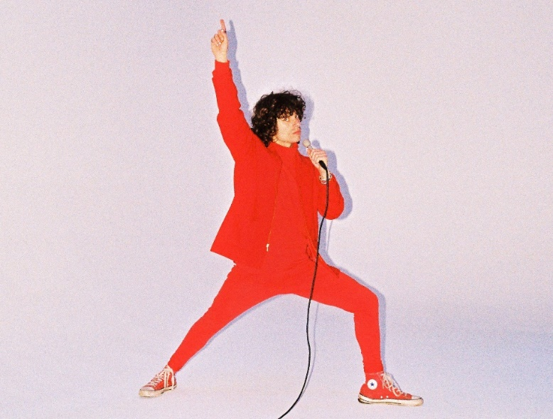
download press photo here; credit: Gabe Dreschler

*****

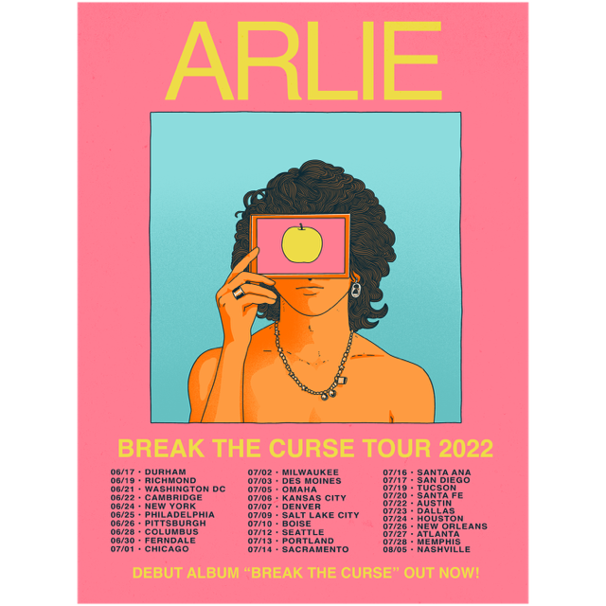

UPCOMING LIVE DATES:
JUNE 17, 2022 – DURHAM, NC – MOTORCO MUSIC HALL
JUNE 19, 2022 – RICHMOND, VA – RICHMOND MUSIC HALL
JUNE 21, 2022 – WASHINGTON, DC – DC9
JUNE 22, 2022 – CAMBRIDGE, MA – SONIA
JUNE 24, 2022 – NEW YORK, NY – MERCURY LOUNGE
JUNE 25, 2022 – PHILADELPHIA, PA – MILKBOY
JUNE 26, 2022 – PITTSBURGH, PA – THUNDERBIRD MUSIC HALL
JUNE 28, 2022 – COLUMBUS, OH – RUMBA CAFÉ
JUNE 30, 2022 – FERNDALE, MI – THE LOVING TOUCH
JULY 3, 2022 – DES MOINES, IA – XBK
JULY 5, 2022 – OMAHA, NE – SLOWDOWN
JULY 6, 2022 – KANSAS CITY, MO – ENCORE AT THE UPTOWN THEATER
JULY 7, 2022 – DENVER, CO – GLOBE HALL
JULY 9, 2022 – SALT LAKE CITY, UT – SOUNDWELL
JULY 10, 2022 – BOISE, ID – THE SHREDDER
JULY 12, 2022 – SEATTLE, WA – MADAME LOU’S
JULY 13, 2022 – PORTLAND, OR – MISSION THEATER
JULY 14, 2022 – SACRAMENTO, CA – GOLDFIELD TRADING POST
JULY 16, 2022 – SANTA ANA, CA – THE CONSTELLATION ROOM
JULY 17, 2022 – SAN DIEGO, CA – VOODOO ROOM AT HOUSE OF BLUES
JULY 19, 2022 – TUCSON, AZ – CLUB CONGRESS
JULY 20, 2022 – SANTA FE, NM – MEOW WOLF
JULY 22, 2022 – AUSTIN, TX – MOHAWK
JULY 23, 2022 – HOUSTON, TX – WAREHOUSE LIVE
JULY 26, 2022 – NEW ORLEANS, LA – GASA GASA
JULY 27, 2022 – ATLANTA, GA – ROOFTOP AT THE EASTERN
JULY 28, 2022 – MEMPHIS, TN – GROWLERS
AUGUST 5, 2022 – NASHVILLE, TN – EASTSIDE BOWL

# # #

CONNECT WITH ARLIE:
OFFICIAL | INSTAGRAM | FACEBOOK | YOUTUBE | TWITTER

FOR ALL PRESS INQUIRIES, PLEASE CONTACT:
Libby Kober | Libby.Kober@AtlanticRecords.com
Trish Mollo | Trish.Mollo@AtlanticRecords.com

