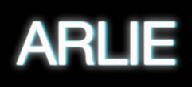

VISIONARY INDIE-POP ACT ARLIE RELEASE OFFICIAL VIDEO FOR “break the curse”

NEW VISUAL INCLUDES HOME VIDEO-STYLE FOOTAGE OF THE BAND IN THE STUDIO AND ON THE ROAD

OPENING FOR THE WRECKS ON TOUR THIS FALL
TICKETS ON SALE HERE
TOUR KICKS OFF OCTOBER 27TH

DEBUT ALBUM BREAK THE CURSE OUT NOW

WATCH “break the curse” VISUAL HERE
BUY/STREAM THE ALBUM HERE

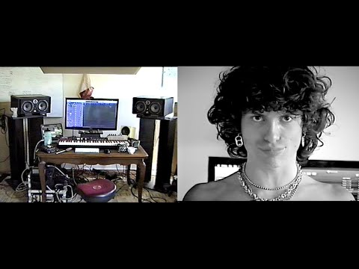
Directed by Gabe Drechsler

Today, visionary indie-pop act Arlie share the official video (watch here) for their debut album’s title track, “break the curse,” giving fans an intimate and engaging look at their time spent writing, recording, performing, and filming music videos for their impressive first full-length. Directed by frequent collaborator Gabe Drechsler, and featuring footage compiled from 2019 through 2021, “break the curse” has a little bit of everything – photo shoots, skate parks, hot pink blazers on the beach, naps between recording sessions, Chemex coffee breaks, beard-shaving, nightswimming, brown paper bags full of goat milk.

Led by singer-songwriter and multi-instrumentalist Nathaniel Banks, Arlie is fresh off the heels of their debut US headline BREAK THE CURSE tour. The majority of the tour was entirely sold out, including shows in New York, LA, Chicago, Austin, Denver, and more. They’ll head back out on the road this fall with LA natives The Wrecks, traversing the country from San Diego to Rhode Island. The tour kicks off on October 27th in New Haven, Connecticut.

Arlie released BREAK THE CURSE in June, the Nashville-based outfit’s highly-anticipated, debut full-length and follow-up to their 2018 debut EP Wait. Laced with unforgettable hooks, deliberately naive sentiments, and winking self-awareness set against a genuine grappling with the weight of existential despair, the album is ultimately a journey centered around the theme of transcending societal, cultural, and generational traumas – ‘breaking the curse’ in order to blossom into one’s true authentic self and genuinely connect with others.

“The indie-pop song ‘landline’ expands upon the band’s saturated sound heard on their 2018 EP ‘Wait,’ taking them to a groovier and more upbeat level.” – V MAGAZINE

“A true collage of everything from pop to alternative, pulled together with a squelching kaleidoscopic flare… beaming with lyrical savviness that exudes alternative infatuation.” – ONES TO WATCH

“…fusing a sound both futuristic and vintage… Arlie flirts with an aroma of nostalgic youth, like a mix between a 1984 Testarossa and The Jetsons’ hovercraft.” - FLAUNT

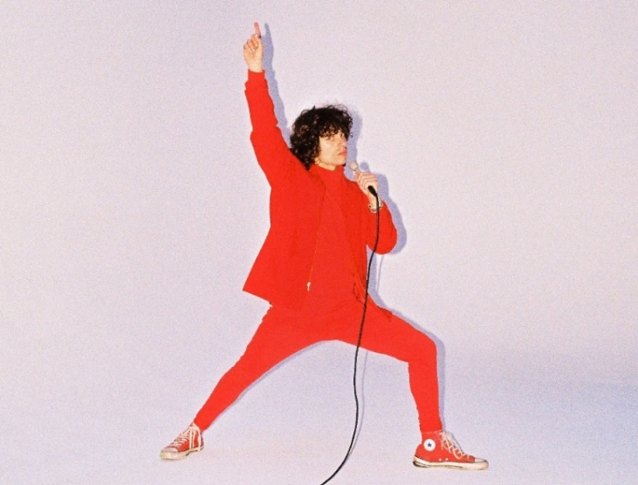
download hi-res press photo here; credit: Gabe Dreschler

With over 93M worldwide streams and counting, Arlie first began in the summer of 2015 as a solo bedroom project for Banks, eventually evolving to a full-band live act by 2017 and growing a fervent fan following in their hometown of Nashville and beyond.

Hailed for its striking synthesis of classic pop melodies with wildly creative modern production, Arlie’s 2018 Wait EP included such hit singles as “didya think” and “big fat mouth.” The project immediately drew acclaim for its invigorating songcraft, meticulous production, and playful, summertime energy.

download album artwork here

*****

UPCOMING LIVE DATES:
OCTOBER 27, 2022 – NEW HAVEN, CT – TOAD’S PLACE*
OCTOBER 28, 2022 – PROVIDENCE, RI – FÊTE MUSIC HALL*
OCTOBER 29, 2022 – BALTIMORE, MD – RAMS HEAD LIVE!*
OCTOBER 30, 2022 – VIRGINIA BEACH, VA – ELEVATION 27*
NOVEMBER 1, 2022 – CARRBORO, NC – CAT’S CRADLE*
NOVEMBER 2, 2022 – ATHENS, GA – 40 WATT CLUB*
NOVEMBER 4, 2022 – MIAMI BEACH, FL – MIAMI BEACH BANDSHELL*
NOVEMBER 5, 2022 – TAMPA, FL – THE RITZ YBOR*
NOVEMBER 6, 2022 – JACKSONVILLE, FL – 1904 MUSIC HALL*
NOVEMBER 8, 2022 – BIRMINGHAM, AL – ZYDECO*
NOVEMBER 10, 2022 – NEW ORLEANS, LA – THE PARISH @ HOUSE OF BLUES*
NOVEMBER 11, 2022 – HOUSTON, TX – WAREHOUSE LIVE*
NOVEMBER 12, 2022 – SAN ANTONIO, TX – THE ROCK BOX*
NOVEMBER 13, 2022 – FORT WORTH, TX – TANNAHILL’S TAVERN & MUSIC HALL*
NOVEMBER 16, 2022 – TUCSON, AZ – CLUB CONGRESS*
NOVEMBER 17, 2022 – SAN DIEGO, CA – HOUSE OF BLUES*
NOVEMBER 18, 2022 – POMONA, CA – THE GLASS HOUSE*
NOVEMBER 19, 2022 – VENTURA, CA – MAJESTIC VENTURA THEATER*

*w/ The Wrecks

# # #

CONNECT WITH ARLIE:
OFFICIAL | INSTAGRAM | FACEBOOK | YOUTUBE | TWITTER

FOR ALL PRESS INQUIRIES, PLEASE CONTACT:
Libby Kober | Libby.Kober@AtlanticRecords.com
Gabby Reese | Tour/Online | Gabrielle.Reese@AtlanticRecords.com

