CASPR RELEASES NEW EP “UNTITLED VOL.1”

RISING ARTIST’S DEBUT EP ARRIVES ALONGSIDE VISUAL FOR “HATE ME” FEATURING TRAVIS BARKER

DOWNLOAD/STREAM HERE

WATCH HERE
Directed by Lake Hills

STRING OF LIVE SHOWS KICKED OFF LAST NIGHT IN LOS ANGELES –
UPCOMING SHOWS INCLUDE NEW YORK AND CHICAGO

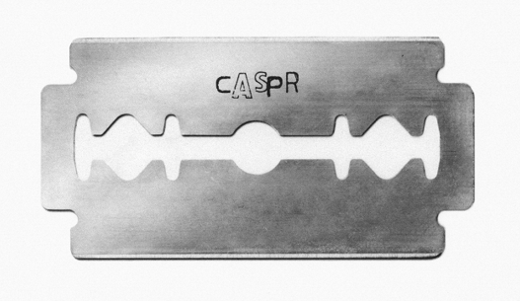
DOWNLOAD HIGH-RES ARTWORK

New York, NY – March 4, 2021 – Rising NYC alternative musician & songwriter Caspr released his debut EP, “Untitled Vol.1,” executively produced by legendary drummer Travis Barker. Download/stream HERE.

The EP arrives alongside the visual for the single “Hate Me” featuring Barker and directed by Lake Hills – WATCH HERE.

Preceding the EP’s release, Caspr braced us with “Snow” and the acoustic guitar-driven track “Don’t Make Sense,” co-produced by Travis Barker (Machine Gun Kelly, jxdn, WILLOW) and Omer Fedi (The Kid Laroi, Machine Gun Kelly, 24KGoldn).

Caspr made his major label debut with the single “Coke Nose,” which was praised by Office Magazine for its, “seamless blend of emo sentimentality, post-punk guitar lines and a bouncy pop-rap rhythm.”

Other highlights from the EP include “Duct Taped Lips,” produced by Andrew Watt and megastar Omar Apollo, as well as “Play Pretend,” which featured frequent collaborator, Travis Barker.

Caspr premiered “Untitled Vol.1” live at Lodge Room in Los Angeles (March 3rd) and will be followed by Brick and Mortar in San Francisco (March 5th), Subterranean in Chicago (March 7th) and Brooklyn Made in New York (March 9th).

“UNTITLED VOL.1” TRACKLIST

“Hate Me” (ft. Travis Barker)
“Coke Nose”
“Don’t Make Sense”
“Play Pretend” (ft. Travis Barker)
“Want Me Dead”
“Duct Taped Lips”
“Snow”

ABOUT CASPR:
Over the past few years, New York artist Caspr (formerly known as PPG Casper) has been building a cult-like fanbase via Soundcloud drops, music videos, underground shows and his work with the meteorically rising Surf Gang collective. It was only a matter of time before Travis Barker and Andrew Watt caught wind and helped shape Caspr’s vision and sound to what you hear now. A unique songwriter, artist and vocalist, Caspr draws inspiration from his experiences and environment which he formulates into intricate stories of heartache, love, loss, late nights, long days and the struggles of everyday life.

Press Contact: Jason Davis – jason.davis@atlanticrecords.com

* * *
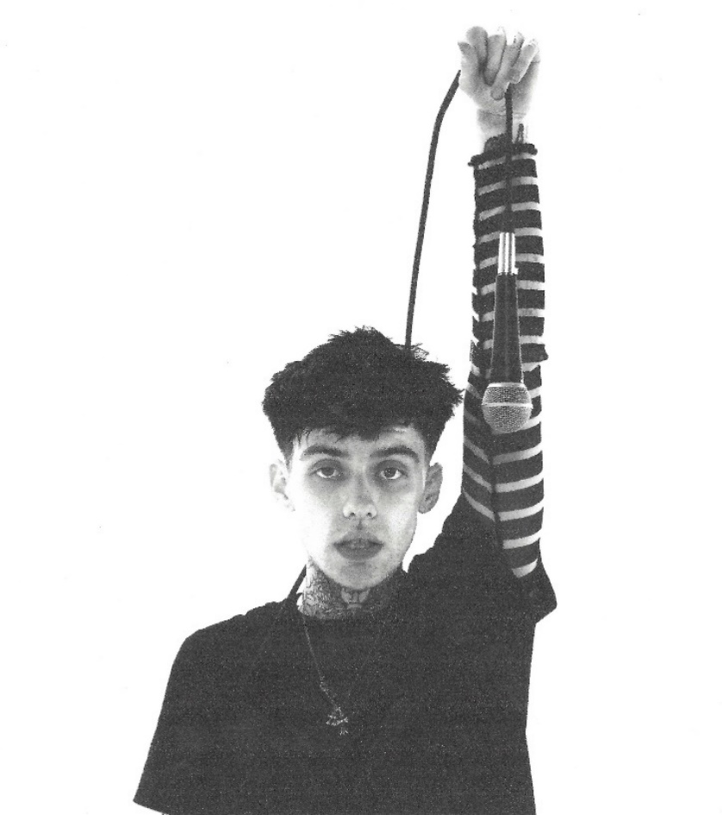
DOWNLOAD PRESS PHOTOS HERE
[Photo Credit: Lake Hills]

CONNECT WITH CASPR:
INSTAGRAM | TWITTER | FACEBOOK | YOUTUBE | PRESS SITE

# # #

