FOR IMMEDIATE RELEASE
AUGUST 1, 2022

CHART-TOPPING MULTI-PLATINUM POP PHENOMENON BAZZI ANNOUNCES THIRD ALBUM INFINITE DREAM OUT SEPTEMBER 16

BAZZI UNVEILS “THE INFINITE DREAM TOUR” FOR FALL IN SUPPORT OF NEW ALBUM

BIGGEST HEADLINE TOUR TO DATE KICKS OFF OCTOBER 17 IN DALLAS, TX

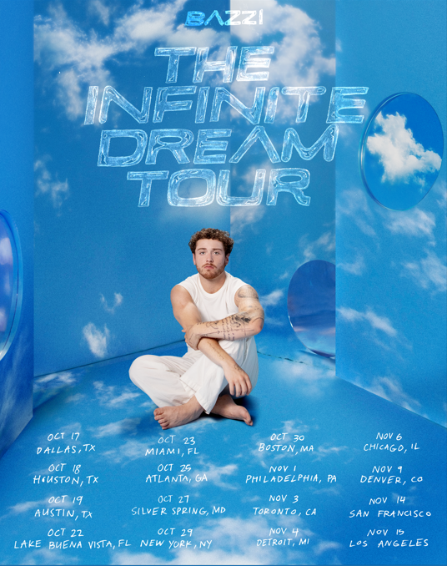
DOWNLOAD HI-RES ADMAT

“Bazzi’s new breakup ballad is sure to strike a chord” – PEOPLE

“’I Like That’ stages Bazzi’s boldest era to date” – AMERICAN SONGWRITER

“[‘Miss America’] is a celebration of love, and one that will definitely light some fireworks in your heart”
– LOS ANGELES MAGAZINE

Chart-topping, multi-platinum phenomenon Bazzi has announced his third album Infinite Dream will be released September 16th on Atlantic Records. The album will include the explosively charged track “Miss America” – which sees Bazzi co-starring alongside actor Dylan Sprouse and supermodels Barbara Palvin and Yovanna Ventura in the official music video, “I Like That,” which is featured in Amazon’s hit TV series The Summer I Turned Pretty, and the deeply personal “Will It Ever Feel The Same?” The album is available for pre-order/pre-save HERE.

In support of the album, Bazzi has announced plans for a long awaited North American headline tour – his biggest live run to date. Produced by Live Nation, “The Infinite Dream Tour” kicks off October 17th at Dallas, TX’s House of Blues and then continues through mid-November before wrapping up in Los Angeles, CA on November 15th at The Wiltern.

“After years of crafting this music & new show I am excited to share this experience with you. It feels like everything has led up to this.” - BAZZI

Presales begin Tuesday, August 2nd at 10:00 am (local) and conclude Thursday, August 4th at 10:00 pm (local). General on-sales begin Friday, August 5th at 10:00 am (local). For complete details, please see www.bazziofficial.com. See full list of tour dates below.

BAZZI
THE INFINITE DREAM TOUR
NORTH AMERICA 2022

OCTOBER
17 - Dallas, TX - House of Blues
18 - Houston, TX - House of Blues
19 - Austin, TX - Emo’s
22 - Lake Buena Vista, FL - House of Blues
23 - Ft. Lauderdale, FL - Revolution
25 - Atlanta, GA - Tabernacle
27 - Silver Spring, MD - The Fillmore
29 - New York, NY - Hammerstein Ballroom
30 - Boston, MA - House of Blues

NOVEMBER
1 – Philadelphia, PA - The Fillmore
3 - Toronto, ON - Rebel
4 - Detroit, MI - The Fillmore
6 - Chicago, IL - Riviera Theatre
9 - Denver, CO - Summit
14 - San Francisco, CA - The Fillmore
15 - Los Angeles, CA - The Wiltern

# # #
About Bazzi:
Born to a Lebanese immigrant father and American mother in Canton, MI, Bazzi and his dad moved to California during his senior year where he single-handedly wrote and produced a series of viral smashes like “Alone” and “Beautiful,” earning millions of worldwide streams and top 10 placement on a variety of influential playlists. Now with over 1.9 billion streams to date, 2018’s 5x RIAA platinum certified “Mine“ proved Bazzi’s true breakthrough, ascending to #1 at CHR/Top 40 and making the top 20 on Billboard’s “Hot 100” after reaching #1 on virtually all streaming platforms. As if all that weren’t enough, the “Mine” companion video boasts over 192 million views via YouTube alone. Praised by Playboy for its “genre-bending…warts-and-all approach to songwriting,” Bazzi’s RIAA platinum certified debut album, COSMIC, debuted among the top 15 on the SoundScan/Billboard 200 upon its 2018 release, earning over 4.3 billion global streams with hits like the 4x platinum certified, top 40 hit duet version of “Beautiful (Ft. Camila Cabello),” accompanied by a spectacular companion visual now with over 188 million views. In 2019, Bazzi unveiled his first ever mixtape, SOUL SEARCHING, collecting over 1.8 billion streams on the strength of such RIAA platinum certified singles as “I.F.L.Y.“ and “Paradise.” Hailed by Billboard as “his most personal work to date,” the project made a top 20 debut on the Billboard 200, while “Paradise” proved one of Bazzi’s biggest hits with over 675 million global streams and counting.

Bazzi made the most of his 2020, releasing a string of intimate and deeply confessional tracks – including “Young & Alive,” “Renee’s Song,” “I Got You,” “I Don’t Think I’m Okay,” and “Crazy“ – all of which drew millions of streams around the world. Bazzi followed the impressive singles run with his 2021 hit “I Like That,” which was joined by a colorful official music video directed by Christian Breslauer (Roddy Ricch, Doja Cat, Yungblud). Most recently, Bazzi has shared the deeply personal “Will It Ever Feel The Same?” and dazzling new pop anthem “Miss America.”

Currently boasting over 9 billion catalogue streams worldwide, Bazzi is fully focused on the future and is set to release his third album Infinite Dream on September 16, now as always cross-pollinating modern pop with more traditional aspects of craft and performance.

About Live Nation:
Live Nation Entertainment (NYSE: LYV) is the world’s leading live entertainment company comprised of global market leaders: Ticketmaster, Live Nation Concerts, and Live Nation Sponsorship. For additional information, visit www.livenationentertainment.com.

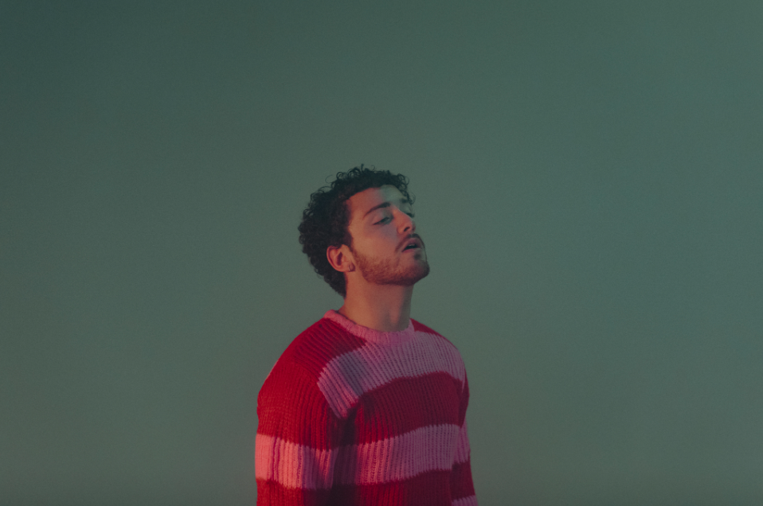
DOWNLOAD HI-RES IMAGE // PHOTO CREDIT: HENRY AMMANN

CONNECT WITH BAZZI
BAZZIOFFICIAL.COM | FACEBOOK| INSTAGRAM| TWITTER | YOUTUBE

For press inquiries, please contact:
Kelly McWilliam // Kelly.McWilliam@atlanticrecords.com

Live Nation Concerts
Monique Sowinski // moniquesowinski@livenation.com

