FRED AGAIN.. LINKS WITH SWEDISH HOUSE MAFIA
ON NEW SINGLE
‘TURN ON THE LIGHTS AGAIN..’ (FEAT. FUTURE)

LISTEN HERE

FRED TO EMBARK ON US HEADLINE TOUR
IN SEPT/OCT INCLUDING A TRIO OF SOLD-OUT SHOWS AT
HOLLYWOOD FOREVER CEMETERY (LA) & TERMINAL 5 (NYC)

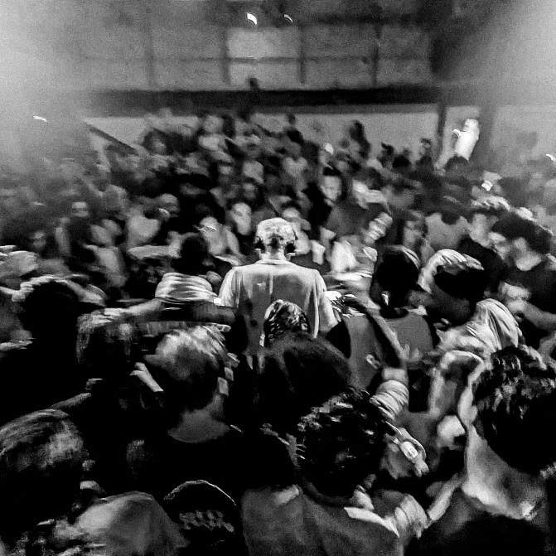
DOWNLOAD ARTWORK HERE

Fred again.. is back with new single, “Turn On The Lights again..” (feat. Future) – a collaboration with dance music titans, Swedish House Mafia, and US rap kingpin, Future. Listen HERE.

Following hot on the heels of ‘Jungle’ – which also featured a crushing Rico Nasty Remix – and featuring artwork shot at Fred’s recent Boiler Room session broadcast from London, ‘Turn On The Lights again..’ was born out of an impromptu studio session in Sweden. After ripping a sample from a video clip of Future’s ‘Turn On The Lights’ online, he played a skeleton of the track to Swedish House Mafia, before going back-and-forth with the trio (Axwell, Steve Angello & Sebastian Ingrosso) to land on the final mix. Teased by Fred on Tik Tok via a viral clip that’s already racked up over 3.7 million views, further creations on the platform have generated an additional 10 million (!) views since, with French football champions PSG also using an audio clip to soundtrack the unveiling of summer transfer signing, Vitinha.

‘Turn On The Lights again..’ (feat. Future) follows on from a run of acclaimed collaborative singles, including January’s ‘Lights Out’ with HAAi & Romy and March’s ‘Admit It (U Don’t Want 2)’ with I. Jordan; both now fixtures in DJ sets around the world, as well as Fred’s own live performances. Uniquely transcendent, Fred’s one-of-a-kind live show takes crowds through a raft of material; from the achingly beautiful moments of his ‘Actual Life’ album series to two of the standout dance floor tracks of last summer, ‘Marea (We’ve Lost Dancing)’ and ‘Billie (Loving Arms)’. ‘Turn On The Lights again..’ is out now on Atlantic: https://fredagain.lnk.to/TOTLA

Looking ahead, Fred again.. is gearing up for a 16-date US headline tour throughout September and October, including a trio of virtually sold-out shows at both Hollywood Forever Cemetery in LA and Terminal 5 in NYC. For tickets and more information, please visit https://www.fredagain.com/tour/. See full list of tour dates below.

FRED AGAIN..
NORTH AMERICA 2022

SEPTEMBER
23 - San Francisco, CA - The Warfield (SOLD OUT)
24 - San Francisco, CA - Portola Festival
25 - San Diego, CA - CRSSD Festival
28 - Los Angeles, CA - Hollywood Forever Cemetery (SOLD OUT)
29 - Los Angeles, CA - Hollywood Forever Cemetery (SOLD OUT)
30 - Los Angeles, CA - Hollywood Forever Cemetery (SOLD OUT)

OCTOBER
1 - George, WA - Gorge Amphitheatre
2 - Denver, CO - Mission Ballroom
5 - Chicago, IL - Riviera Theater
6 - Toronto, Canada - Danforth Music Hall (SOLD OUT)
8 - Washington, DC - 9:30 Club (SOLD OUT)
11 - Boston, MA - Roadrunner
13 - New York, NY - Terminal 5 (SOLD OUT)
14 - New York, NY - Terminal 5 (SOLD OUT)
16 - New York, NY - Terminal 5
29 - Oakland, CA - Oakland Arena

###

CONNECT WITH FRED AGAIN..
WEBSITE / INSTAGRAM

CONTACT: KELLY MCWILLIAM / ATLANTIC RECORDS
KELLY.MCWILLIAM@ATLANTICRECORDS.COM

