FOR IMMEDIATE RELEASE
AUGUST 5, 2022

LIL EAZZYY IS BACK WITH “UP THERE”

MULTI-MILLION STREAMING RAPPER CONTINUES STEADY FLOW OF NEW MUSIC
WITH BIG SCARR-PRODUCED SINGLE

OFFICIAL MUSIC VIDEO STREAMING NOW – WATCH

“UP THERE” AVAILABLE NOW AT ALL DSPS AND STREAMING SERVICES

CHICAGO RAPSTAR BLOWS UP FIRE IN THE BOOTH + FROM THE BLOCK
WITH NEW FREESTYLES AHEAD OF FORTHCOMING MIXTAPE

WATCH FIRE IN THE BOOTH HERE | WATCH FROM THE BLOCK HERE

PREVIOUSLY PERFORMED “NOTHING LEFT” LIVE ON THE EYE SESSIONS
WATCH FULL SESSION HERE

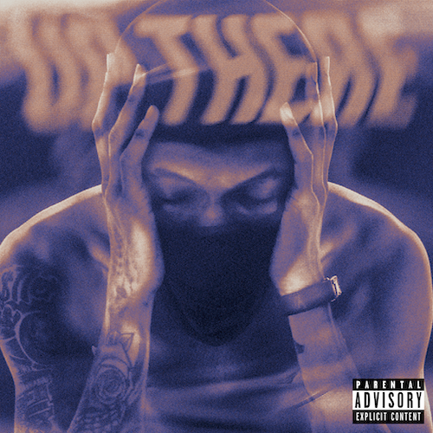
DOWNLOAD HI-RES IMAGE

Multi-million streaming Chicago rapper Lil Eazzyy continues to dish out new music to his devoted fan following the release of “Up There,” available now via Atlantic Records at all DSPs and streaming services. Produced by The New 1017/Atlantic recording artist Big Scarr, the heartfelt open letter to a close friend who recently passed is joined by an emotionally charged official music video premiering today via YouTube HERE.
“Up There” marks the latest in a series of recent releases including the recently released mixtape, TOO EAZZYY, highlighted by such tracks as “Hard Way (Feat. Shoebox Baby),” “Nothing Left,” and “Forever Been Steppin,” all available now for streaming and download everywhere. Official visual are streaming now at YouTube HERE.

Heating up in time for his forthcoming new mixtape, the Chicago rap star continues to use his killer flow and mic instincts with a Charli Sloth, Fire In The Booth freestyle and From The Block performance.

Lil Eazzyy – who recently followed his first ever North American tour (supporting NLE Choppa) by lighting it up with an electrifying performance at Rolling Loud Miami – has also offered up a number of live renditions of tracks from TOO EAZZYY, including a methodical take on “Nothing Left” for THE EYE Sessions (streaming HERE) and a fiery “Forever Been Steppin” for TRSH (streaming HERE).

With hundreds of millions of streams under his belt alongside acclaim from The FADER, UPROXX, and Complex, Lil Eazzyy consistently asserts himself as a proficient rhymer reverent of old school rap’s rules of engagement yet incendiary enough to set the genre on fire in the 21st century. The Chicago-born, Los Angeles-based rapper broke into the game with such successful independent tracks as “Finesse,” “Listen Up,” and “Letter Tracy” before ascending to the forefront of hip-hop with the breakthrough hit single, “Onna Come Up,” earning more than 157 worldwide streams while reaching #6 on Spotify’s “US Viral 50,” #14 on the “Global Viral 50,” and #21 on Rolling Stone’s “Breakthrough 25” chart. At just 20 years old, Lil Eazzyy is proving he is a force to be reckoned with as he laces hard-hitting production with lyrical dexterity.

“There aren’t really any active bar-for-bar rappers at my age,” says Lil Eazzyy. “It’s just me. I’m going to be dropping more heat though. When you hear this, I want you think, ‘He is the best bar-for-bar rapper out right now’. Somebody needs to correct me if I’m wrong.”

# # #

CONNECT WITH LIL EAZZYY
WEBSITE | FACEBOOK | INSTAGRAM | TIKTOK | TWITTER | YOUTUBE

