**LIZZO CELEBRATES BILLBOARD HOT 100 #1, “**[**ABOUT DAMN TIME**](https://lizzo.lnk.to/AboutDamnTimeID)**”**

**WORLDWIDE SMASH MARKS LIZZO’S SECOND HOT 100 #1 AND FOURTH TOP 10**

**3x GRAMMY**® **AWARD-WINNING SUPERSTAR’S NEW ALBUM** [***SPECIAL***](https://lizzo.lnk.to/SPECIALPR)

**BECOMES THE BIGGEST DEBUT FOR A FEMALE ARTIST THIS YEAR SO FAR**

**WITH #2 BILLBOARD 200 DEBUT**

**6x EMMY AWARD NOMINATED *LIZZO’S* *WATCH OUT FOR THE BIG GRRRLS***

**STREAMING NOW VIA PRIME VIDEO**

***THE SPECIAL TOUR* KICKS OFFSEPTEMBER 23RD WITH ADDITIONAL DATES**

**IN NEW YORK CITY, LOS ANGELES, AND PORTLAND ADDED DUE TO HIGH DEMAND**

[***SPECIAL***](https://lizzo.lnk.to/SPECIALPR) **AVAILABLE EVERYWHERE NOW**

**VIA NICE LIFE RECORDING COMPANY/ATLANTIC RECORDS**

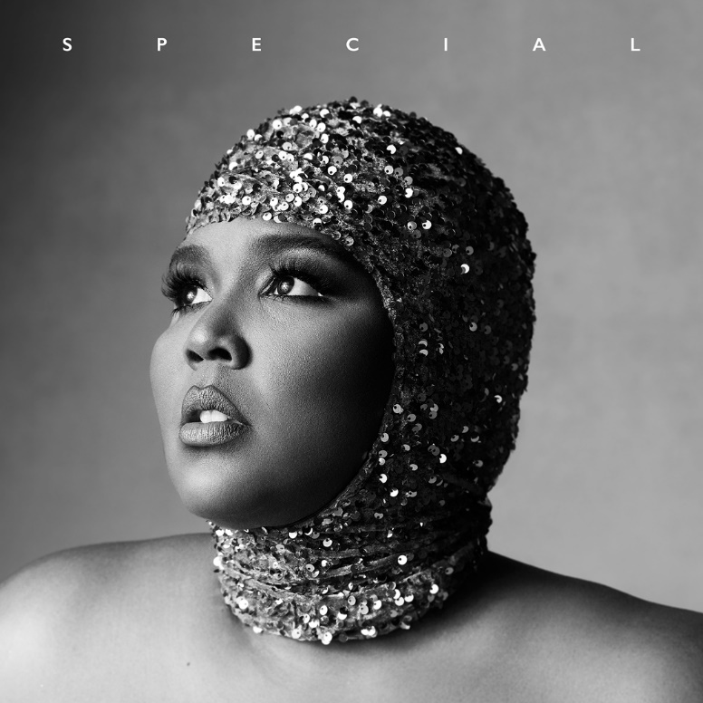

([DOWNLOAD](https://warnermusicgroup.box.com/s/jrjdv8u7j6rw3kzl2ve32x5g2syus3n2) HI-RES PHOTOS + ARTWORK)

“*it’s hard to imagine [SPECIAL] isn’t immediately locked in as one of the leading album of the year candidates.”* – **VARIETY**

3x GRAMMY® Award-winning, RIAA multi-platinum certified superstar **Lizzo** is celebrating her second Billboard Hot 100 #1 and fourth top 10 with the ascension of her worldwide smash “[About Damn Time](https://lizzo.lnk.to/AboutDamnTimeID)” to the top of the Hot 100 chart. With over 1 million units sold, “About Damn Time” is also still holding #1 at Top 40 radio and building #1 on Hot AC. On track to become Lizzo’s highest streaming song thus far, “About Damn Time” follows her first #1 “Truth Hurts” (which spent seven weeks at #1), and further top 10 hits “Good As Hell,” and “Rumors (Feat. Cardi B).”

Her new album [***SPECIAL***](https://nam04.safelinks.protection.outlook.com/?url=https%3A%2F%2Flizzo.lnk.to%2FSPECIALPR&data=05%7C01%7CTiana.Timmerberg%40atlanticrecords.com%7C7c79d5aecb8e4f63da6708da666230c6%7C8367939002ec4ba1ad3d69da3fdd637e%7C0%7C0%7C637934869474989735%7CUnknown%7CTWFpbGZsb3d8eyJWIjoiMC4wLjAwMDAiLCJQIjoiV2luMzIiLCJBTiI6Ik1haWwiLCJXVCI6Mn0%3D%7C3000%7C%7C%7C&sdata=BmOqTr08rxDAiOquhdb4%2FqQN8tZp77psC%2BtYibwb%2B1o%3D&reserved=0) also just debuted at #2 on the Billboard 200 album chart, making it the highest Billboard 200 charting album released this year by any female artist. Along with its #2 debut overall, *SPECIAL* is also the #1 top-selling album this week, and #1 on the Pop Albums chart. The album, hailed by ***Rolling Stone*** as “*the most unabashedly joyous, sonically diverse, and emotionally profound album put out by a major label since Beyonce’s Lemonade,”* is available everywhere now via Nice Life Recording Company/Atlantic Records [HERE](https://nam04.safelinks.protection.outlook.com/?url=https%3A%2F%2Flizzo.lnk.to%2FSPECIALPR&data=05%7C01%7CTiana.Timmerberg%40atlanticrecords.com%7C7c79d5aecb8e4f63da6708da666230c6%7C8367939002ec4ba1ad3d69da3fdd637e%7C0%7C0%7C637934869474989735%7CUnknown%7CTWFpbGZsb3d8eyJWIjoiMC4wLjAwMDAiLCJQIjoiV2luMzIiLCJBTiI6Ik1haWwiLCJXVCI6Mn0%3D%7C3000%7C%7C%7C&sdata=BmOqTr08rxDAiOquhdb4%2FqQN8tZp77psC%2BtYibwb%2B1o%3D&reserved=0).

*SPECIAL* was introduced with the help of Lizzo’s celebratory live performance for NBC’s 2022 “Citi Concert Series on *TODAY*,” (streaming [HERE](https://www.today.com/popculture/citi-music-series/watch-lizzo-turn-up-the-music-on-today-plaza-with-performances-rcna38372)), a heartwarming comedy bit on ABC’s *Jimmy Kimmel Live!* (streaming [HERE](https://www.youtube.com/watch?v=UOAJ0a3PqAg)), and a hilarious guest spot on *Watch What Happens Live With Andy Cohen*. Lizzo’s recent TV appearances also include a double duty hosting and performance gig on NBC’s *Saturday Night Live* (streaming [HERE](https://nam04.safelinks.protection.outlook.com/?url=https%3A%2F%2Fwww.youtube.com%2Fwatch%3Fv%3DXMuTV1nlFBk&data=05%7C01%7CTiana.Timmerberg%40atlanticrecords.com%7C7c79d5aecb8e4f63da6708da666230c6%7C8367939002ec4ba1ad3d69da3fdd637e%7C0%7C0%7C637934869474989735%7CUnknown%7CTWFpbGZsb3d8eyJWIjoiMC4wLjAwMDAiLCJQIjoiV2luMzIiLCJBTiI6Ik1haWwiLCJXVCI6Mn0%3D%7C3000%7C%7C%7C&sdata=jVUCOhIOMsCuzz5QiGqzFH6TbXe1kGNL6vFxAzOQN2A%3D&reserved=0)), a live performance of “About Damn Time” kicking off the 2022 BET Awards (streaming [HERE](https://nam04.safelinks.protection.outlook.com/?url=https%3A%2F%2Fwww.youtube.com%2Fwatch%3Fv%3Du4cUx9fMp1A&data=05%7C01%7CTiana.Timmerberg%40atlanticrecords.com%7C7c79d5aecb8e4f63da6708da666230c6%7C8367939002ec4ba1ad3d69da3fdd637e%7C0%7C0%7C637934869474989735%7CUnknown%7CTWFpbGZsb3d8eyJWIjoiMC4wLjAwMDAiLCJQIjoiV2luMzIiLCJBTiI6Ik1haWwiLCJXVCI6Mn0%3D%7C3000%7C%7C%7C&sdata=It%2F0FcFqV7LVXzDCaQ2Ayz4m%2FjIK2aKQflz5F0QWWeo%3D&reserved=0)), and an unforgettable installment of *Carpool Karaoke* (streaming [HERE](https://nam04.safelinks.protection.outlook.com/?url=https%3A%2F%2Fwww.youtube.com%2Fwatch%3Fv%3DWo-43D41pOA&data=05%7C01%7CTiana.Timmerberg%40atlanticrecords.com%7C7c79d5aecb8e4f63da6708da666230c6%7C8367939002ec4ba1ad3d69da3fdd637e%7C0%7C0%7C637934869474989735%7CUnknown%7CTWFpbGZsb3d8eyJWIjoiMC4wLjAwMDAiLCJQIjoiV2luMzIiLCJBTiI6Ik1haWwiLCJXVCI6Mn0%3D%7C3000%7C%7C%7C&sdata=28E3tsLizQuzTMZlJtXAFlRY3qvHE%2Bi5C6EMrV9AtHo%3D&reserved=0)) on CBS’s *The Late Late Show with James Corden*, the latter of which amassed 1M views in the first 24 hours following its premiere last month and soon rose to #4 on YouTube’s “Trending” chart.

**LIZZO**

***SPECIAL***

**(Nice Life Recording Company/Atlantic Records)**

TRACKLIST

The Sign

About Damn Time

Grrrls

2 Be Loved (Am I Ready)

I Love You Bitch

Special

Break Up Twice

Everybody’s Gay

Naked

Birthday Girl

If You Love Me

Coldplay

Along with the eagerly-awaited release of *SPECIAL*, Lizzo is celebrating a whopping six Emmy Award nominations for her #1 Amazon Prime Video Reality TV series *Watch Out For The Big Grrrls,* streaming now via Prime Video*.* Nods include nominations in the Outstanding Competition Program, Outstanding Directing for a Reality Program, and Outstanding Casting for a Reality Program categories. “We didn’t do this for awards, we did this for ourselves,” Lizzo writes in an Instagram post. “For the lives we touched making this… To shake up the industry… and show the world how BEAUTIFUL AND TALENTED WE AREEEEE!”

*SPECIAL* will be further celebrated by Lizzo’s biggest North American headline tour to date. *The Special Tour* gets underway September 23 at Sunrise, FL’s FLA Live Arena and then travels through mid-November with support from special guests Latto and Saucy Santana on select dates. Due to overwhelming demand, additional shows in New York at Madison Square Garden, Los Angeles at the Kia Forum, and Portland at Moda Center were recently added to the tour. For complete details and remaining ticket availability, please visit [www.lizzomusic.com/tour](https://nam04.safelinks.protection.outlook.com/?url=http%3A%2F%2Fwww.lizzomusic.com%2Ftour&data=05%7C01%7CTiana.Timmerberg%40atlanticrecords.com%7C7c79d5aecb8e4f63da6708da666230c6%7C8367939002ec4ba1ad3d69da3fdd637e%7C0%7C0%7C637934869474989735%7CUnknown%7CTWFpbGZsb3d8eyJWIjoiMC4wLjAwMDAiLCJQIjoiV2luMzIiLCJBTiI6Ik1haWwiLCJXVCI6Mn0%3D%7C3000%7C%7C%7C&sdata=za387J06cRfX%2FYbqZKtMAoAh%2BOG5fnad3xqkXab%2FPrI%3D&reserved=0).

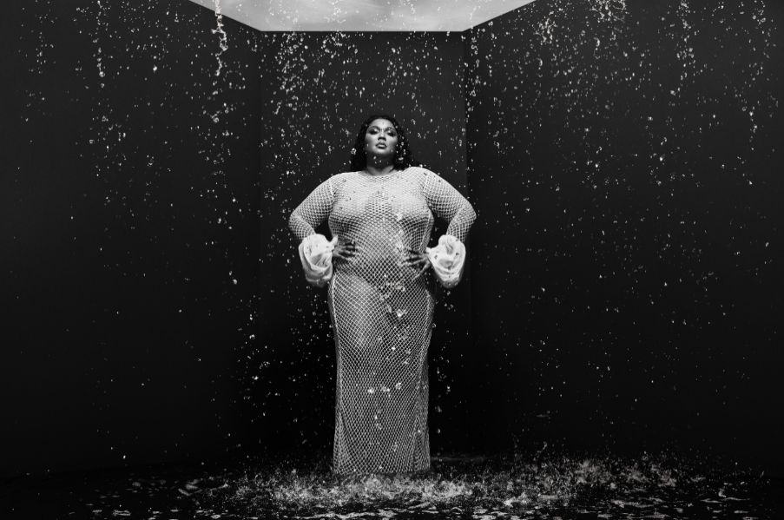

(DOWNLOAD PRESS PHOTOS [HERE](https://warnermusicgroup.box.com/s/jrjdv8u7j6rw3kzl2ve32x5g2syus3n2))

ABOUT LIZZO

A 3x GRAMMY® Award-winning singer, songwriter, rapper, actress, and so much more, Lizzo has shifted the sound, soul, and spirit of popular music and culture. 2019’s now-classic, RIAA platinum certified debut album, *CUZ I LOVE YOU*, bowed at #4 on the *Billboard 200*, fueled in part by such history-making hits as the platinum certified “Tempo (Feat. Missy Elliott),” the 2x platinum “Juice,” the 4x platinum “Good As Hell,” and the 7x platinum “Truth Hurts.” The latter of which ascended to #1 on *Billboard*’s “Hot 100,” affirming Lizzo as only the third female rapper to top the chart without a featured artist, as well as the first black solo female R&B singer to claim the top spot since 2012. “Truth Hurts” dominated the chart for seven weeks, further making history as the longest running #1 by a solo female rap artist ever. Named by *Rolling Stone* as one of the ”500 Greatest Songs Of All Time,” “Truth Hurts” went on to earn a 2020 GRAMMY® Award for “Best Pop Solo Performance,” with *CUZ I LOVE YOU (DELUXE)* receiving that year’s GRAMMY® for “Best Urban Contemporary Album” and “Jerome” earning “Best Traditional R&B Performance.”

Lizzo has maintained her unstoppable momentum on 2021’s RIAA gold certified “Rumors (Feat. Cardi B)” and what has already proven a jam-packed 2022 with the release of her biggest, boldest, and brightest revolution thus far: her massively anticipated album SPECIAL, out now via Nice Life Recording Company/Atlantic Records. Met by immediate critical acclaim in high profile outlets, Variety writes “*it’s hard to imagine [SPECIAL] isn’t immediately locked in as one of the leading album of the year candidates.” SPECIAL* was led by instant hit and #1 Pop radio smash “About Damn Time,” now #1 on *Billboard*’s “Hot 100” after lighting up TikTok with over 5M creates. “About Damn Time” marks Lizzo’s fourth top 10 “Hot 100” hit, following “Truth Hurts” (which spent seven weeks at #1), “Good As Hell,” and “Rumors (Feat. Cardi B).”

Crowned 2019’s “Entertainer of the Year” by both *TIME* and *Entertainment Weekly*, Lizzo has adorned the covers of countless publications around the globe, spanning *People*, *Rolling Stone*, *Billboard*, *Elle*, *British Vogue*, and many more. Among her many unforgettable TV appearances, Lizzo has lit up the stage at the American Music Awards, the MTV Video Music Awards, the BET Awards, a double duty hosting and performance on  *Saturday Night Live*, and an epic opening performance at the GRAMMYs, to name just a few. Lizzo can currently be seen in the 6x Emmy Award nominated #1 hit reality show, Amazon Prime Video’s *Lizzo’s Watch Out For The Big Grrrls*, streaming now exclusively via Prime Video. Lizzo also recently added fashion entrepreneur to her multi-hyphenate career by joining forces with parent company Fabletics, Inc. for the launch of her revolutionary new shapewear brand, YITTY, with sizes ranging from size 6X to XS.

# # #

***The Special* *Tour***

**North America 2022**

September 23 - Sunrise, FL - FLA Live Arena*

September 24 - Tampa, FL - Amalie Arena+

September 27 - Washington, DC - Capital One Arena^

September 29 - Philadelphia, PA - Wells Fargo Center*

September 30 - Boston, MA - TD Garden^

October 2 - New York, NY - Madison Square Garden^

**October 3 - New York, NY - Madison Square Garden – ADDED DATE^**

October 6 - Detroit, MI - Little Caesars Arena*

October 7 - Toronto, ON - Scotiabank Arena^

October 11 - St. Paul, MN - Xcel Energy Center^

October 14 - Kansas City, MO - T-Mobile Center^

October 16 - Chicago, IL - United Center^

October 18 - Indianapolis, IN - Gainbridge Fieldhouse*

October 20 - Charlotte, NC - Spectrum Center^

October 22 - Atlanta, GA - State Farm Arena^

October 23 - Nashville, TN - Bridgestone Arena^

October 25 - Austin, TX - Moody Center^

October 26 - Houston, TX - Toyota Center*

October 28 - Dallas, TX - American Airlines Center^

October 31 - Denver, CO - Ball Arena^

November 2 - Salt Lake City, UT - Vivint Arena^

November 4 - Portland, OR - Moda Center^

November 7 - Vancouver, BC - Rogers Arena^

November 9 - Seattle, WA - Climate Pledge Arena^

**November 10 - Portland, OR – Moda Center – ADDED DATE^**

November 12 - San Francisco, CA - Chase Center^

November 18 - Los Angeles, CA - Kia Forum^

**November 19 - Los Angeles, CA - Kia Forum – ADDED DATE^**

\**With Support From Latto and Saucy Santana*

*+With Support From Saucy Santana*

*^With Support From Latto*

# # #

**CONNECT WITH LIZZO**

[OFFICIAL](https://nam04.safelinks.protection.outlook.com/?url=http%3A%2F%2Fwww.lizzomusic.com%2F&data=05%7C01%7CTiana.Timmerberg%40atlanticrecords.com%7C7c79d5aecb8e4f63da6708da666230c6%7C8367939002ec4ba1ad3d69da3fdd637e%7C0%7C0%7C637934869474989735%7CUnknown%7CTWFpbGZsb3d8eyJWIjoiMC4wLjAwMDAiLCJQIjoiV2luMzIiLCJBTiI6Ik1haWwiLCJXVCI6Mn0%3D%7C3000%7C%7C%7C&sdata=1ZB%2Fkli4pRHmQmPHD6iUVnP%2Fv71JvhViF042oBl3R7M%3D&reserved=0)| [FACEBOOK](https://nam04.safelinks.protection.outlook.com/?url=https%3A%2F%2Fwww.facebook.com%2FLizzoMusic&data=05%7C01%7CTiana.Timmerberg%40atlanticrecords.com%7C7c79d5aecb8e4f63da6708da666230c6%7C8367939002ec4ba1ad3d69da3fdd637e%7C0%7C0%7C637934869474989735%7CUnknown%7CTWFpbGZsb3d8eyJWIjoiMC4wLjAwMDAiLCJQIjoiV2luMzIiLCJBTiI6Ik1haWwiLCJXVCI6Mn0%3D%7C3000%7C%7C%7C&sdata=7dl4MTrG9yByL2qPxwMnlQTTezjSx5JHG0wh%2Bnhdtuc%3D&reserved=0) | [INSTAGRAM](https://nam04.safelinks.protection.outlook.com/?url=https%3A%2F%2Fwww.instagram.com%2Flizzobeeating%2F&data=05%7C01%7CTiana.Timmerberg%40atlanticrecords.com%7C7c79d5aecb8e4f63da6708da666230c6%7C8367939002ec4ba1ad3d69da3fdd637e%7C0%7C0%7C637934869474989735%7CUnknown%7CTWFpbGZsb3d8eyJWIjoiMC4wLjAwMDAiLCJQIjoiV2luMzIiLCJBTiI6Ik1haWwiLCJXVCI6Mn0%3D%7C3000%7C%7C%7C&sdata=XFxASL%2FVaFGLKckruK1ZzYLb0McJ1bYcylhsdR7Wr64%3D&reserved=0) | [TIKTOK](https://nam04.safelinks.protection.outlook.com/?url=https%3A%2F%2Fwww.tiktok.com%2F%40lizzo&data=05%7C01%7CTiana.Timmerberg%40atlanticrecords.com%7C7c79d5aecb8e4f63da6708da666230c6%7C8367939002ec4ba1ad3d69da3fdd637e%7C0%7C0%7C637934869474989735%7CUnknown%7CTWFpbGZsb3d8eyJWIjoiMC4wLjAwMDAiLCJQIjoiV2luMzIiLCJBTiI6Ik1haWwiLCJXVCI6Mn0%3D%7C3000%7C%7C%7C&sdata=xaUqdDcqtIRxtjZSbhILpMVKXeDGwbITh58eKizFuGg%3D&reserved=0) | [TWITTER](https://nam04.safelinks.protection.outlook.com/?url=https%3A%2F%2Ftwitter.com%2Flizzo&data=05%7C01%7CTiana.Timmerberg%40atlanticrecords.com%7C7c79d5aecb8e4f63da6708da666230c6%7C8367939002ec4ba1ad3d69da3fdd637e%7C0%7C0%7C637934869474989735%7CUnknown%7CTWFpbGZsb3d8eyJWIjoiMC4wLjAwMDAiLCJQIjoiV2luMzIiLCJBTiI6Ik1haWwiLCJXVCI6Mn0%3D%7C3000%7C%7C%7C&sdata=9zJ5WavCeMCAzeVWxWybTjAKNsuUcKKlQI3Jtqka3LY%3D&reserved=0) | [YOUTUBE](https://nam04.safelinks.protection.outlook.com/?url=https%3A%2F%2Fwww.youtube.com%2Fchannel%2FUCXVMHu5xDH1oOfUGvaLyjGg&data=05%7C01%7CTiana.Timmerberg%40atlanticrecords.com%7C7c79d5aecb8e4f63da6708da666230c6%7C8367939002ec4ba1ad3d69da3fdd637e%7C0%7C0%7C637934869474989735%7CUnknown%7CTWFpbGZsb3d8eyJWIjoiMC4wLjAwMDAiLCJQIjoiV2luMzIiLCJBTiI6Ik1haWwiLCJXVCI6Mn0%3D%7C3000%7C%7C%7C&sdata=YBNSXv4fhBHKeWvXU45l9wUKI73D5e9FjTOH0Qcafv4%3D&reserved=0)

**PRESS CONTACT:**

Ashley Kalmanowitz

[Ashley.Kalmanowitz@atlanticrecords.com](mailto:Ashley.Kalmanowitz@atlanticrecords.com)