POP SENSATION MIA RODRIGUEZ RETURNS WITH NEW SINGLE “SUPER GLUE”

LISTEN / WATCH HERE!

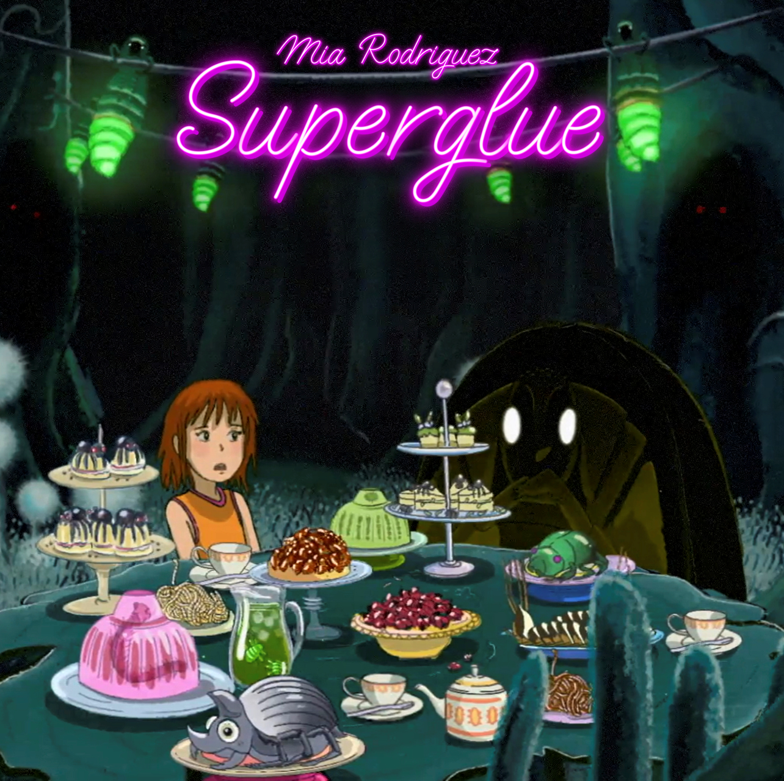

“Mia Rodriguez is one of the most innovative and arresting artists on the scene.”
– ROLLING STONE

“If Mia Rodriguez were a color, she would radiate rainbows, bubblegum pink, and lemon drop yellow.”
– ONES TO WATCH

Pop phenom Mia Rodriguez returns with new single “Super Glue,” available everywhere now at via City Pop and Atlantic Records. The hauntingly beautiful melody is the perfect soundtrack for Mia’s depiction of the push and pull of falling in love, and the difficulties of letting somebody love you. LISTEN/WATCH HERE.

“Super Glue” marks the latest in a series of self-assured international hit singles from the songstress, following this spring’s release of “Shut Up”, which was met by online applause from such outlets as Ones To Watch, which raved, “One can’t help but find themselves effortlessly body rolling to this impressively catchy tune…With the world currently on fire, ‘Shut Up’ is an instantaneous earworm that at the very least provides a blast of color to any gray day.”

Last summer Rodriguez unleashed her City Pop/Atlantic debut single, “Billion Dollar Bitch (Ft. Yung Baby Tate),” a hyped-up anthem that was joined by a playfully inventive visual boasting close to 3.5M views. “Billion Dollar Bitch” earned acclaim around the globe, with Rolling Stone Australia declaring it a “Song You Need To Know.”

Named “Best New Artist” at 2021’s Rolling Stone Australia Awards, Mia Rodriguez has quickly proved a force to be reckoned with, a seemingly unstoppable pop phenomenon weaving inexorable attitude and ambition with trendsetting personal style and an infectious sound inspired by a wide range of musical approaches spanning alternative, emo, hip-hop, K-pop, and more. The Sydney-based singer-songwriter-musician first attracted attention by posting inventive videos on TikTok, quickly building a fervent fan following now exceeding 2M. Signed as the first artist to the new City Pop Records label (co-founded by legendary Australian concert promoter Michael Chugg and his business partner Andrew Stone), Rodriguez made her official debut with 2019’s “Emotion.” “Psycho“ dropped in 2020 and immediately catapulted Rodriguez to the forefront of Australia’s contemporary pop scene, earning her more than 10M worldwide streams and over 19M individual views for a companion music video HERE. A series of remixes and stripped-down acoustic rendition (boasting close to 3M views HERE) followed, as did a prestigious “Unearthed Artist of the Year” nomination from the Australian Broadcasting Corporation’s annual J Awards. Rodriguez kept the momentum going with “Beautiful & Bittersweet”.

DOWNLOAD PRESS PHOTO HERE

CONNECT WITH MIA RODRIGUEZ
WEBSITE | FACEBOOK | INSTAGRAM | TWITTER | TIKTOK | YOUTUBE | PRESS ASSETS

FOR MORE INFORMATION
paige.rosoff@atlanticrecords.com

