MIA RODRIGUEZ TELLS IT LIKE IT IS
WITH NEW SINGLE ‘I LUV YOU’

LISTEN HERE | WATCH HERE

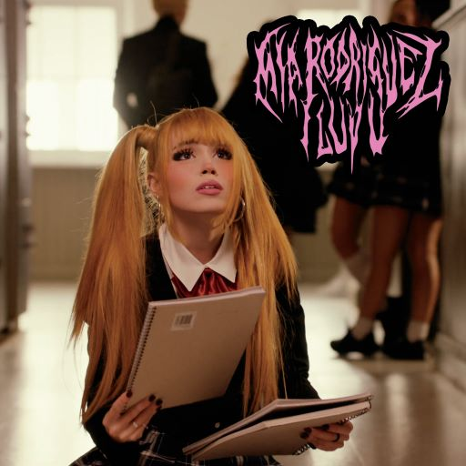
DL ART

“Rodriguez’s vocals, flitting between coquettish and powerfully dynamic, reflect the empowered youth of today”
– ROLLING STONE

Love is a beautiful thing. Or is it? It’s been said “To fall in love is to be reminded of a frustration that you didn’t know you had.”

Australian pop sensation Mia Rodriguez knows the feeling, and on her new single ‘I LUV U’ she doesn’t mince words.

Mia explains: “Loving people is hard, sometimes it can hurt, so much so that it tears emotions in two different directions. [The lyric] “I love you so much I want to punch you in the face” isn’t literal but it symbolizes the overwhelming feelings which you can be impacted by from love.”

Written by Mia with Teal Douville (Gwen Stefani, Daya) and Salem Ilese (Imanbek), the video for ‘I LUV U’ was shot by Australian director Josh Harris and sees Mia back at school, battling with the feelings that love can bring. “It was fun to take this video into a darker place that symbolizes the overwhelming feelings that can be triggered by love,” Mia said on making the video.
Mia’s latest single is her third release for 2022 and adds to her impressive catalog of pop anthems, now totaling close to 100 million combined streams. ‘I LUV U’ joins the list of songs Mia has written that explores love and the complex human emotions it brings. On ‘Superglue’ Mia asks “why is it the hardest thing to do, to let somebody love you?”. On ‘Beautiful & Bittersweet’ Mia declares “love, we got that kind of love, the one that cuts you deep.” As a songwriter, Mia is an artist who’s honest and wears her heart on her sleeve.

After making her recording debut in 2019 with her single ‘Emotion’, Mia hasn’t had a lot of opportunities to perform live. But that’s now starting to change with live music now open for business and Mia isn’t wasting any time with a busy 2022 so far. Starting with her first ever festival performance at Groovin’ The Moo in Canberra, Mia was then a special guest on UK via Australia, singer songwriter Thomas Headon’s national tour. Just recently, Mia performed to some of her biggest crowds yet as a guest of Californian artist Oliver Tree during his Splendour In The Grass sideshows. Stay tuned for more live shows from Mia this year.

ABOUT MIA RODRIGUEZ:
Named “Best New Artist” at 2021’s Rolling Stone Australia Awards, Mia Rodriguez has quickly proved a force to be reckoned with a seemingly unstoppable pop phenomenon weaving inexorable attitude and ambition with trendsetting personal style and an infectious sound inspired by a wide range of musical approaches spanning alternative, emo, hip-hop, K-pop, and more. The Sydney-based singer-songwriter-musician first attracted attention by posting inventive videos on TikTok, quickly building a fervent fan following now exceeding 2M. Signed as the first artist to the new City Pop Records label (co-founded by legendary Australian concert promoters Michael Chugg and Andrew Stone), Rodriguez made her official debut with 2019’s ‘Emotion’. ‘Psycho’ dropped in 2020 and immediately catapulted Rodriguez to the forefront of Australia’s contemporary pop scene, earning her more than 30M worldwide streams and over 20M individual views for a companion music video HERE. A series of remixes and stripped-down acoustic rendition (boasting close to 3M views HERE) followed, as did a prestigious “Unearthed Artist of the Year” nomination from triple j. Rodriguez kept the momentum going with ‘Beautiful & Bittersweet’, ‘Billion Dollar Bitch’ featuring Yung Baby Tate, 2022’s ‘Shut Up’ and ‘Superglue’. Mia has also now signed a worldwide deal (ex Australia / and NZ) with iconic US label Atlantic Records.

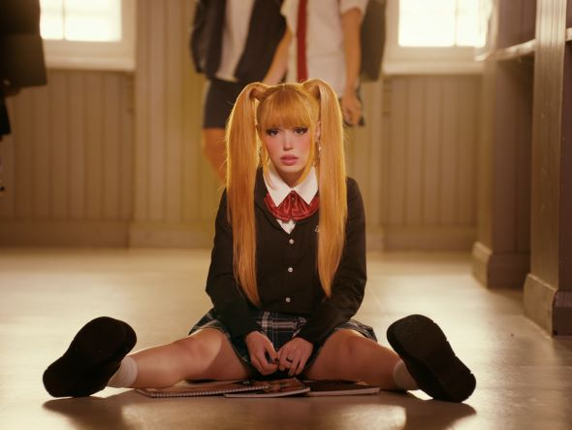
DOWNLOAD PRESS ASSET HERE

CONNECT WITH MIA RODRIGUEZ
WEBSITE | FACEBOOK | INSTAGRAM | TWITTER | TIKTOK | YOUTUBE

FOR MORE INFORMATION:
Paige.Rosoff@atlanticrecords.com
Atlantic Records | Big Beat Records

