FOR IMMEDIATE RELEASE
May 31, 2022

RAEDIO / ATLANTIC RECORDING ARTIST NCOGNITA SHARES
OFFICIAL VIDEO FOR "2X FREESTYLE"
WATCH HERE

SOUTH CENTRAL LYRICIST BLOWS UP FIRE IN THE BOOTH WITH DOPE FREESTYLE
WATCH HERE

NEW NCOGNITA "NITA UNFILTERED: DEDICATION" VLOG EPISODE 2 OUT NOW
WATCH VLOG HERE

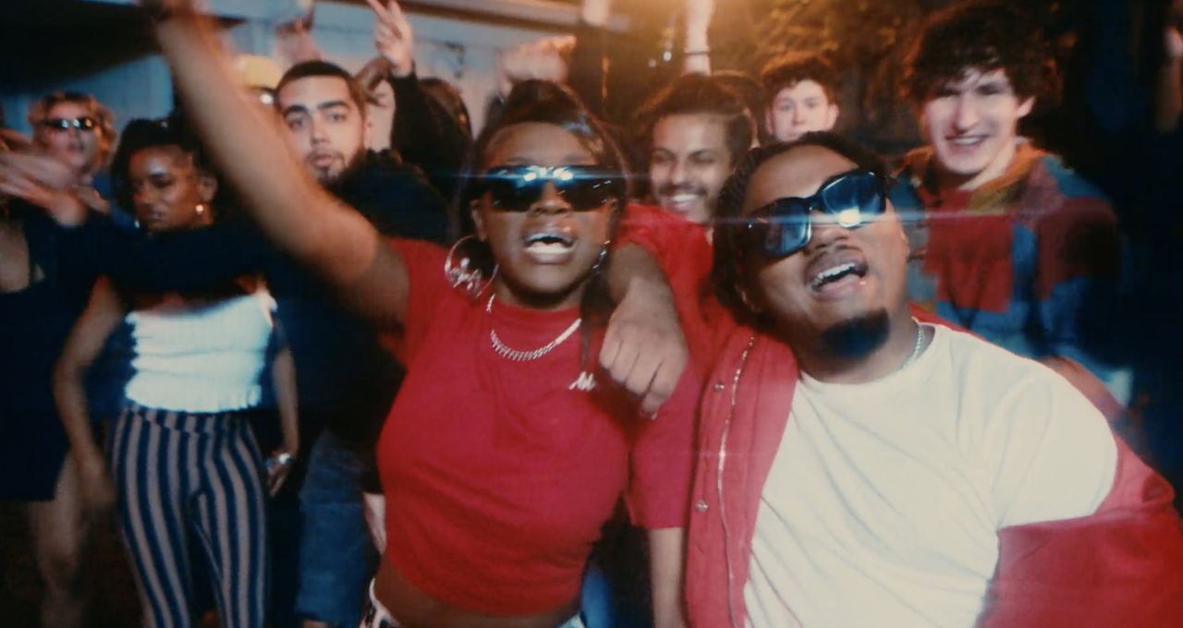
Download Thumbnail HERE

Raedio / Atlantic Records recording artist NCognita is back with an official video to her "2X Freestyle" off her major-label debut EP, The Playbook. While giving you a glimpse into Nita's world— the Jonathan Benavente-directed visual captures NCognita in her truest form as a skilled lyricist and captivating performer. Watch HERE. Listen to The Playbook HERE.

Aiming to win over new fans with the release of The Playbook and exclusive Bars On I-95 episode, NCognita continues to use her killer mic instincts with a new Fire In The Booth Freestyle. Translating her strengths from the page to the mic, Nita is making a tremendous mark in music.

Leading a double life as both a full-time college student at Loyola University New Orleans and a burgeoning Hip Hop artist, NCognita is effortlessly balancing both of her worlds. Check out her newly released vlog, "Nita Unfiltered: Dedicated Episode 2" as she places trust in her journey to unfold organically as it is destined to. NCognita is happily keeping her budding fanbase engaged with an array of one-off freestyles to come this summer.
ABOUT NCOGNITA
Standing firm in the belief that words have incredible power, NCognita is a 21-year-old rapper and poet from Los Angeles. As the latest addition to Issa Rae's music imprint under the renowned Atlantic Records umbrella, the South-Central native brings her unabashed confidence and impassioned lyrical dexterity to the consciously curated Raedio roster. With poetry as her first love, NCognita's vibrant musical upbringing encouraged her to come into her own as a rapper. First embarking on the path of a recording artist during her senior year at the Los Angeles County High School for the Arts, NCognita decided to continue her musical education at Loyola University in New Orleans. Currently a junior in the Urban Electronic Music Production program, NCognita is grinding in every sense of the word, balancing her schoolwork and the release of her debut EP, The Playbook.

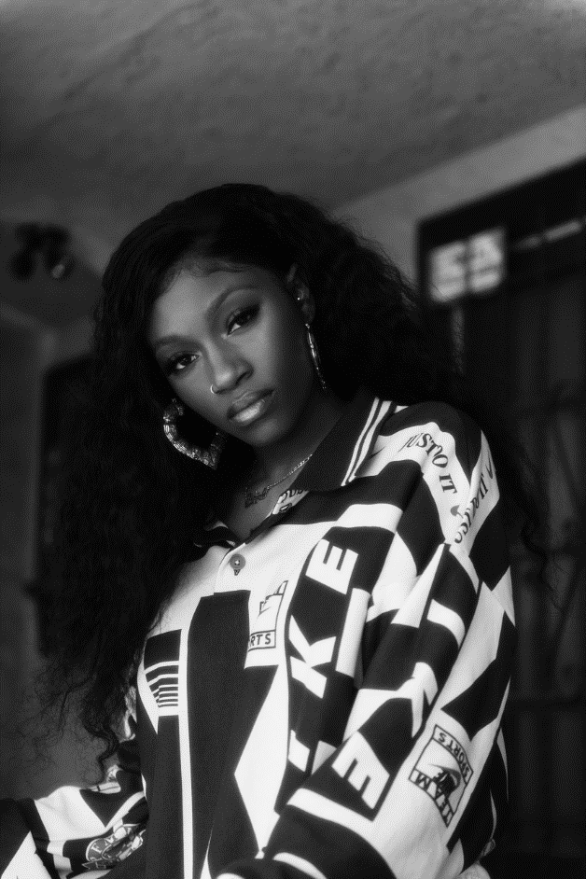
Download Press Asset HERE | Photo Credit: Emilio Sanchez

CONNECT WITH NCOGNITA
WEBSITE | TWITTER | INSTAGRAM | FACEBOOK | YOUTUBE

PRESS CONTACTS
Fairley McCaskill | Fairley.McCaskill@atlanticrecords.com

