sFOR IMMEDIATE RELEASE
AUGUST 12, 2022

OHGEESY IS BACK WITH “UP”

WEST COAST RAP HERO HERALDS EAGERLY AWAITED GEEZYWORLD 2 SOLO PROJECT
WITH HIGH FLYING NEW SINGLE

NEXT LEG OF EPIC GEEZYWORLD HEADLINE TOUR
BEGINS AUGUST 18 IN SAN DIEGO, CA

LISTEN TO “UP” | WATCH OFFICIAL MUSIC VIDEO

DOWNLOAD HI-RES ARTWORK

Multi-platinum rapper OHGEESY has shared his new single, “Up,” available today via Atlantic Records at all DSPs and streaming services. The ENRGY (EST GEE, Lil Yachty) produced track has the boisterous rapper bringing his signature style to the streets of London with his new visual. Watch HERE.

“Up” follows last year’s smash solo debut, GEEZYWORLD, available now in an extended deluxe edition HERE. Highlights include such hit singles as “Get Fly (Feat. DaBaby),” “Big Bad Wolf (Feat YG),” “Who Else (Feat. BlueBucksClan),” “Secret Service,” “Go Fast (Feat. Eladio Carrion),” “Appetizer (Shoreline Mafia),” and “Make It Happen (Feat. Pressa & Bun Dog),” all accompanied by official visuals streaming now at YouTube.

GEEZYWORLD instantly affirmed OHGEESY as an accomplished solo artist, peaking at #6 on Apple Music’s “US Top Albums (Hip-Hop/Rap)” with over 100M worldwide streams to date. What’s more, the project was met by critical applause upon its release, with Pitchfork declaring it to be “a quintessential L.A. rap record,” praising OHGEESY’s “raspy flow, master-crafted hooks, and ability to inject melody into every corner of the music,” and adding, “(GEEZYWORLD) solidifies OHGEESY as potentially one of L.A. rap’s next generation stars.”

OHGEESY will celebrate with the next leg of his epic GEEZYWORLD headline tour with the support of BlueBucksClan, getting underway August 18 at The Observatory North Park in San Diego, CA and then traveling North America through September. Presented by Cookies, the tour features support from DJ Vision and Hawaii Slim. In addition, OHGEESY will follow his show-stopping performance at last month’s Rolling Loud Miami with appearances at Rolling Loud Toronto (Sunday, September 11) and the upcoming Rolling Loud California (dates to be announced soon). For complete details and ticket information, please visit www.geezyworld.com.

ABOUT OHGEESY:
California never gave rise to a rapper quite like OHGEESY. The Los Angeles-born Mexican-American multiplatinum artist, entrepreneur, and visionary not only continues the legacy of his hometown, but he also puts a whole culture rarely represented in hip-hop on his back with pride, poise, and power. As such, he emerges as a trailblazer with vicious wordplay, vibrant storytelling, and a vital message. Breathing new life into the culture, he co-founded Shoreline Mafia during 2016. He locked down the group’s legacy with the double-platinum “Bands,” platinum-certified “Musty” and “Nun Major,” and the gold-certified “Bottle Service” and “Whuss The Deal.” During 2021, he served up his solo debut, GEEZYWORLD, which led him to his first sold-out tour. Among many highlights, “Get Fly” [feat. DaBaby] raked in over 32 million Spotify streams, while “Keeper” [feat. A Boogie Wit Da Hoodie] posted up 20.6 million Spotify streams. Right out of the gate, Pitchfork proclaimed, “GEESY is well placed to thrive as a lone star. GEEZYWORLD is a quintessential L.A. rap record.” On its heels, he supported the release with a massive sold-out headline tour. His world keeps expanding though. It includes exclusive merchandise with his line OTXBOYZ sold through his GEEZYWORLD web site. At the same time, he co-owns Mexican seafood spot Sunset Mariscos inside of the famed Fred Segal store in West Hollywood. Posting up hundreds of millions of streams and attracting widespread praise from GQ, Complex, UPROXX, XXL, OkayPlayer, and HotNewHipHop, he instigates another era for new music to come and much more.
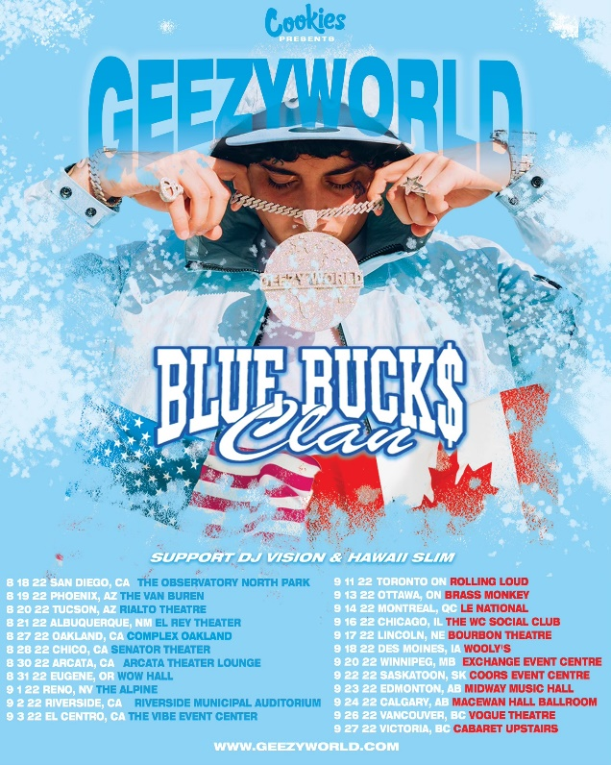

OHGEESY
GEEZYWORLD TOUR
NORTH AMERICA 2022
TOUR SUPPORT: BLUEBUCKSCLAN

AUGUST
18 - San Diego, CA - The Observatory North Park
19 - Phoenix, AZ - The Van Buren
20 - Tucson, AZ - Rialto Theatre
21 - Albuquerque, NM - El Rey Theater
27 - Oakland, CA - Complex Oakland
28 - Chico, CA - Senator Theater
30 - Arcata, CA - Arcata Theater Lounge
31 - Eugene, OR - Wow Hall

SEPTEMBER
1 - Reno, NV - The Alpine
2 - Riverside, CA - Riverside Municipal Auditorium
3 - El Centro, CA - The Vibe Event Center
11 - Toronto, ON - Rolling Loud Toronto
13 - Ottawa, ON - Brass Monkey
14 - Montreal, QC - Le National
16 - West Chicago, IL - The WC Social Club
17 - Lincoln, NE - Bourbon Theatre
18 - Des Moines, IA - Wooly’s
20 - Winnipeg, MB - Exchange Event Centre
22 - Saskatoon, SK - Coors Event Centre
23 - Edmonton, AB - Midway Music Hall
24 - Calgary, AB - MacEwan Hall Ballroom
26 - Vancouver, BC - Vogue Theatre
27 - Victoria, BC - Cabaret Upstairs

# # #

CONNECT WITH OHGEESY
GEEZYWORLD.COM | FACEBOOK | INSTAGRAM | TWITTER | YOUTUBE

PRESS CONTACT:
Brittany Bell | Brittany.Bell@atlanticrecords.com

