FOR IMMEDIATE RELEASE
AUGUST 19, 2022

CHART-TOPPING POP PHENOMENON BAZZI SHARES “HEAVEN”

MULTI-PLATINUM SINGER-SONGWRITER UNVEILS LATEST SINGLE
FROM EAGERLY AWAITED THIRD ALBUM

BIGGEST HEADLINE TOUR TO DATE KICKS OFF OCTOBER 17 IN DALLAS, TX

INFINITE DREAM ARRIVES EVERYWHERE ON FRIDAY, SEPTEMBER 16

LISTEN TO “HEAVEN”

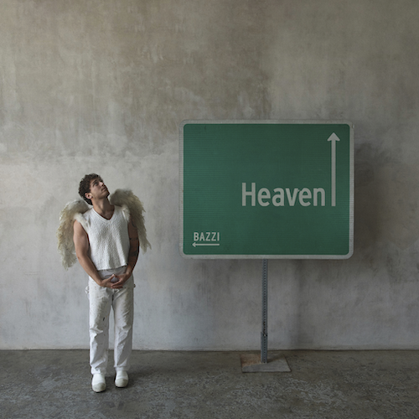
DOWNLOAD HI-RES ARTWORK

Chart-topping multi-platinum pop phenomenon Bazzi has shared his celestial new single, “Heaven,” available now at all DSPs and streaming services. Co-written with longtime collaborator Kevin White of GRAMMY® Award-nominated production and songwriting duo Rice N’ Peas (G-Eazy, Jason Derulo), the track features a sample from Fiction Factory’s New Wave classic “(Feels Like) Heaven.”

“Heaven to me is interesting because selecting a single off the album is so tough. Infinite Dream is so versatile, and it shows so many different sides of my music making abilities picking one single to represent the entirety of the work is impossible. But heaven is something I thought fans would enjoy and would be a nice precursor to all the madness and insanity that they’re going to get to hear on the album. I made “Heaven” in Hawaii around 2 and a half years ago with longtime collaborator and best friend, Kevin White. When I listen to the record, I can still see the pink and purple sunsets…. and all the crazy other activities that went on over there ;) I hope you guys love it as much as we loved making it” - BAZZI

“Heaven” marks the latest single from Bazzi’s eagerly awaited third solo album, INFINITE DREAM, arriving via Atlantic Records on Friday, September 16. Pre-orders and pre-saves are available now HERE. The 19-track album also includes such recent singles as the deeply personal “Will It Ever Feel The Same?,” “I Like That” (currently featured in Amazon’s hit series, The Summer I Turned Pretty), “Young & Alive,” and the dazzling new anthem, “Miss America,” the latter of which is accompanied by an official music video co-starring actor Dylan Sprouse and supermodels Barbara Palvin and Yovanna Ventura.

Bazzi will celebrate INFINITE DREAM with an epic North American headline tour – his biggest live run to date. Produced by Live Nation, “The Infinite Dream Tour” kicks off October 17 at Dallas, TX’s House of Blues and then continues through mid-November. For complete details, please see www.bazziofficial.com.

BAZZI
THE INFINITE DREAM TOUR
NORTH AMERICA 2022

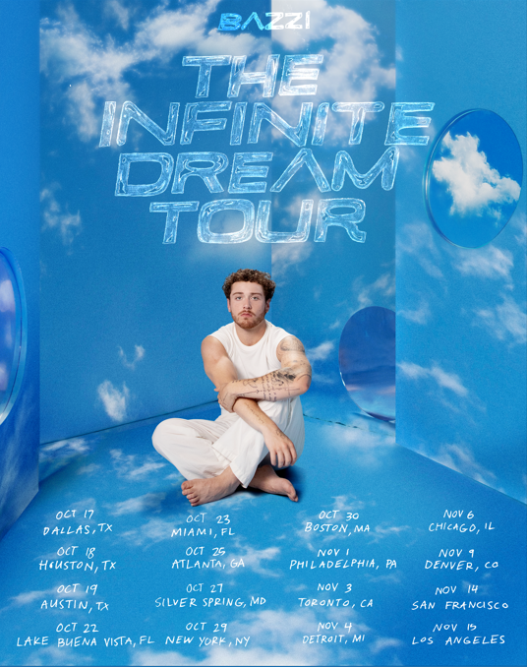

OCTOBER
17 - Dallas, TX - House of Blues
18 - Houston, TX - House of Blues
19 - Austin, TX - Emo’s
22 - Lake Buena Vista, FL - House of Blues
23 - Ft. Lauderdale, FL - Revolution
25 - Atlanta, GA - Tabernacle
27 - Silver Spring, MD - The Fillmore
29 - New York, NY - Hammerstein Ballroom
30 - Boston, MA - House of Blues

NOVEMBER
1 – Philadelphia, PA - The Fillmore
3 - Toronto, ON - Rebel
4 - Detroit, MI - The Fillmore
6 - Chicago, IL - Riviera Theatre
9 - Denver, CO - Summit
14 - San Francisco, CA - The Fillmore
15 - Los Angeles, CA - The Wiltern

# # #

ABOUT BAZZI:
Born to a Lebanese immigrant father and American mother in Canton, MI, Bazzi and his dad moved to California during his senior year where he single-handedly wrote and produced a series of viral smashes like “Alone” and “Beautiful,” earning millions of worldwide streams and top 10 placement on a variety of influential playlists. Now with over 1.9 billion streams to date, 2018’s 5x RIAA platinum certified “Mine“ proved Bazzi’s true breakthrough, ascending to #1 at CHR/Top 40 and making the top 20 on Billboard’s “Hot 100” after reaching #1 on virtually all streaming platforms. As if all that weren’t enough, the “Mine” companion video boasts over 192 million views via YouTube alone. Praised by Playboy for its “genre-bending…warts-and-all approach to songwriting,” Bazzi’s RIAA platinum certified debut album, COSMIC, debuted among the top 15 on the SoundScan/Billboard 200 upon its 2018 release, earning over 4.3 billion global streams with hits like the 4x platinum certified, top 40 hit duet version of “Beautiful (Ft. Camila Cabello),” accompanied by a spectacular companion visual now with over 188 million views. In 2019, Bazzi unveiled his first ever mixtape, SOUL SEARCHING, collecting over 1.8 billion streams on the strength of such RIAA platinum certified singles as “I.F.L.Y.“ and “Paradise.” Hailed by Billboard as “his most personal work to date,” the project made a top 20 debut on the Billboard 200, while “Paradise” proved one of Bazzi’s biggest hits with over 675 million global streams and counting.

Bazzi made the most of his 2020, releasing a string of intimate and deeply confessional tracks – including “Young & Alive,” “Renee’s Song,” “I Got You,” “I Don’t Think I’m Okay,” and “Crazy” – all of which drew millions of streams around the world. Bazzi followed the impressive singles run with his 2021 hit “I Like That,” which was joined by a colorful official music video directed by Christian Breslauer (Roddy Ricch, Doja Cat, Yungblud) and co-starring such close personal friends as high profile influencers Luca Sabbat, Scarlett Rose Leithold, Charlotte D’Alessio, Valentina Bilbao, Bruna Lirio, Chandler Lovelle, Duke Nicholson, and more. Most recently, Bazzi has released his most personal song yet, “Will It Ever Feel The Same?,” the dazzling pop anthem “Miss America” and the celestial “Heaven.”

Bazzi is gearing up to release his third album Infinite Dream due out September 16th and head out on his biggest tour yet in support of the new album. Currently boasting over 9 billion catalogue streams worldwide, Bazzi is fully focused on the future.

# # #

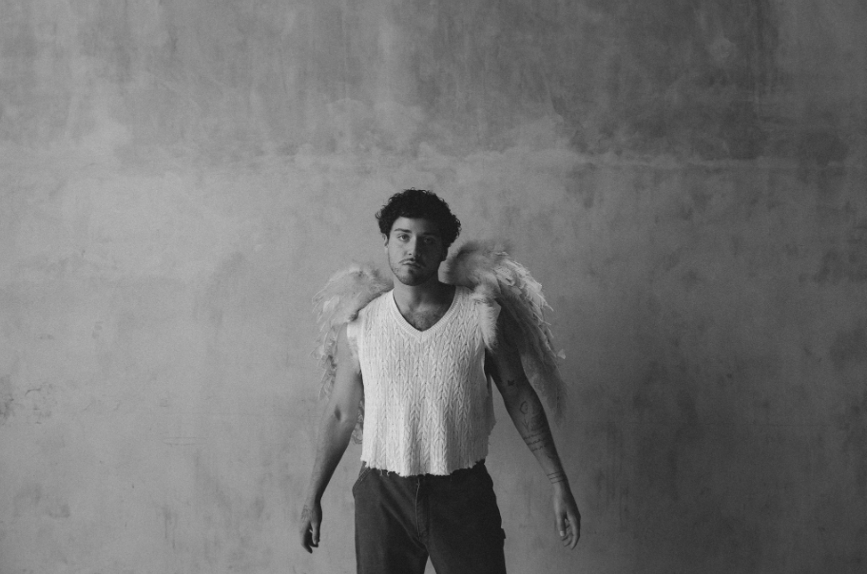
DOWNLOAD HI-RES IMAGE // PHOTO CREDIT: HENRY AMMANN

CONNECT WITH BAZZI
BAZZIOFFICIAL.COM | FACEBOOK| INSTAGRAM| TWITTER | YOUTUBE

For press inquiries, please contact:
Kelly McWilliam // Kelly.McWilliam@atlanticrecords.com

