FOR IMMEDIATE RELEASE
JULY 29, 2022

HAYLEY KIYOKO’S “PANORAMA” ARRIVES TODAY

HIGHLY ANTICIPATED SOPHOMORE ALBUM FEATURES STANDOUT SINGLES
“FOR THE GIRLS,” “DEEP IN THE WOODS,” “CHANCE,” AND “FOUND MY FRIENDS”

CATHARTIC VISUAL FOR POWERFUL TITLE TRACK PREMIERING NOW HERE

SUMMER TOUR WITH LAUV KICKS OFF AUGUST 11

LISTEN TO “PANORAMA” HERE

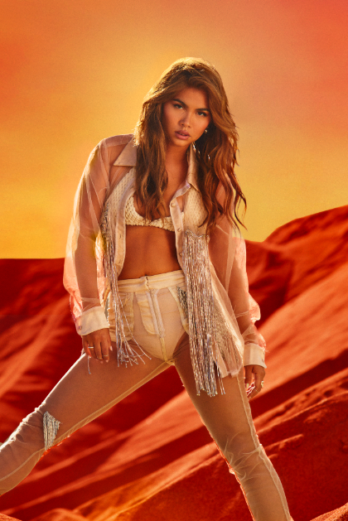

Download Hayley’s Bio
Download Hi-Res Artwork + Press Photos
Credit: Trevor Flores

Trailblazing pop star Hayley Kiyoko has officially released her hugely anticipated sophomore album, PANORAMA, available now via Atlantic Records HERE. Co-written by Hayley and produced by Kiyoko, Danja (Beyoncé, Britney Spears) and Pat Morrissey & Kill Dave, the transformative 12-track collection features previously released singles, “For The Girls,” “Deep In The Woods,” “Chance,” and “Found My Friends” and arrives alongside an emotionally raw visual for the album’s cinematic and orchestral title track, available to stream now HERE.

“I went through a period of time after my last album where I'd lost my confidence and my self-worth. Thankfully I was surrounded by friends and family who kept me grounded, always supporting me in my lowest moments and reminding me who I was along the way. ‘Panorama’ was the last song I wrote for this album, in a moment of clarity to enjoy the present and not let my trauma define me. One of my favorite lyrics from this song is ‘I’m done confusing all these ashes with my worth,’ which is a metaphor for when we measure our own value only by our struggles and hardships, but in reality, our worth is unwavering. We just need to give ourselves the space to appreciate the highs and the lows of this beautiful journey.” – HAYLEY KIYOKO

To celebrate the arrival of PANORAMA, Hayley hosted a release event last night at Lighthouse LA where fans and tastemakers were immersed in the album’s sonic and visual world for the very first time. Today at 3PM ET/12PM PT, Kiyoko will celebrate release day by joining BlueListTV live on Twitch’s front page for an exclusive look into the new album and an interactive chat with fans. Tune in HERE.

In a few weeks, Hayley will take PANORAMA on the road as she joins Lauv as special guest on his “All 4 Nothing Tour,” kicking off August 11 at the Armory in Minneapolis, MN and highlighted by stops at New York’s Hammerstein Ballroom (August 26 and 27) and Los Angeles’ famed Greek Theatre (September 9). For complete details and ticket information, please visit hayleykiyoko.lnk.to/LauvTour.

Hayley first announced PANORAMA alongside the release of standout single, “For The Girls,” a bass-boosted mission statement that followed the effervescent “Chance” and self-affirming “Found My Friends”. Joined by a self-directed music video starring Kiyoko in a romantic queer parody of America’s favorite dating show, “For The Girls” was met with instant critical praise from Billboard, Rolling Stone, People, NYLON, Stereogum, Cosmopolitan and more. Watch the official video, complete with chaotic and hysterical reality melodrama, and approaching 2.7M views, HERE.

Since the release of “For The Girls,” Hayley graced the cover of Teen Vogue’s Music issue, performed at the first-ever Pride reception at Vice President Kamala Harris’ DC residence, and shared “Deep In The Woods,” which offered fans the first official glimpse into the visual world of PANORAMA.



ABOUT HAYLEY KIYOKO:
Kiyoko has become one of the most celebrated pop artists since releasing EXPECTATIONS, which — according to Rolling Stone, placed her “at the forefront of an unapologetically queer pop movement.” In #20GAYTEEN, the multihyphenate performer was nominated for two VMAs and won “Push Artist Of The Year.” Since her 2015 debut, Hayley has amassed nearly 1B global streams and over 2.26M YouTube subscribers, accrued over 819M lifetime YouTube views, and sold out numerous venues across the country and abroad. Lauded as one of “The 21st Century's Most Influential Women Musicians” by NPR, Hayley inspires her community through nuanced storytelling and lyricism, encouraging hope as her resounding message. Last year, Hayley launched her first-ever gender-inclusive fragrance, Hue, available to order at huebyhayley.com. An audacious scent designed as an expression of liberation, freedom, and self-empowerment, Hue became a 2022 finalist for the Fragrance Foundation’s “Universal Prestige Award” and has received coverage from Vogue, Allure, NYLON, Glamour, Cosmopolitan, and more.

HAYLEY KIYOKO
PANORAMA TRACKLIST

Sugar At The Bottom
Luna
For The Girls
Flicker Start
Underground
Forever
Deep In The Woods
Supposed To Be
Chance
Well
SOS
Found My Friends
Panorama

HAYLEY KIYOKO ON TOUR 2022

AUGUST
11 – Minneapolis, MN – The Armory
12 – Chicago, IL – Byline Bank Aragon Ballroom
13 – Detroit, MI – Meadow Brook
15 – Toronto, ON – RBC Echo Beach
16 – Montreal, QC – Place Bell
17 – Boston, MA – Leader Bank Pavilion
19 – Philadelphia, PA – The Met Philadelphia
20 – Pittsburgh, PA – Stage AE
21 – Cincinnati, OH – ICON (Rockstar Energy Drink Stage at Smale Park)
23 – Columbus, OH – KEMBA Live!
25 – Washington, DC – The Anthem
26 – New York, NY – Hammerstein Ballroom
27 – New York, NY – Hammerstein Ballroom
28 – Asbury Park, NJ – Stone Pony Summer Stage
30 – Charlotte, NC – Charlotte Metro Credit Union Amphitheater
31 – Atlanta, GA – Coca-Cola Roxy

SEPTEMBER
1 – Nashville, TN – Ryman Auditorium
3 – Houston, TX – 713 Music Hall
4 – Dallas, TX – Pavilion at Toyota Music Factory
6 – Denver, CO – Mission Ballroom
7 – Ogden, UT – Ogden Amphitheater
9 – Los Angeles, CA – Greek Theatre
11 – San Diego, CA – Cal Coast Credit Union Open Air Theatre
12 – Phoenix, AZ – Arizona Federal Theatre
15 – Berkeley, CA – Greek Theatre @ UC Berkeley
17 – Vancouver, BC – Doug Mitchell Thunderbird Sports Centre
20 – Seattle, WA – WaMu Theater

CONNECT WITH HAYLEY KIYOKO:
WEBSITE | FACEBOOK | TWITTER | INSTAGRAM | TIKTOK | YOUTUBE | PRESS ASSETS

PRESS CONTACT:
Andrew George / Atlantic Records
andrew.george@atlanticrecords.com

